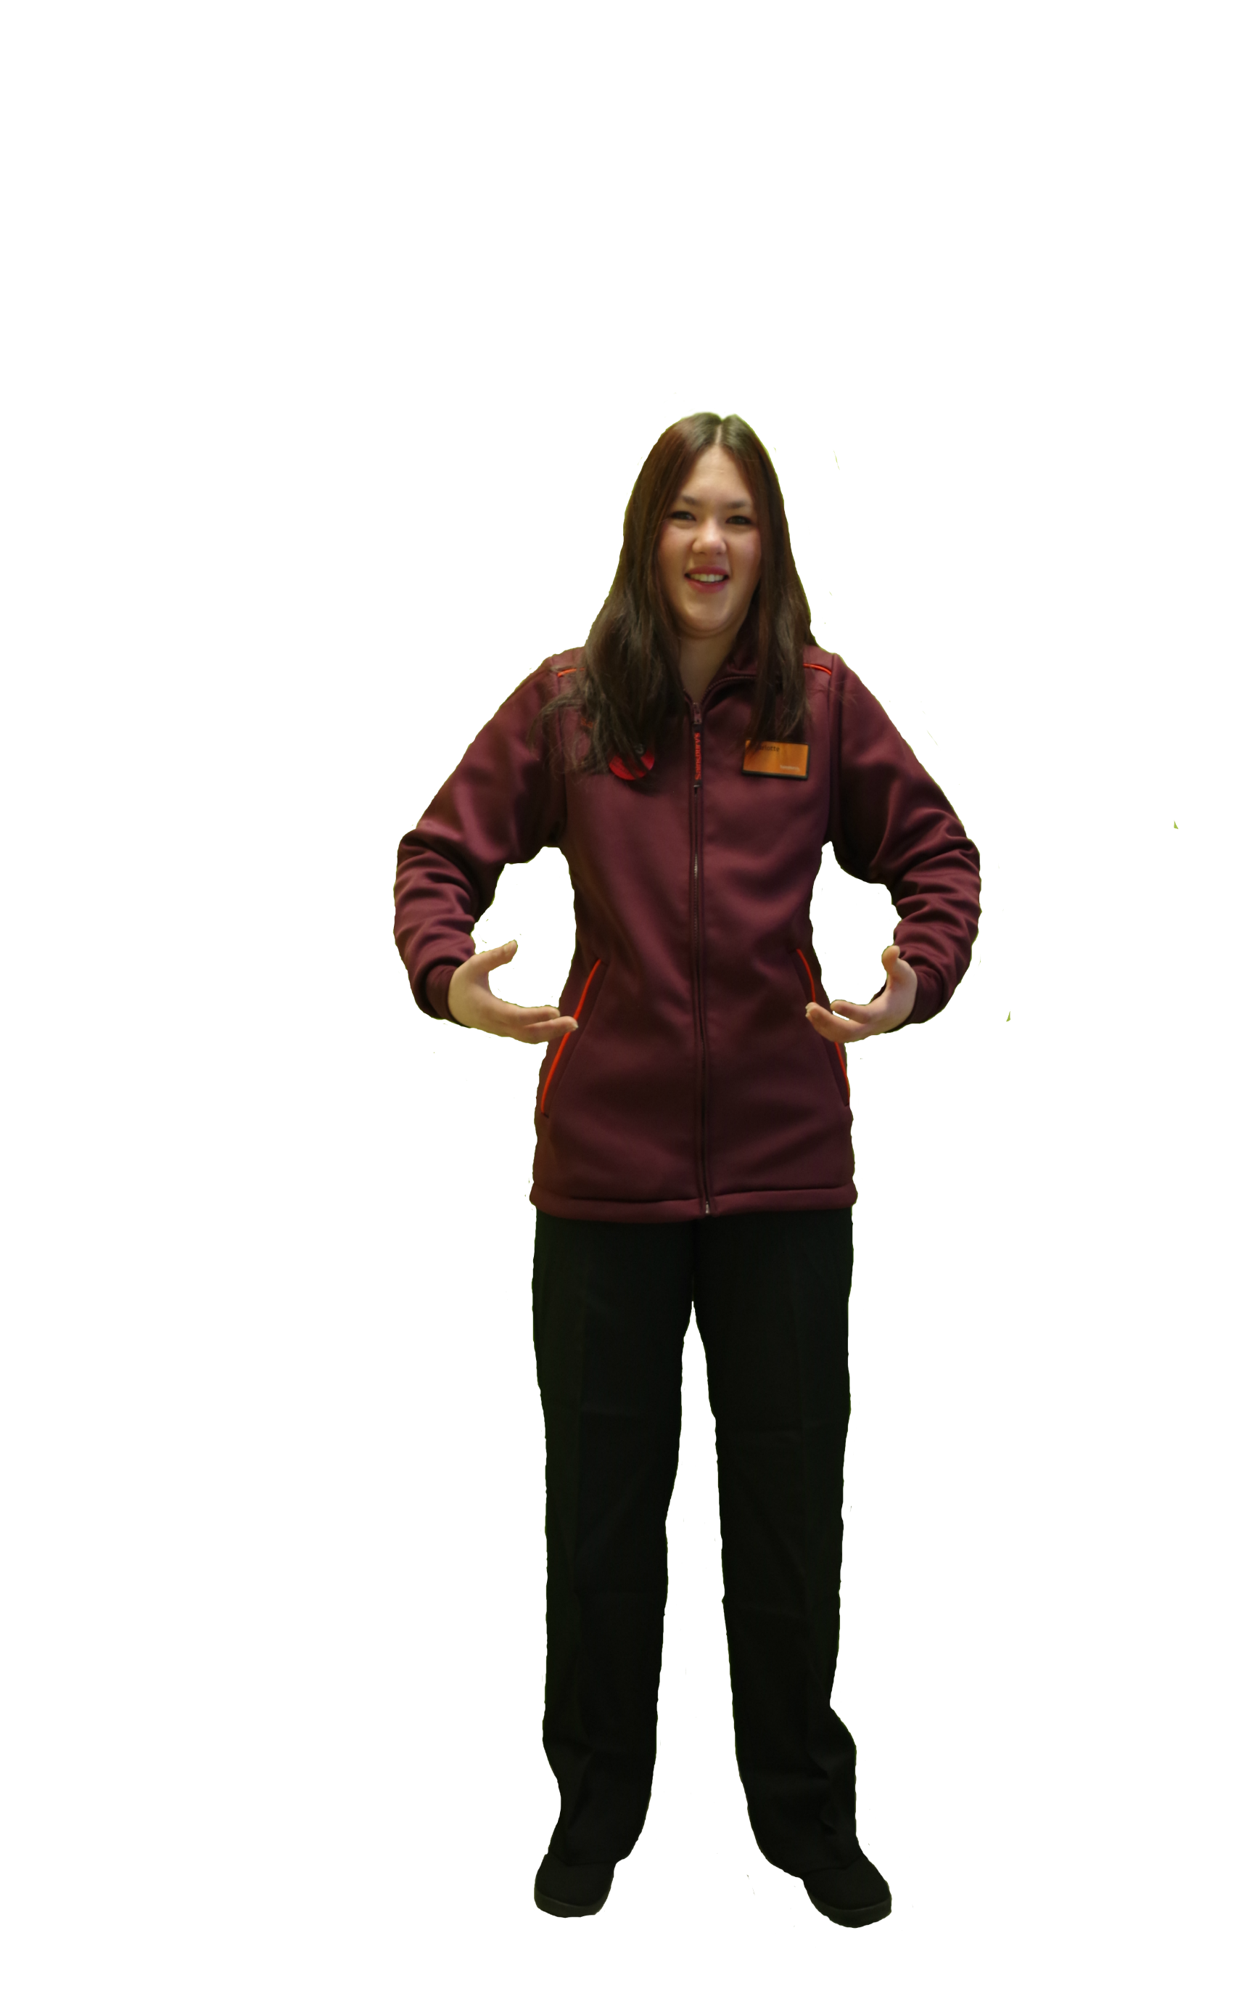

“

It’s really important that you can be confident using money and know that you are giving the customer the correct change.

I walk to work and I’m on my feet all day, so it is important for me to keep healthy.

“

**GOSDEN GRADUATE**

**SAINSBURY’S SUPERVISOR**

”

”

“

“

I am always using my ICT skills, I have to help my colleagues if there is a problem with the tills especially when they freeze and stop working!

I have now learnt to drive, which has given me lots more independence.





I am a level 2 Qualified Gym Instructor and work at a local gym club in the evenings

”

* 2”

.”

“

”

“

My literacy skills are important as I need to be able to talk to staff and customers. I also have to leave messages for staff for when they start a new shift.