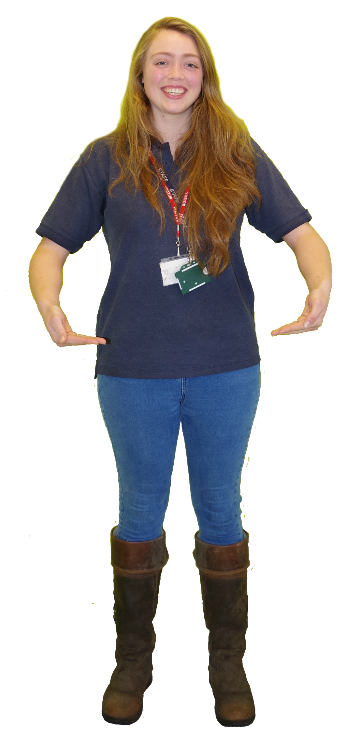

My numeracy skills are really important, for example when I am weighing animal food and making sure I am giving animals the right medicine dosage.

**GOSDEN GRADUATE SMALL ANIMAL INSTRUCTOR**



“

At work I feel part of a team and like working with other people and sharing ideas.



”



”

“

I use my literacy skills all of the time. I have to make clear notes on animals that are ill, writing reports for colleagues, sending emails and speaking to vets about deliveries.

If I have any worries at work I can talk to my manager. I feel I can talk to the people in my team to get advice. It’s important to ask for help if you need it.

”

“

“

“

”

It is important to be honest and respectful.

”

I have achieved a Level 2 Diploma in Horse Care, a Level 2 Diploma in Animal Care, a Level 3 BTEC Diploma in Animal Management and a Level 3 BTEC Extended Diploma in Animal Management.