**Leaf Rubbing** [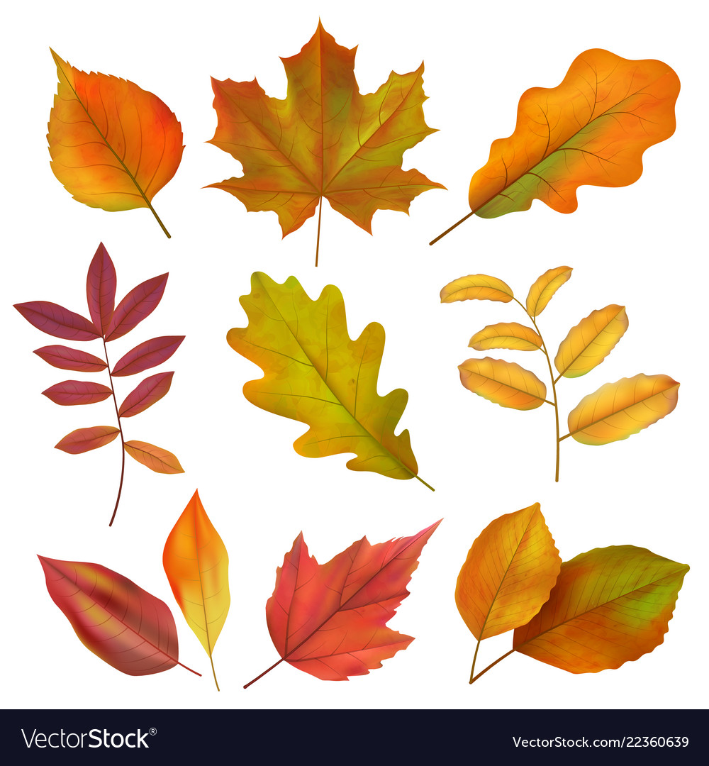](https://www.google.co.uk/url?sa=i&url=https://www.vectorstock.com/royalty-free-vector/autumn-leaves-realistic-yellow-and-red-fall-leaf-vector-22360639&psig=AOvVaw2uxLLxUnS3J26xjx86srhR&ust=1600010488662000&source=images&cd=vfe&ved=0CAIQjRxqFwoTCIjGn-D14-sCFQAAAAAdAAAAABAD)

**What you need:** Crayons and paper

**What to do: Place the leaf under the paper and gently rub with crayon.**

**What it is good for: Fine motor skills.**

**Can you create a repeating pattern?**

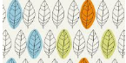

**Leaf Collection**

**What you need: Bag.** 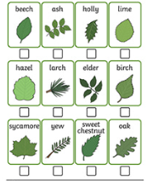

**What to do: Go on a walk and collect some leaves. How many different leaves can you find? Can you identify them?**

**What it is good for: Observational skills. Maths: counting.**

**Autumn Nature Walk**

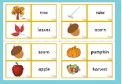

**What you need: Bag**

**What to do: Collect items of interest. How many cones can you find? Which is the biggest? Smallest?**

**What it is good for: observational skills. Vocabulary extension.**

**Leaf Collage**

[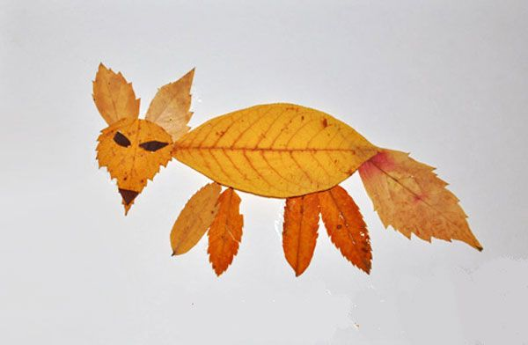](https://www.google.co.uk/url?sa=i&url=https://www.pinterest.com/pin/429319776952078737/&psig=AOvVaw0suOnbPRP6Rse0P5p2MZh5&ust=1600011218827000&source=images&cd=vfe&ved=0CAIQjRxqFwoTCMiWgLb44-sCFQAAAAAdAAAAABAD)

**What you need: Collection of leaves**

**What to do: Design a picture out of the leaves you have collected.**

**What it is good for: fine motor skills, imagination.**

[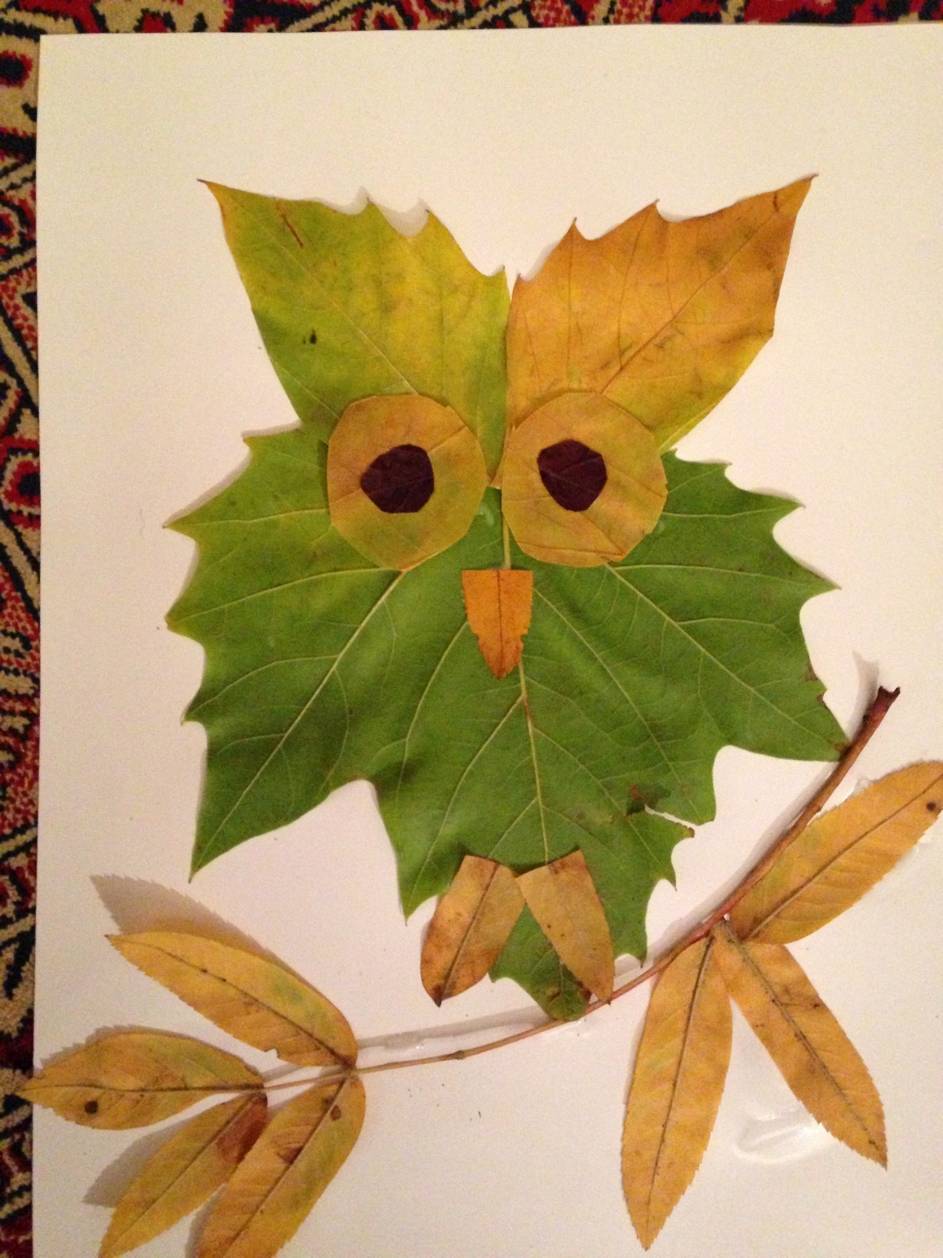](https://www.google.co.uk/url?sa=i&url=https://www.pinterest.com/pin/194640015119090255/&psig=AOvVaw0suOnbPRP6Rse0P5p2MZh5&ust=1600011218827000&source=images&cd=vfe&ved=0CAIQjRxqFwoTCMiWgLb44-sCFQAAAAAdAAAAABAJ)

**Halloween**

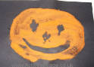

**What you need: Black paper, orange paint or crayons**

**What to do: Design a scary pumpkin face**

**What it is good for: fine motor skills, imagination.**

**Research: Halloween – Can you find 5 Halloween facts?**

**Autumn Sensory Walk**

[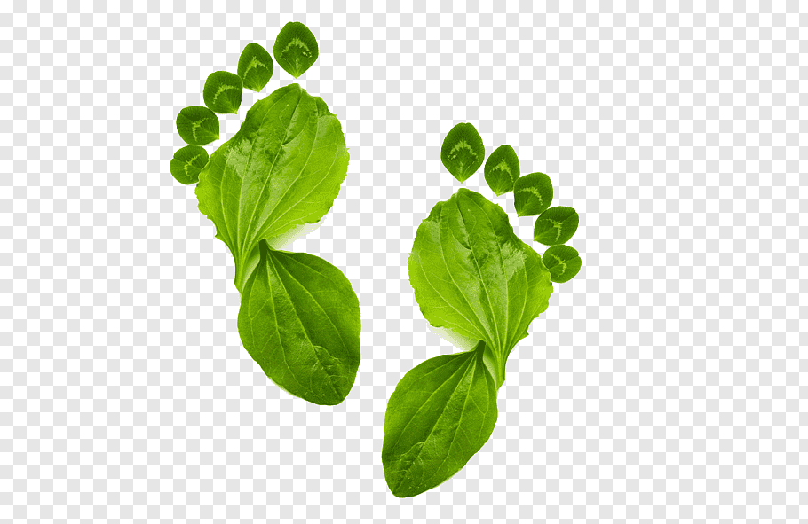](https://www.google.co.uk/url?sa=i&url=https://www.pngwave.com/png-clip-art-abuuk&psig=AOvVaw3MKmHMIQxS2BfzKoUsocvo&ust=1600012657506000&source=images&cd=vfe&ved=0CAIQjRxqFwoTCNDI4-b94-sCFQAAAAAdAAAAABAD)

**What you need: Paper/camera to record findings**

**What to do: Go on a sensory walk. What can you see, hear, touch, smell?**

**What it is good for: Language development**

**Autumn Memory Game**

[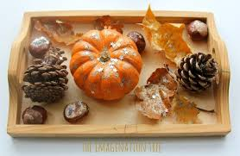](https://www.google.co.uk/url?sa=i&url=https://theimaginationtree.com/best-autumn-activities-kids/&psig=AOvVaw0it1yYnRRvnbdT6JUFjwXi&ust=1600014436963000&source=images&cd=vfe&ved=0CAIQjRxqFwoTCICL272E5OsCFQAAAAAdAAAAABAH)

**What you need: Tray and items from autumn walk**

**What to do: Place items on tray. Take turns to take one item away and identify what is missing**

**What it is good for: Memory development.**

**Autumn Mosiac**

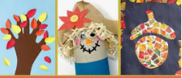

**What you need: an assortment of small pieces of card, coloured paper or matherial**

**What to do: Design something associated with autumn; acorn, tree, scarecrow**

**What it is good for: fine motor skills, imagination.**

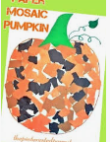

**Leaf Prints**

[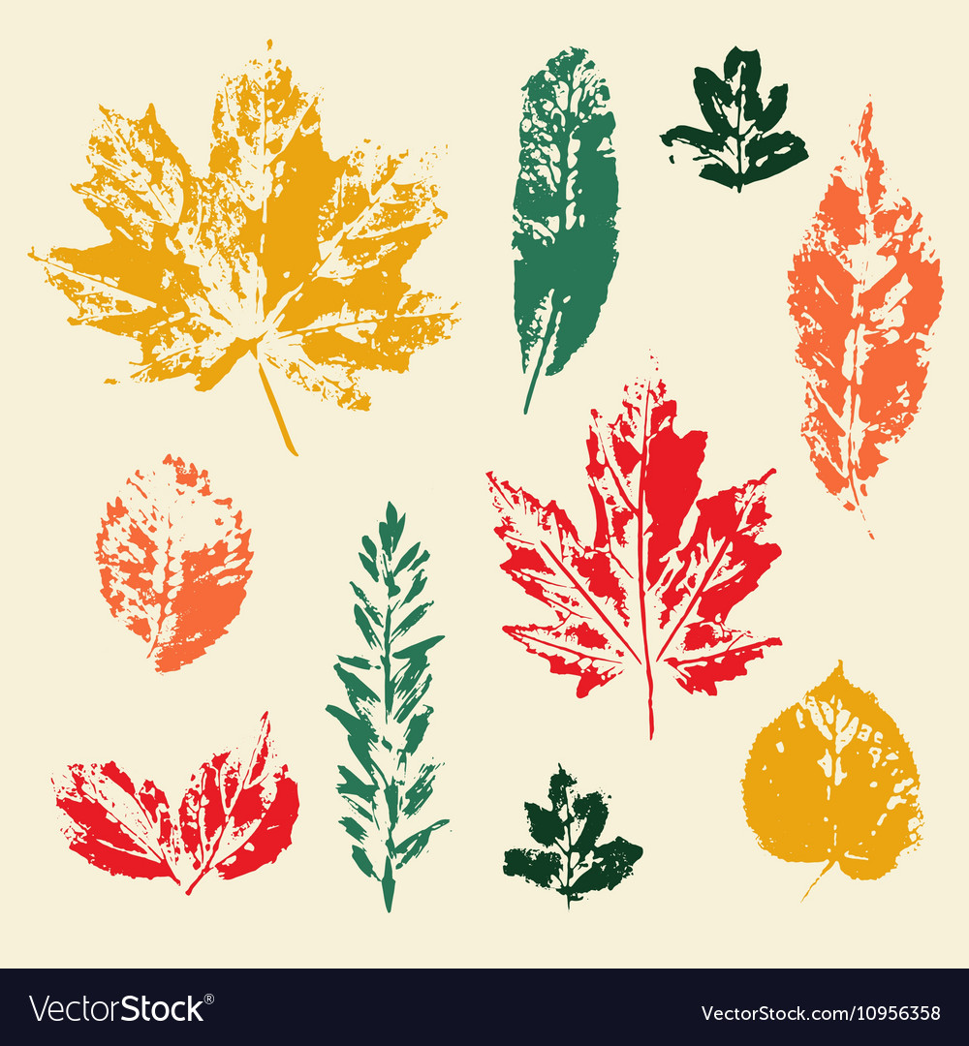](https://www.google.co.uk/url?sa=i&url=https://www.vectorstock.com/royalty-free-vector/colorful-leaves-prints-set-vector-10956358&psig=AOvVaw3XsgZ_QwaQ1AxOfnXDnEJn&ust=1600013957407000&source=images&cd=vfe&ved=0CAIQjRxqFwoTCICYic-C5OsCFQAAAAAdAAAAABAD)

**What you need: Collection of leaves and paint**

**What to do: Paint and print the leaves.**

**What it is good for: Hand and eye co-ordination. Vocabulary development**

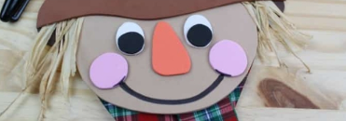

**Scarecrow**

**What you need: Assortment of card, material, glue, paper**

**What to do:**

**Design a scarecrow by cutting out paper or materials**

**What it is good for: Hand and eye co-ordination. Imagination development.**

**Autumn Leaf Face/People**

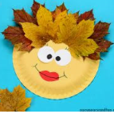

**What you need: Paper plate, glue, leaves, paper eyes, pencil/felt tip pen.**

**What to do:**

**Glue leaves in place, draw a face on the plate.**

**What it is good for: Hand and eye co-ordination. Imagination.**

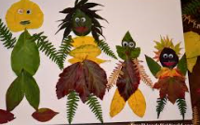

**A** **utumn Seeds**

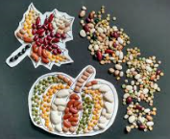

**What you need: seeds, pasta, dried lentils, glue, paper/card.**

**What to do:**

**Design an autumn picture using seeds or pasta.**

**What it is good for: Hand and eye co-ordination. Concentration and focus.**

**Autumn Tree**

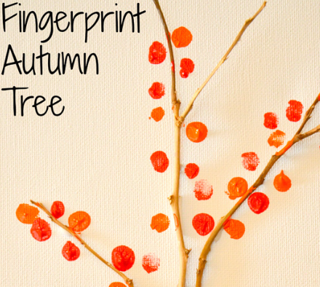

**What you need: Twigs, orange, red, paint, paper/card, glue.**

**What to do: Stick the twigs onto the paper/card. Use fingers prints for leaves.**

**What it is good for: fine motor skills, imagination.**

**Conker Count**

[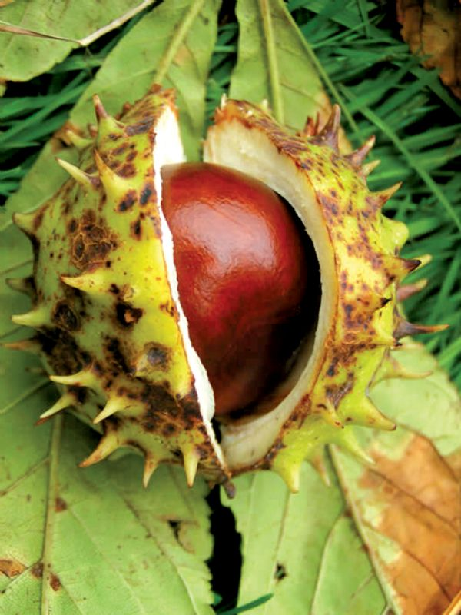](https://www.google.co.uk/url?sa=i&url=https://thelocalanswer.co.uk/news/pets-and-wildlife/wildlife-matters/1809-all-sep-18-wildlife-matters.aspx?area%3Dall&psig=AOvVaw1Pk8Bwj3AiH7pxqQYHktHI&ust=1600012873102000&source=images&cd=vfe&ved=0CAIQjRxqFwoTCLDtptT-4-sCFQAAAAAdAAAAABAD)

**What you need: Horse chestnut tree and bag.**

**What to do: Collect the conkers. Count how many you have, can you place them in size order, can you identify the heaviest?**

**What it is good for: Maths, counting, weight and measure.**

**Ask an adult to make a hole through them. Can you make a conker snake?**