**Scribble Art**

**What you need:** A sheet of paper, a pen/pencil and some colouring pencils/pens

**What to do:** Draw a large scribble on the paper with lots of empty gaps. Each gap has to be coloured with either a different colour or using a different pattern.

**What it is good for:** Mindfulness, creativity, fine motor skills

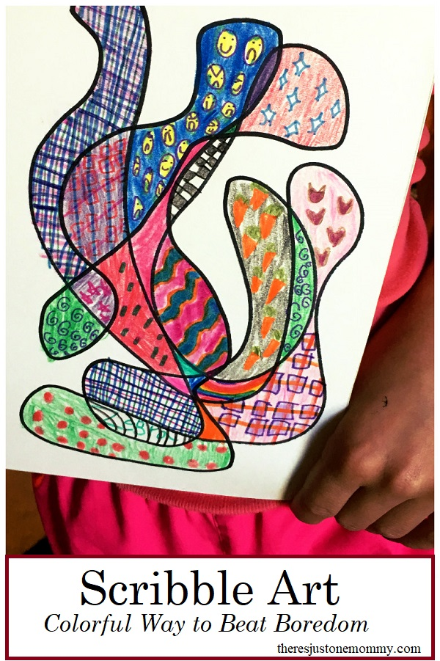

**Find my number**

**What you need:** Someone to play with.

**What to do:** Ask your partner to give you a number between 1-10. You then need to go and find that number, you might find 5 plates or 7 sticks. Take it in turns and see what numbers you can find. Maybe you can challenge yourself to find 1 more or 1 less than your partner’s number.

**What it is good for:** Number recognition, addition and subtraction

