**Dance routine**

**What you need:** Music or song of your choice and space

**What to do:** Make up a dance routine to your favourite song / music

Can you teach a family member or friend your dance?

**What it is good for:** Motor skills, focus, concentration, thinking skills and well-being.

[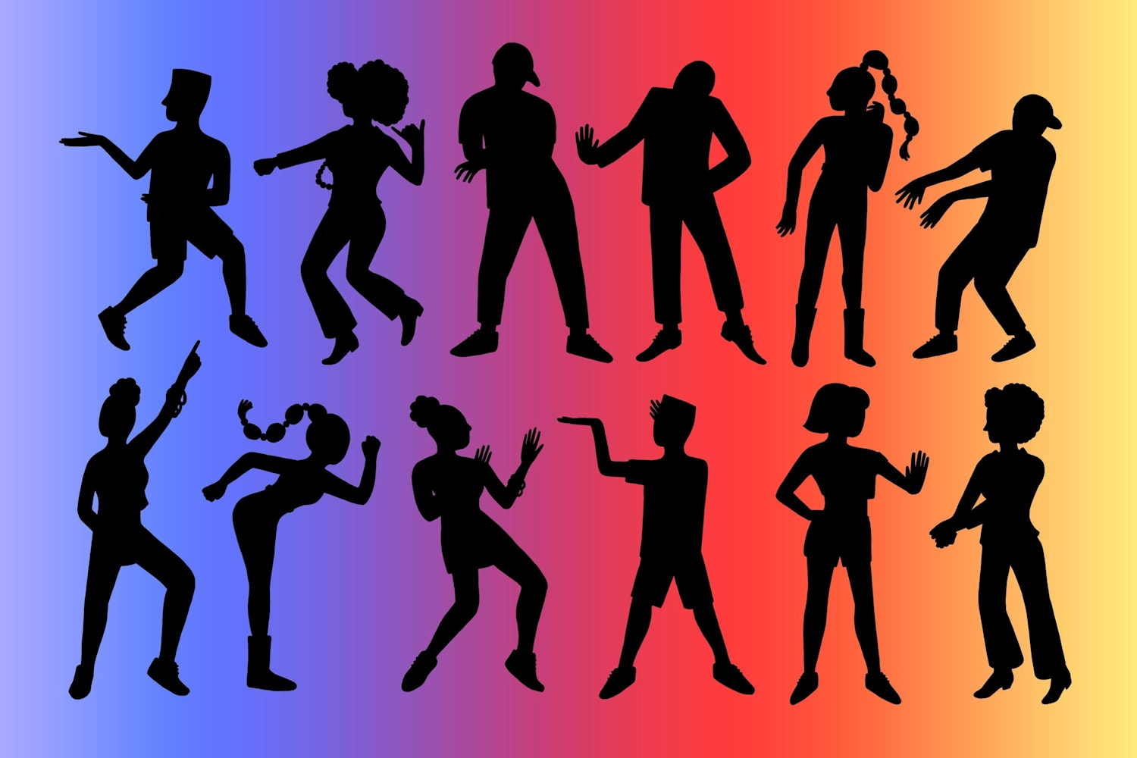](https://www.google.co.uk/url?sa=i&url=https%3A%2F%2Fwww.redbull.com%2Fint-en%2Fmusic%2Fa-history-of-afropop-dance-crazes&psig=AOvVaw2S51aWHH6MejAD_kKvtMAS&ust=1602065629153000&source=images&cd=vfe&ved=0CAIQjRxqFwoTCPit_9rdn-wCFQAAAAAdAAAAABAK)

**Our World**

**What you need:** pen, paper, atlas and internet

**What to do:** Produce an information leaflet about a country of your choice.

1. What is the country and capital city?
2. What language does they speak?
3. At least 5 interesting facts
4. Can you add some picture?

**What it is good for:** Literacy skills, ICT skills and life skills,

