**Cress heads**

**What you need:** Cress seeds, water, egg shell, cotton wool, pen

**What to do:**

* Use an empty egg shell as the head.
* Draw on the face.
* Place cotton wool inside, add a dash of water.
* Place the seeds inside and watch it grow!

**What it is good for:**

Knowledge of the world, following instructions, plant care.

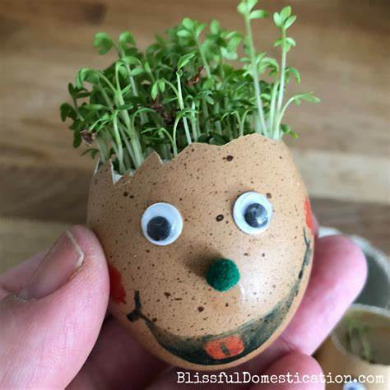

**Egg in the hole sandwich**

**What you need:**

2 slices of bread, 2 eggs, 4 rashers of bacon, oil, a round cutter, salt, pepper, parmesan cheese.

**What to do:**

* Grill the bacon
* Put the bread on the baking tray (oiled)
* Using the cutter, cut out the middle of the bread, brush with oil and then turn over.
* Lay the bacon on top.
* Crack egg over hole.
* Sprinkle with salt, pepper and parmesan.
* Bake for 15 minutes.

**What it is good for:**

Developing independence, following instructions, creative thinking, confidence building, life skills.