Teacher tip: Appropriate for KS4 students
Shading an object

What you need:
Plain paper, colouring pencils

What to do:
Choose something from outside- a plant, flower, tree and draw it on a plain piece of paper. With colouring pencils, shade in the object using different shades of the same colour.

What it is good for:
Drawing skills, mindfulness, shading skills, fine motor skills
Draw a bird’s-eye view plan of your bedroom

What you need:
Plain paper, ruler, tape measure

What to do:
Measure your room with a tape measure or using an app on your phone. Try and show the furniture that you have in your bedroom and how it is laid out. (Do this as though you are looking down from the ceiling).
What it is good for:
Measuring the perimeter of your room.
Drawing/design skills

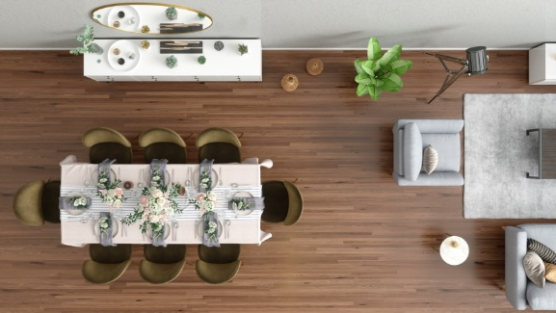

- Find and write down the lyrics to your favourite songs. Look up any words that you do not know in the dictionary. Can you think of other describing words that they could have used instead? Using a Thesaurus (orApp on your phone) find alternative words. For example: if they use ‘alternative’, you could use other, different or another, or if they use troubled, you could use: anxious, concerned, distressed) If you have a computer at home, you can use the Thesaurus in Word. It is in Review.
- Read each day - a magazine or book or anything! Tell the year 10 staff what you have been reading each morning. (It may be that you have read what is on the cereal box or instructions for using your new item of make- up that you have just bought)
- Write a daily diary. Each day record what you have been doing and/or how you have been feeling. Write the day and date for each entry, making sure you spell the days of the week correctly.
- Using the alphabet, write as many describing word that you can think of:
eg A – amazing, adventurous, angelic.
Do this for the whole alphabet. Use your best handwriting as this will be really useful for English lessons.

