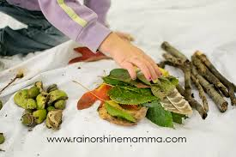 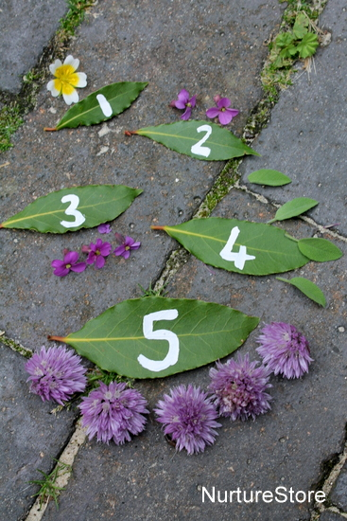  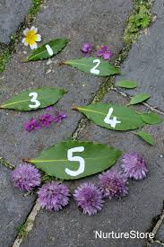  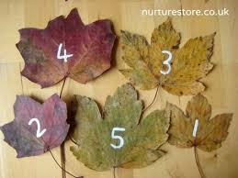    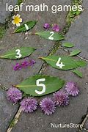

**Numbered leaves**

**What you need:** Leaves collected from outside, dry board wipe pen or felt tips

**What to do: Write numbers from 1 – 10 on leaves (or ask an adult to help). Then put the leaves in order. You can also write numbers 1 – 10 on two sets of leaves and match them. You can also ask the children to find, e.g. number 3 etc**

**What it is good for: Number order, matching, writing of numbers.**

**Sorting natural materials**

**What you need:** Leaves, twigs, flowers etc. from outside.

**What to do: Can you find some leaves, twigs and flowers etc. from outdoors. Can you sort them? How will you sort them? Colour/size/category.**

**What it is good for: Maths sorting activity.**

Teacher tip: Good for level 1 learners