**Cress heads**

**What you need:** Cress seeds, water, egg shell, cotton wool, pen

**What to do:**

* Use an empty egg shell as the head.
* Draw on the face.
* Place cotton wool inside, add a dash of water.
* Place the seeds inside and watch it grow!

**What it is good for:**

Knowledge of the world, following instructions, plant care.

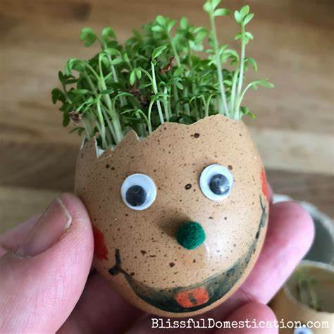

**Mini PE Lesson**

**What you need:**

Equipment for your chosen game.

**What to do:**

Teach a family member a sports game.

Challenge other family member to partake and create a competition.

**What it is good for:**

Gross motor skills, team work, speech and language, co-ordination.

