Money! Money! Money!

**4 minute playdough**

[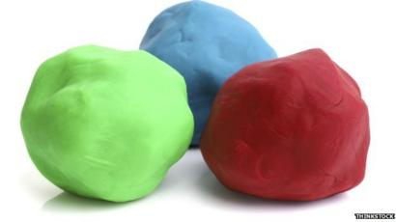](https://www.google.co.uk/url?sa=i&url=https%3A%2F%2Fwww.bbc.com%2Fnews%2Fuk-scotland-28951774&psig=AOvVaw3TnaFjfFYlgQiEnfCs5vpO&ust=1600417900631000&source=images&cd=vfe&ved=0CAIQjRxqFwoTCNjlxrfj7-sCFQAAAAAdAAAAABAD)

**What you need:**  
2 cups of plain flour  
2 tablespoons of vegetable oil

Half a cup of salt  
2 tablespoons of cream of tartar

1 cup of boiling water (adult supervision)  
Few drops of food colouring

**What to do:**

* Mix the flour, salt, cream of tartar and oil in a large mixing bowl
* Add food colouring TO the boiling water then into the dry ingredients
* Stir continuously until it becomes a sticky, combined dough
* Allow it to cool down then take it out of the bowl and knead it vigorously for a couple of minutes until all of the stickiness has gone. **\*** This is the most important part of the process, so keep at it until it’s the perfect consistency!**\***
* If it remains a little sticky then add a touch more flour until just right

**What it is good for:  
Sensory, imagination, creation**

**What you need:** [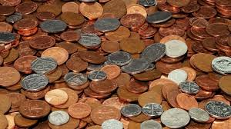](https://www.google.co.uk/url?sa=i&url=https%3A%2F%2Fstarctmag.com%2Fnews%2F1p-and-2p-coins-to-stay-in-circulation-report-12738-2019%2F&psig=AOvVaw1mY3uTtdiUIi45tTDBPLvF&ust=1600418327202000&source=images&cd=vfe&ved=0CAIQjRxqFwoTCIi13oPl7-sCFQAAAAAdAAAAABAJ)  
Coins or notes   
or print examples off the computer  
Paper  
Pens

**What to do:**Coin recognition – can you find the ……?  
Choose an amount and see if you can find the correct coin/note.  
  
Play shops – label a few objects around the house with prices. Using the money given, can you work out what you would need to buy a certain item?Adding coins to make an amount.  
Working out what coins can make another amount for example what coins apart from a 5p piece can we use to make 5p? (2 2ps and 1 1p)

**What it is good for:  
Counting, recognition, coin value, social skills**

Teacher note/who for – Level 1 learners