**Rock snake**

**What you need:** Large pebbles or stones. Paint, paint brush.

**What to do:** Carefully paint the stones using bright attractive colours. Arrange them into the start of a snake shape. Leave a note encouraging others to add their own designs. Check and record the progress of your rock snake.

**What it is good for:** Counting, fine motor skills, recognising patterns.

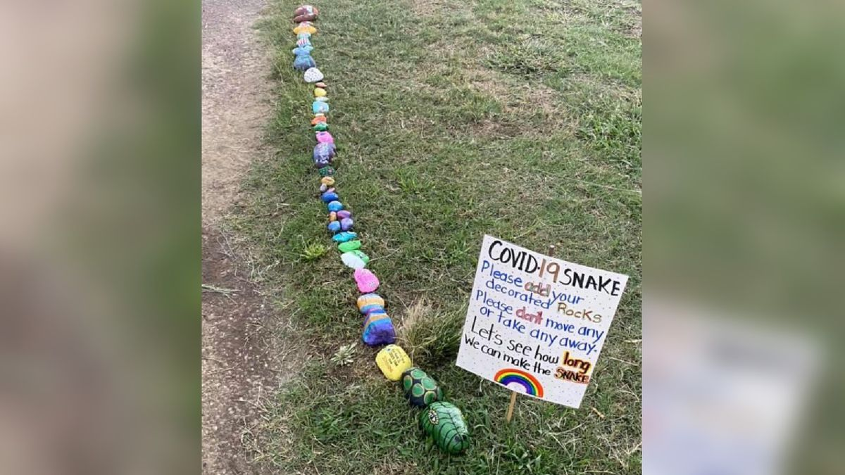

**Freindship braclets**

**What you need:** A variety of coloured thread, sellotape, scissors.

**What to do:** Select up to 5 different coloured pieces of string, cut them all to the same length (about the length of your arm). Tie them all together at one end and secure to the edge of a table using Sellotape. Plait the string together and tie at the end. Your friendship bracelet is sure to make someone smile.

**What it is good for:** Fine motor, focus, concentration, well-being.

