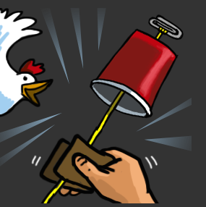

**Seasons**

**What you need:** Access to variety of Clothes, shoes and Accessories (hats, scarfs, glasses ect.) Cards with words Autumn, winter, Summer, Spring.

**What to do:**

* Put the seasons in order,
* Identifying keywords associated either saying or writing for example: Autumn wet, windy, cold, red leaves, pumpkins.
* Choose and get dressed independently in to appropriate clothing for a chosen season take a photo and or Draw items.
* Label /Name the items of clothing.

**What is it good for:**

Fine motor skills, sequencing, Life skills, Writing.

**What it is good for:**

**Musical Chicken in a Cup**

**What you need:** plastic or paper cup, String or yarn ,scissors ,paper clip,

Wet paper towel

**What to do:** 1)Ask an adult to pierce a hole in the centre of the bottom of the Cup.

2)Tie one end of the string to the middle of a paperclip

3) thread the other end of the string through the hole in the cup and pull it through.

4) get a piece of paper towel or cloth and make it damp with water

5) Make some Chicken noises: Hold the cup in one hand, Wrap the damp paper towel around the string near the cup . While you squeeze the string pull down in short quick motion so paper towel slides along the string. It should make a chicken noise.

6) try using different string or cup or cloth can you make a different sound.

**What it is good for**:

Investigating Science of sound

and friction,

Instruction following, sensory,

Finemotor skills.

Teacher tip: Good for level 1 learners

**Digging for letters**

**What you need:**

A tray, some type of cover, sand/rice/pasta, cars or diggers, paper

**What to do:**

To set up – write some letters on a piece of paper, cut them out and put them on a tray, write the same letters on another piece of paper and put next to the tray.

Cover with your material.

To play – When your child shows interest, ask if they can dig out the letters. Once they find a letter see if you can sound it out or recognise it together. Then see if you can match the letter you found to the sheet.

**What it is good for:**

Reading, letter recognition and fine motor skills. 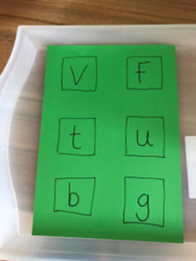

**Days of the week flashcards**

**What you need:**

Flashcards for the days of the week.

**What to do:**

Use the cards

* practice ordering them
* Write in a white board pen over the letters
* turn them over and practice writing and spelling them then check you got them correct.
* Make your own for months of the year

**What it is good for:**

Reading, writing, spelling