**Picture Crossword**

**Picture Crossword**

**What you need:**

This card, a pencil.

**What to do:**

Try doing a picture crossword.

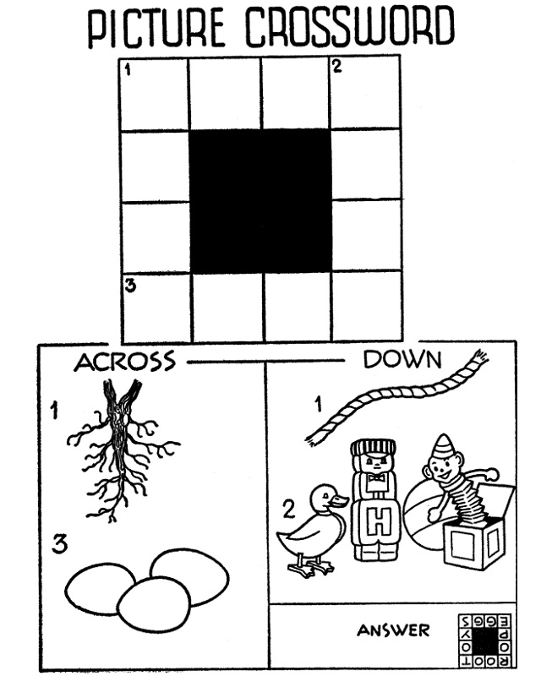

**What is it good for?**

Literacy.

**What you need:**

This card, a pencil.

**What to do:**

Try doing a picture crossword.



**What is it good for?**

Literacy.

Teacher note/who for – Level 1 learners

**What it is good for:**