**SUDOKU**

**NUMBER FUN**

**SUDOKU**

**NUMBER FUN**

**What you need:**

This card, a pencil and a rubber.

**What to do:**

Try doing a Sudoku puzzle. **This one is a little harder.**

Therule of the game is every column and row must have all of the numbers from 1 to 4.

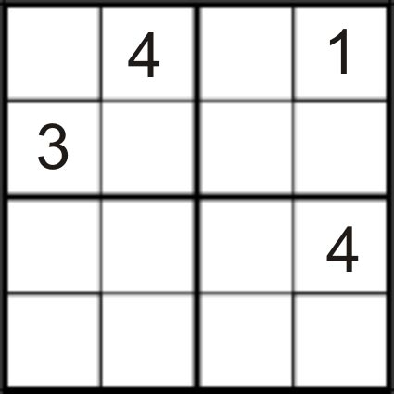

**What is it good for?**

Numeracy.

**What you need:**

This card, a pencil and a rubber.

**What to do:**

Try doing a Sudoku puzzle. **This one is a little harder.**

Therule of the game is every column and row must have all of the numbers from 1 to 4.

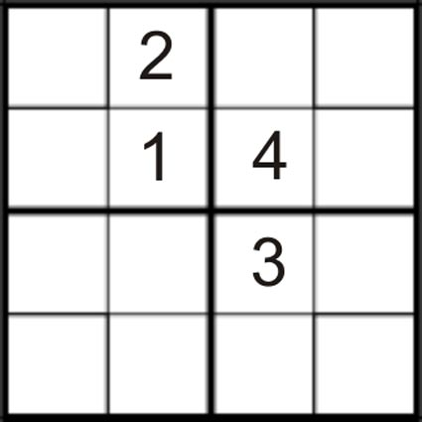

**What is it good for?**

Numeracy.

Teacher note/who for – Level 1 learners

**What it is good for:**