**What you need:**

**What to do:**

**What it is good for:**

**What you need:** letters, magnet and string

**What to do:**

The 5 easy steps to play this game are:

1. Put the magnetic letters in a bowl
2. Make a fishing rod – we used a wooden spoon, some string and a metal bottle opener that I got in a Christmas cracker but you can use ANYTHING. so long as the letters stick!
3. Drop the rod into the bowl and see what comes out. Stick the letter you get to a fridge/radiator/metal tray/tin lid or match them to an alphabet board.
4. As they collect them talk about which letter it is. Can they make the sound? What starts with that letter? Which letter do they think they will catch next?
5. If you like make two rods and take it in turns. Who can catch their name first?

If you don’t have magnetic letters you could write letters on paper and scoop them out with a ladle or big spoon and pretend you are making alphabet soup!

**What it is good for:**

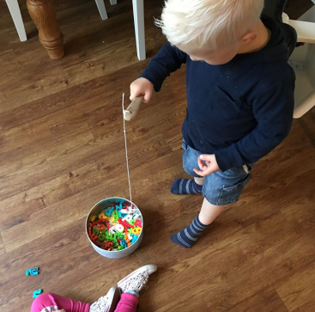

**Alphabet Game**

Teacher note/who for – Level 1 learners