**What you need:**

**What to do:**

**What it is good for:**

**What you need:** Egg shells, a pen and a spoon

**What to do:** To set up – write some letters or some numbers on to each egg shell and put them on a tray

To play – when your child shows interest ask if they would like to play a game take it in turns calling out a number or letter sound and see if they can find the correct one and smash it. Or let them choose which one to smash then ask them which letter sound or number they have smashed.

**What it is good for:** letter recognition, sound recognition or number recognition

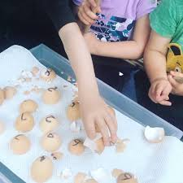

**Egg Smash**

Teacher note/who for – Level 1 learners