**Making Faces**

**From found items**

**What you need:**

Found objects such as Cutlery and crockery,

Fruit and vegetables, Paper, scissors pens etc.

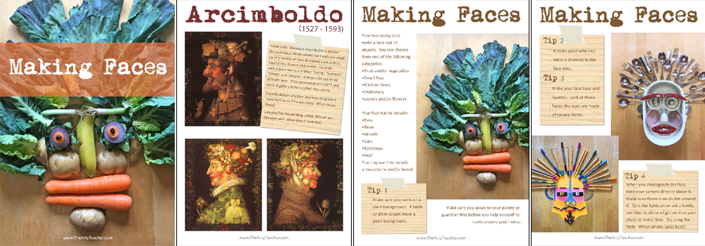

**What to do:**

Make a face out of found objects.

Eg tomatoes for eyes, egg cup for nose, hair clips for lips.

Add lots of details like hair, eyebrows etc.

Show it to your family.

Take a photo of it.

Now try to change the expression on the face by closing the eyes or making the hair stick up.

Think of other pictures you could make using found items.

**What it is good for:**

Creativity :- looking at objects in a different way.

Fun:- see how funny the face can look!

Maths : symmetry

**What you need:**

**What to do:**

**What it is good for:**

Teacher note/who for – Level 1 learners