**Colour Explosion**

**What you need:**

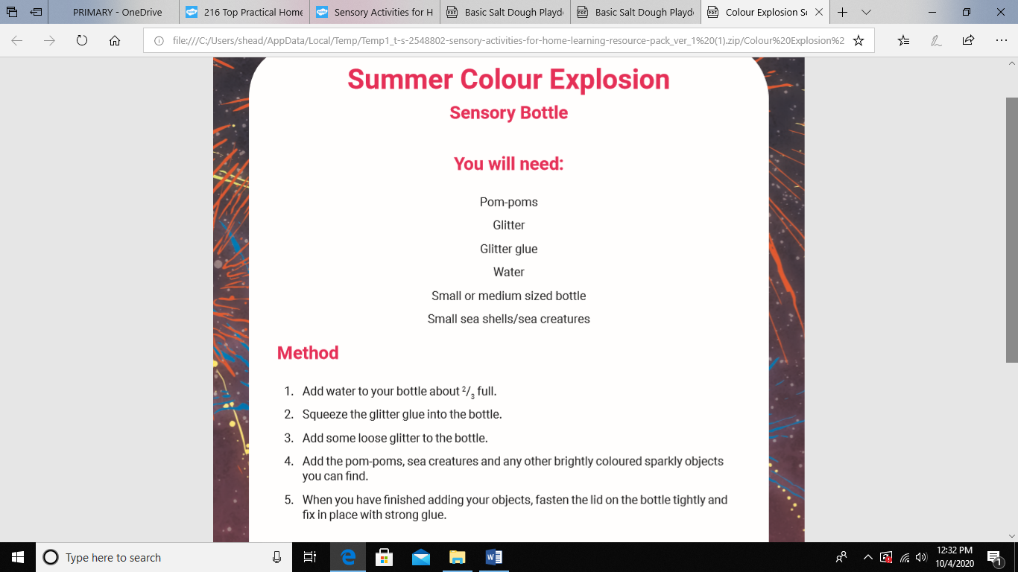

**What to do:**



**What it is good for:** measuring, motor skills, well-being

**Salt Dough**

**What you need:**

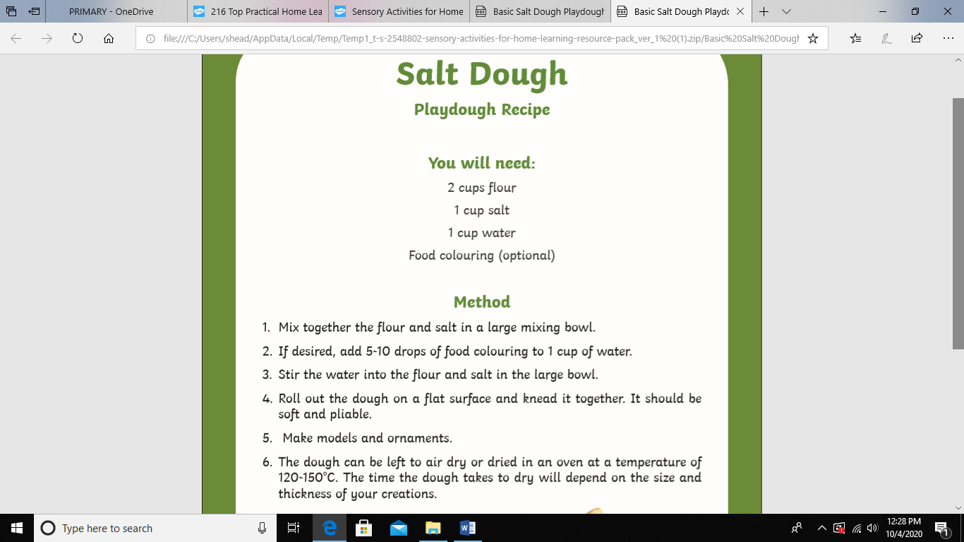

**What to do:**



**What it is good for:** Fine motor and gross, focus, concentration, well-being