**What you need:**

**What to do:**

**What it is good for:**

**What you need:** paper and pen

**What to do:** 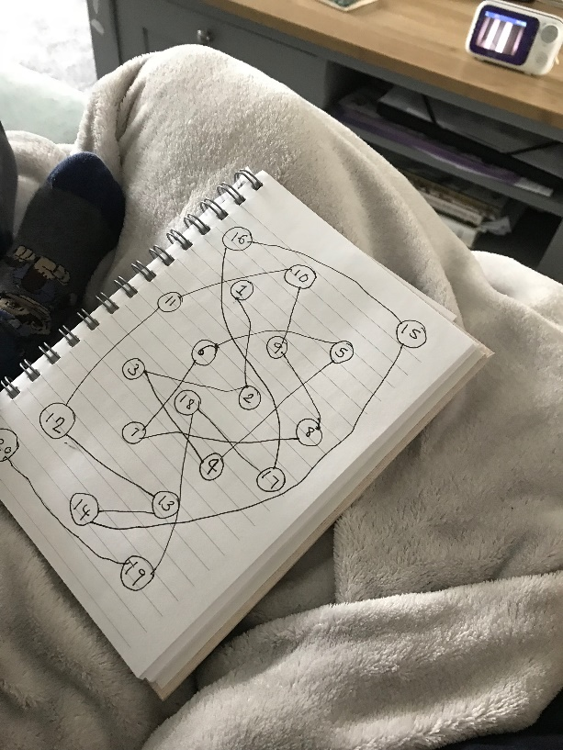

Write 1-5 or 1 – 10 randomly on the page with circles around them. Remember wait for them to show an interest if they ask you what they are doing you could say - “I’m making a number spider web, would you like to help?’ He did. They can help with counting and guessing the next number. If they want to help making the web give them a pen and get going. You can always make a deliberate mistake and laugh at this together. It’s always OK to make mistakes.

**What it is good for:**

number recognition, writing numbers

**Alphabet Game**

Teacher note/who for – Level 1 learners