**What you need:**

**What to do:**

**What it is good for:**

**What you need:** paper, pen, toys (any kind of toy!) and a bowl or hat

**What to do:** To set up –

1. Write numbers on a bit of paper. Go up to the number you think your child will be able to do confidently. Could be 1 – 5, 1 – 10 or 1 – 20.
2. Cut the numbers up and fold into quarters and pop into a bag or box.
3. Grab the corresponding number of toys/items. Lay them out in a line.
4. The game is pick a “ticket” from the bag and open it (fine motor skills required to unfold the paper) and then count along the line to see which toy they’ve ‘won’
5. Put the number next to the toy and choose again until they are all done.

**What it is good for:** counting, sharing, number recognition

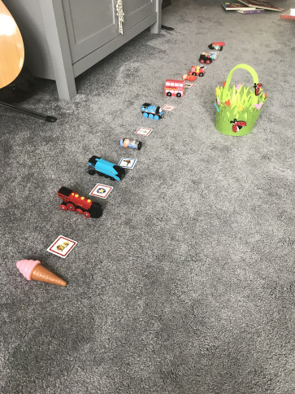

**Toy Tombola**

Teacher note/who for – Level 1 learners