Robin Class - Early Years Overview
 | Autumn |  | Spring |  | Summer
Our Topics! | All about me  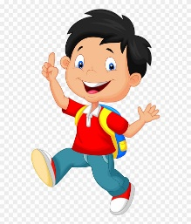 | Animals  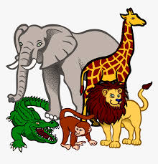 | Under the sea  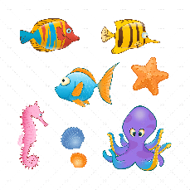 | Traditional Tales  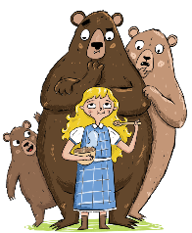 | People who help us  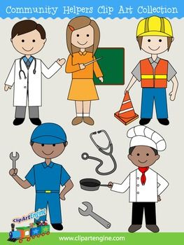 | Mini beasts  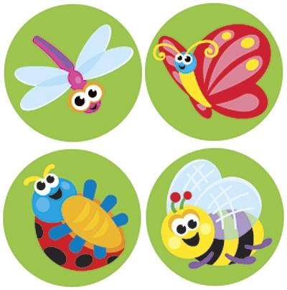
Literacy  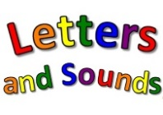  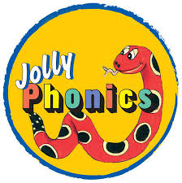  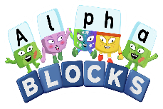 | Pupils develop skills in listening and recognising sounds through interactive learning and games within Letters and Sounds Phase 1. This is a first step in reading and writing. Pupils enjoy a range of mark making experiences and activities, communicating their ideas.  Learning within literacy develops a love of stories, songs and rhymes. Regularly a story is the focus for up to 2 weeks, providing plenty of opportunities to predict, join in with repeated refrains and much more. |  | Dependent on learners’ confidence, the focus moves to the concept of identifying letter shapes and phonemes, synthetic phonics. Jolly Phonics is used to support the understanding of this concept, with the use of a specific action accompanying a letter shape / sound.  This sound knowledge allows building and reading words through blending and segmenting. Development of mark making continues through painting, using chalk, shaving foam, hand printing and lots more. We continue to build on our understanding of stories, songs and rhyme. |  | During the Summer term the letter shapes and corresponding sounds learnt previously from Letters and Sounds Phase 2 are consolidated and added to. There is significant focus on blending and segmenting sounds in reading and making simple words.  Mark making moves towards skills for writing, including developing pencil control and the formation of letter shapes. The natural world outdoors becomes the backdrop for story work. This is includes drama, wildlife hunts, walks and much more.
Mathematics  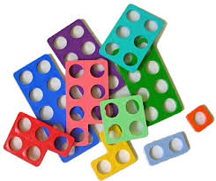Numicon  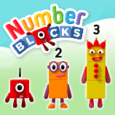 | Concepts of early number and counting develop through practical, hands-on experience in the classroom, including games, play, building and snack time. Pupils develop and rehearse counting skills and begin to appreciate that a number represents a specific quantity, which is not dependent on the context. Identifying, recognising and writing numbers are all part of every day. |  | Numicon, a resource that provides a visual image of number, is integrated into teaching and learning, supporting understanding of this abstract idea. Teaching also focuses on shape, space and measure. Topics may include using prepositional language, size and capacity. |  | Developing skills and knowledge of number and counting allow for problem solving, using physical resources such as Numicon and Compare Bears. Practical activities such as P.E., cooking and gardening provide opportunities for embedding pupils’ understanding of both number and shape, space and measure.
Personal, Social and Emotional Development  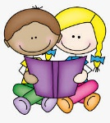 | This subject is integral to everything that happens at school and is covered every day. Teaching and learning is split into three sections; Making Relationships, Managing Feelings and Behaviour and Self-Confidence and Awareness. Pupils learn how to share, how to be a good friend, what our emotions are and how to manage these. They discover what makes us special as a person and that people can be different but have similarities. Within this curriculum area, essential life skills are developed as pupils learn about making relationships and how to play with other children.
Understanding the World | Teaching and Learning is split into three sections; Technology, The World and People and Communities. Pupils learn about different types of families, promoting inclusion and celebrate each person’s differences. Our moto for this term is, ‘We are all different but we are all friends.’ |  | During the Spring term the focus is on different celebrations. Some of these are the Chinese New Year and Christmas (the children have had first-hand experience of this, so a good time to learn more). |  | The focus for the Summer term moves to the world around us. The expansive school grounds allow for wide-ranging learning experiences including mini-beast hunts, wild life walks and exploration of our environment. Learners have the opportunity to grow, observe and care for their own plants.
Expressive Arts and Design  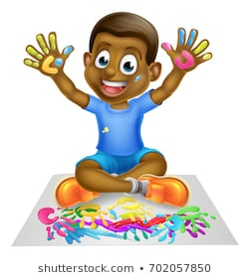 | This is lots of fun! Free-flow activity provides an excellent opportunity to focus on creativity, together with cross-curricular planning. This area of teaching and learning is in two sections; Media and Materials and Being Imaginative. Pupils are initially encouraged to explore and discover. Whilst Being Imaginative, pupils are supported to engage in lots of role play. The themed classroom role play area is changed routinely and based on children’s interests and needs. This is an environment rich in language and pupil speech. Small world play is a constant provision with settings changing regularly, including farm, jungle and dolls house.  In exploring Media and Materials, learners work with a wide range of materials including paint, playdough and junk modelling. Mark making is always provided for within a targeted area with imaginative resource for learners to work with. Building models using all sorts of construction materials like Lego, Big Blocks, Popoids and Interstellar provide opportunities for innovation and expression.
Communication and Language  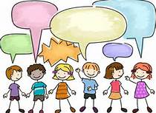 | At Gosden House there are Speech and Language Therapists on site. They work collaboratively with teaching staff to tailor the communication and language offer to each individual child.  The development of speech and language skills are an intrinsic part of learning in Robins. Supporting children’s questioning skills, vocabulary range, sentence building skills and communicative intent is embedded in all teaching and learning across the curriculum.
Physical Development  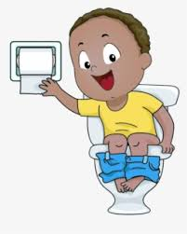 | Within Physical Development, skills in jumping, running and navigating spaces are a focus for teaching and learning alongside other important areas of independent health care skills including toileting, dressing and eating healthily. Robins are fortunate to have a P.E. coach to support the development of P.E. skills through fun games and activity. Changing clothes is an important part of our children’s early learning and this move towards independence is supported. Across the curriculum pupils learn how to hold tools such as pencils and scissors correctly and have lots of practice with these across the year.

