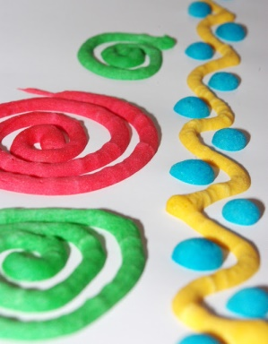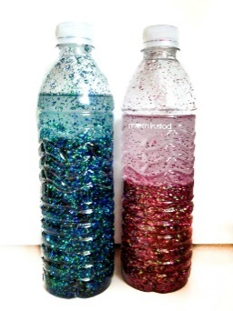

**Microwave Puffy Paint**

**What you need:**

1 cup flour

3 teaspoons baking powder

1 teaspoon salt

Enough water to make it a pancake batter consistency

Food colouring

Paper

Paint brushes

**What to do:**

**Mix all ingredients together and divide batter up into different bowls and colour each bowl mix a different colour. Paint a picture (it is best if the painting is solid lines). Microwave for 25-35 seconds. Paint will come out dry.**

**What it is good for: Creativity and imagination, literacy, measuring and counting skills.**

**Make a board game**

**What you need:** Paper, colouring pens or pencils, counters, dice, and someone to play with.

**What to do: come up with an idea for a board game (for example snakes and ladders) and design a board.**

**You can either find some counters or cut some out of paper. Find someone to play the game with and explain the rules. Play your game!**

**What it is good for: Creativity and imagination, counting, language and communication.**