**Gratefulness**



**What you need:** Paper & pen

**What to do: Write or draw five things that you are grateful for.**

**What it is good for: Your wellbeing.**

**Meditation**

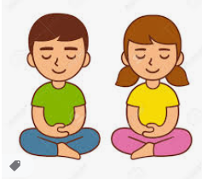

**What you need:** A quiet place, where you can sit up or lay down undisturbed for 20 minutes.

**What to do: Close your eyes. Take 3 deep breaths in and out. Relax your body. Lay or sit still and listen, note: what you can hear, what you can smell, how your body is feeling.**

**What it is good for: Your wellbeing.**

**Mindfulness**

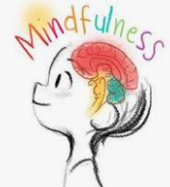

**What you need: Pop a piece of chocolate into your mouth.**

**What to do: Move the chocolate around your mouth and note the difference it makes to the taste. Let it dissolve, note how long it takes.**

**What it is good for: Developing observational skills and general wellbeing.**

**Mindfulness**



**What you need: Find something interesting to look at.**

**What to do: Look closely at that object, note the different colours and shapes you see. Can you draw it?**

**What it is good for:** Developing observational skills and general wellbeing.

**Mindfulness**



**What you need: Tune into the sounds of your surroundings for 5 minutes.**

**What to do: Note what you can hear. Can you hear a bird singing, the low hum of the refrigerator, or faint sounds of traffic? Illustrate all the things you heard.**

**What it is good for:** Developing observational skills and general wellbeing**.**

**Yoga**

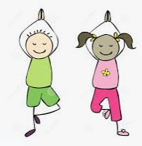

**What you need: Position your body in the tree pose (as above)**

**What to do: Hold the position for as long as you can. Then change legs.**

**What it is good for:** Core body strength and wellbeing.