**Making Toast**

**(to do with adult supervision)**

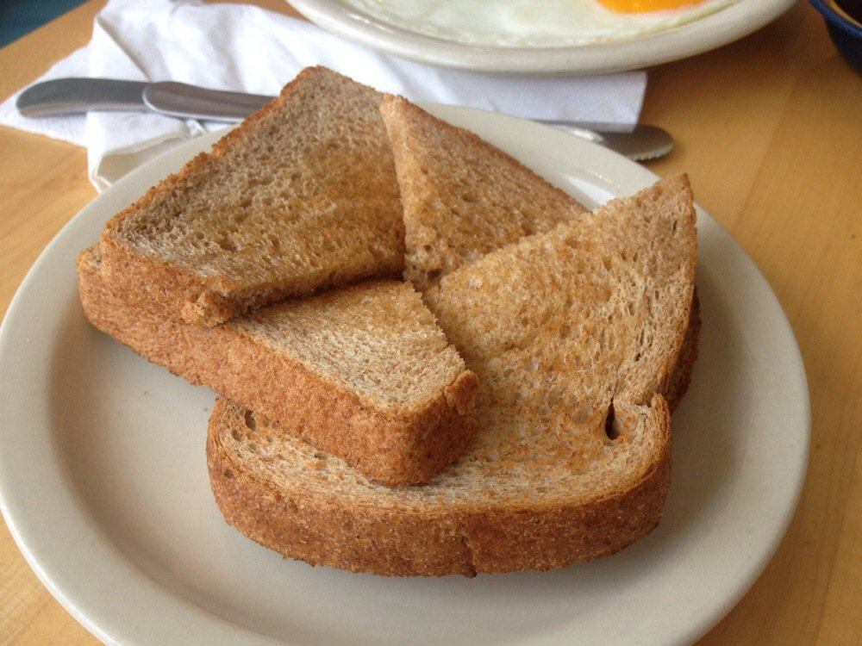

**What you need:**

**Bread, a toaster, butter, knife and plate**

**What to do:.**

**Follow the instructions for making toast**

1. **Get your bread out.**
2. **Put your bread in the toaster.**
3. **Wait for your toast to pop up.**
4. **Wait for it to get cool.**
5. **Put butter on your toast.**
6. **Cut your toast in half**
7. **Eat it!**

**What it is good for: learning how to follow instructions, life skills.**

**Bird Watching**

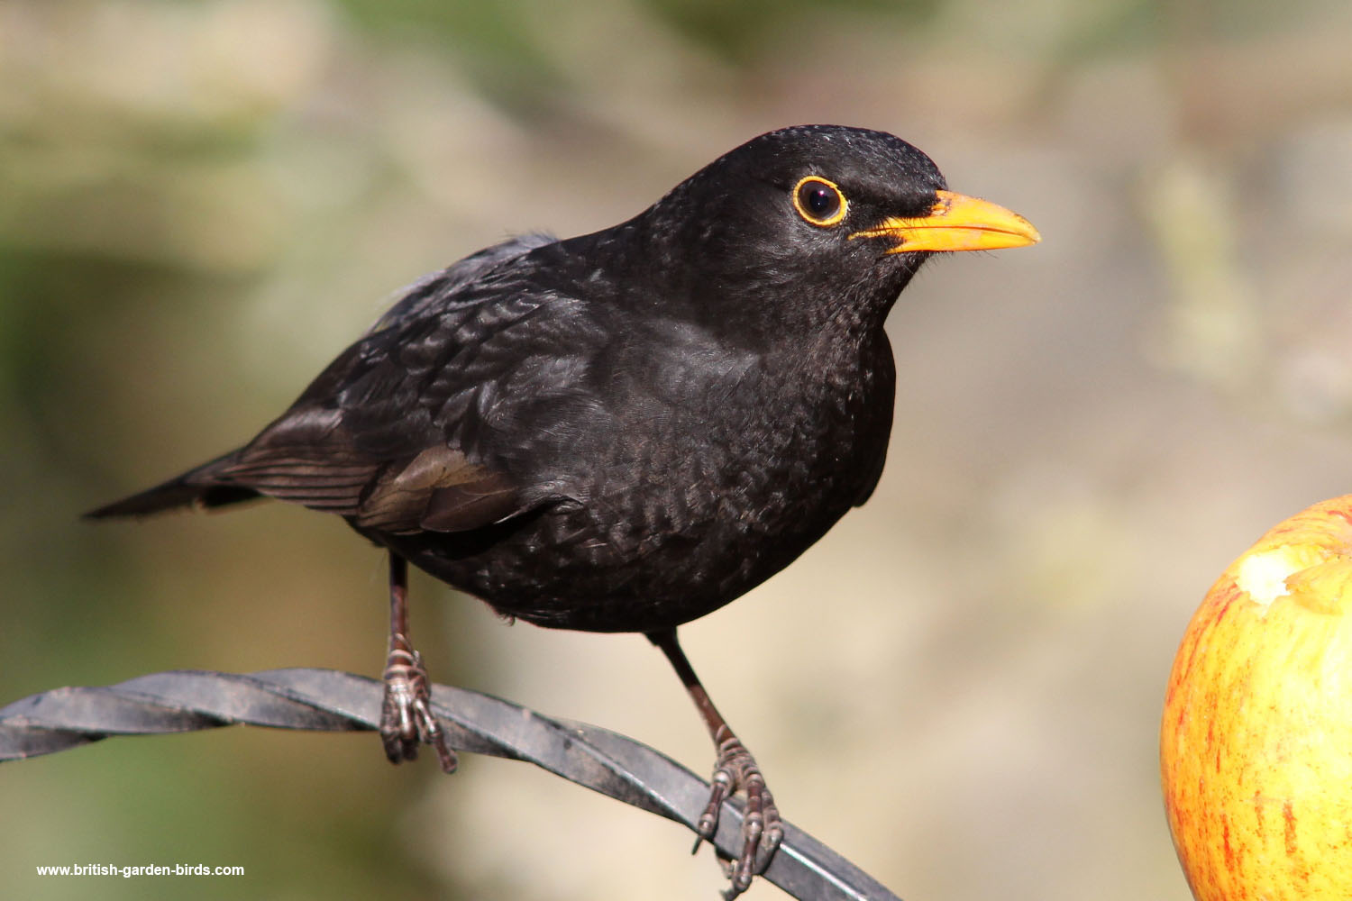

**What you need: A window and a chair to sit on, a pencil and paper**

**What to do: Make a mark on your paper when you see a bird.**

**How many can you see in 10 mins?**

**Draw or paint a picture of your favourite one**

**What it is good for:** . **observation skills, appreciation of nature, concentration**

**First Letter Sounds**

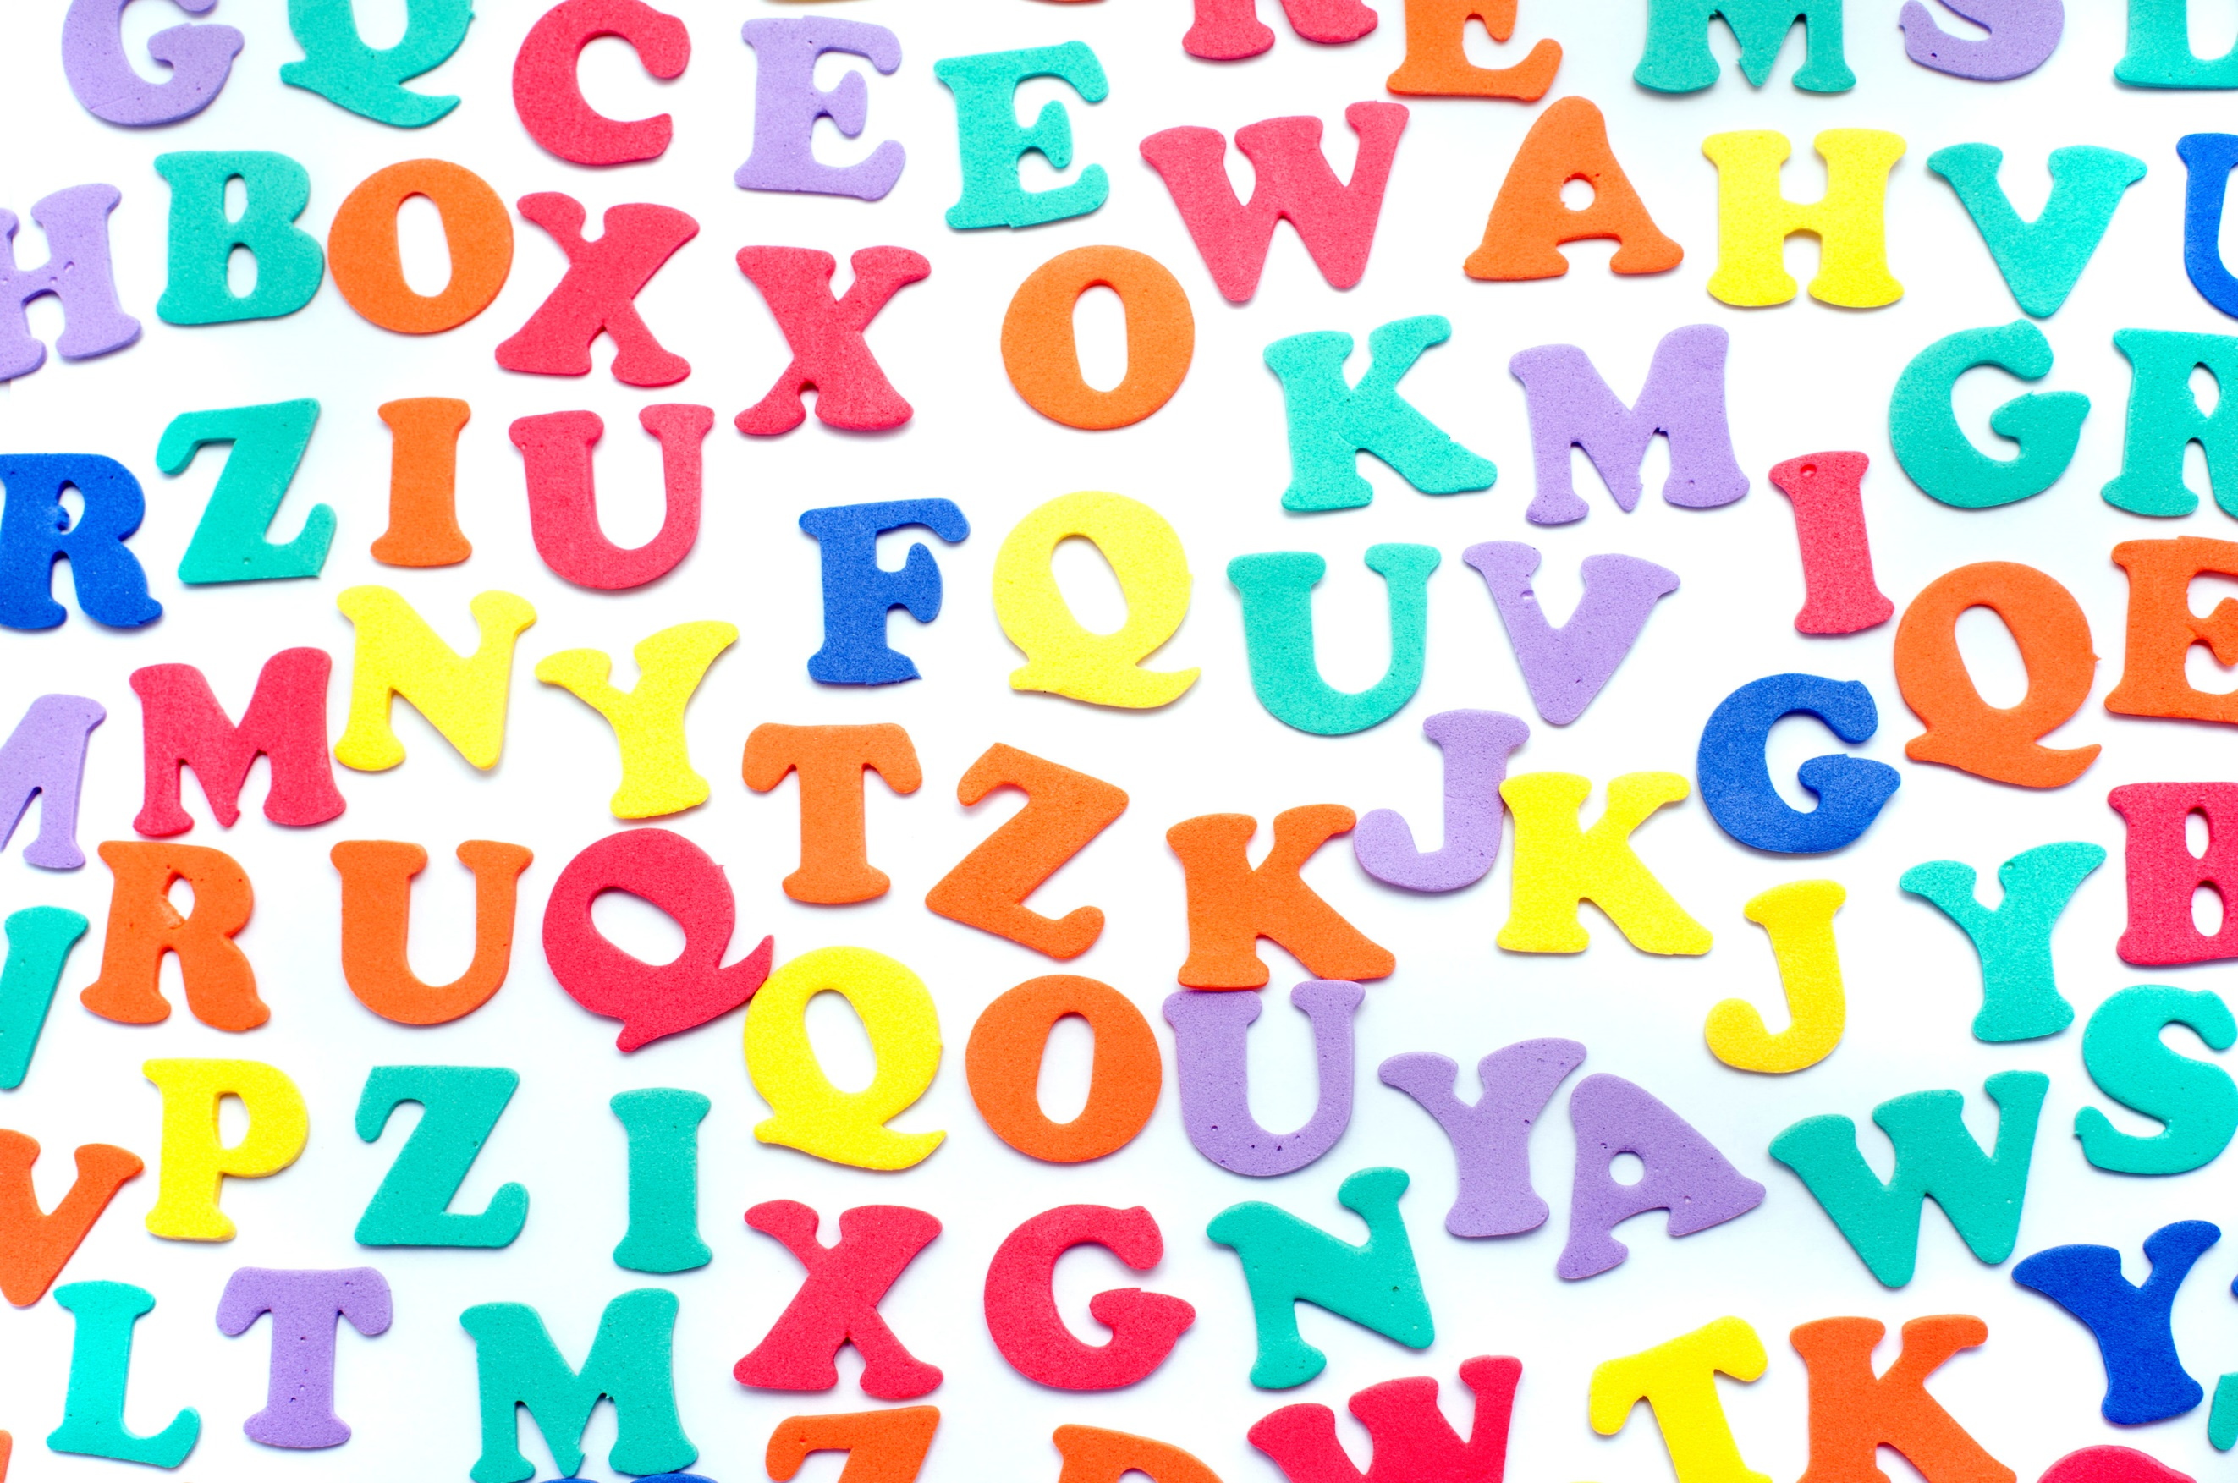

**What you need: Pen, paper**

**What to do: Look around the house and garden to find things beginning with the sounds:**

**t m c r b f**

**See how many you can find and make a list. Happy hunting.**

**What it is good for:.Phonics, fine motor skills, writing**

**Describing Rooms**

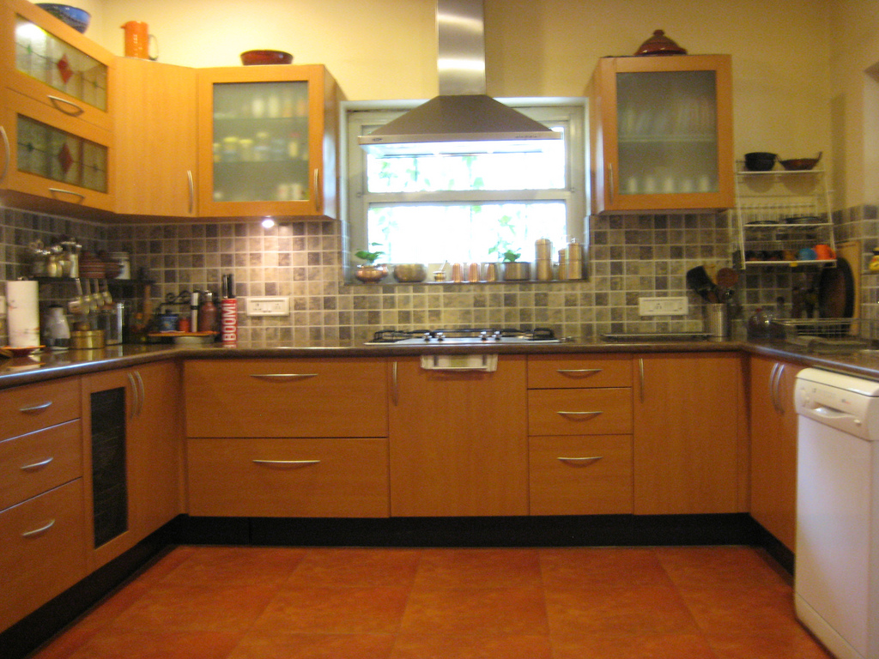

**What you need: Paper, pen and colouring pencils**

**What to do: 1. Write a sentence to describe 3 rooms in your home. Try to remember capital letters, finger spaces and full stops.**

**2. Draw and colour a picture of each room you described.**

**What it is good for:** Creative thinking, writing and fine motor skills