Busy Box

We have created a ‘busy box document’ for you so that a range of resources are in one place for you to refer back to. This is so that when you have finished a learning task set during a lesson you can choose a learning activity from the ‘busy box’ to explore with your child. This way you can choose an activity to suit your child’s needs in the moment – getting active or sitting quietly.
Education City- you will still have access to Education city via your child’s log on (on the sheet in their home learning pack), there will be a range of suitable games that have been signposted by their class teacher for them to play and explore.
https://go.educationcity.com/?_ga=2.120589120.930454051.1609767868-1221206136.1609767868
Websites -
- https://www.topmarks.co.uk – good range of maths games on here
- https://www.phonicsplay.co.uk/Phase2Menu.htm - good for phonics games
- http://www.familylearning.org.uk/phonics_games.html - good for phonics games – a range of phonics games on here
There is also the class page on the school website with ideas and different learning ideas for you to choose from https://gosden-house.surrey.sch.uk/class-pages/owls/ On the class page you will find videos made by the teachers with learning opportunities, activity cards with different ideas and signposts to a range of other services. This will be updated regularly by the class teacher so check back for new learning opportunities.
Things to watch on YouTube:
- Numberjacks
- Alphablocks
- Come outside
- Mr Tumble
- Watch people reading your favourite stories.
Things to watch on BBC iPlayer:
- Bed-time stories

Apps –

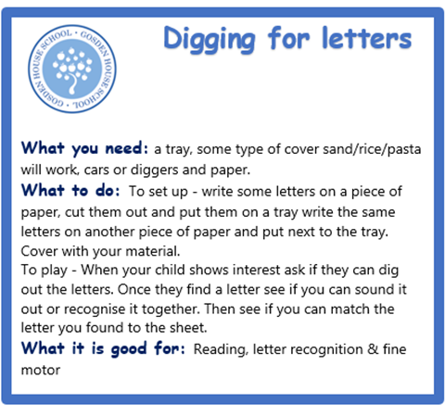
Activity cards – Activity cards look like this.
They will walk you through the activity name, which resources you will need, how to play the game and which area of learning this will help with.
There is a range of activity cards available on the class pages on the school website as well as in your child’s home learning pack.

