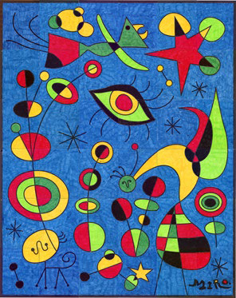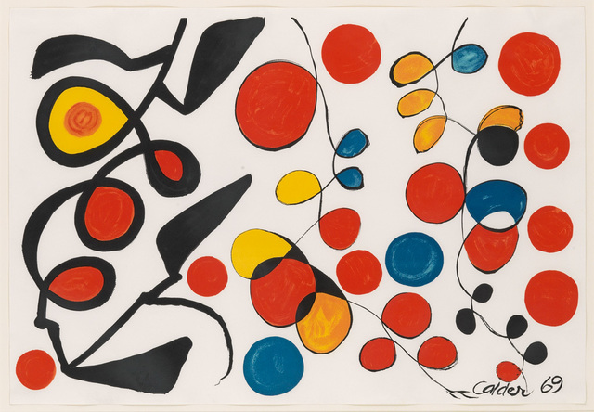

**What you need:** Paper & pens

**What to do:**

1. Find out about Alexander Calder and Joan Miro on Sapphire Teams.
2. Using a black pen or pencil, do a big, simple scribble all over one side of paper (see worksheet). You can use straight or curved lines.
3. Using just 3 primary colours – (Red, Blue and Yellow) and black, **Carefully** colour in each separate enclosed shape a different colour.
4. Try not to have any of the same colour next to each other.
5. Keep going until all the shapes are filled except the background.

**What it is good for:**

Manual dexterity hand eye coordination.

Maths :closed and open shapes

Art : primary colours, finding out about artists

**Extension :**

Colour like Joan Miro worksheet.

Type Joan Miro or Alexander Caldo into Google and look at more of their artwork.

**Calder & Miro**

**Art & Design**

Alexander Calder

Step 1

Joan Miro

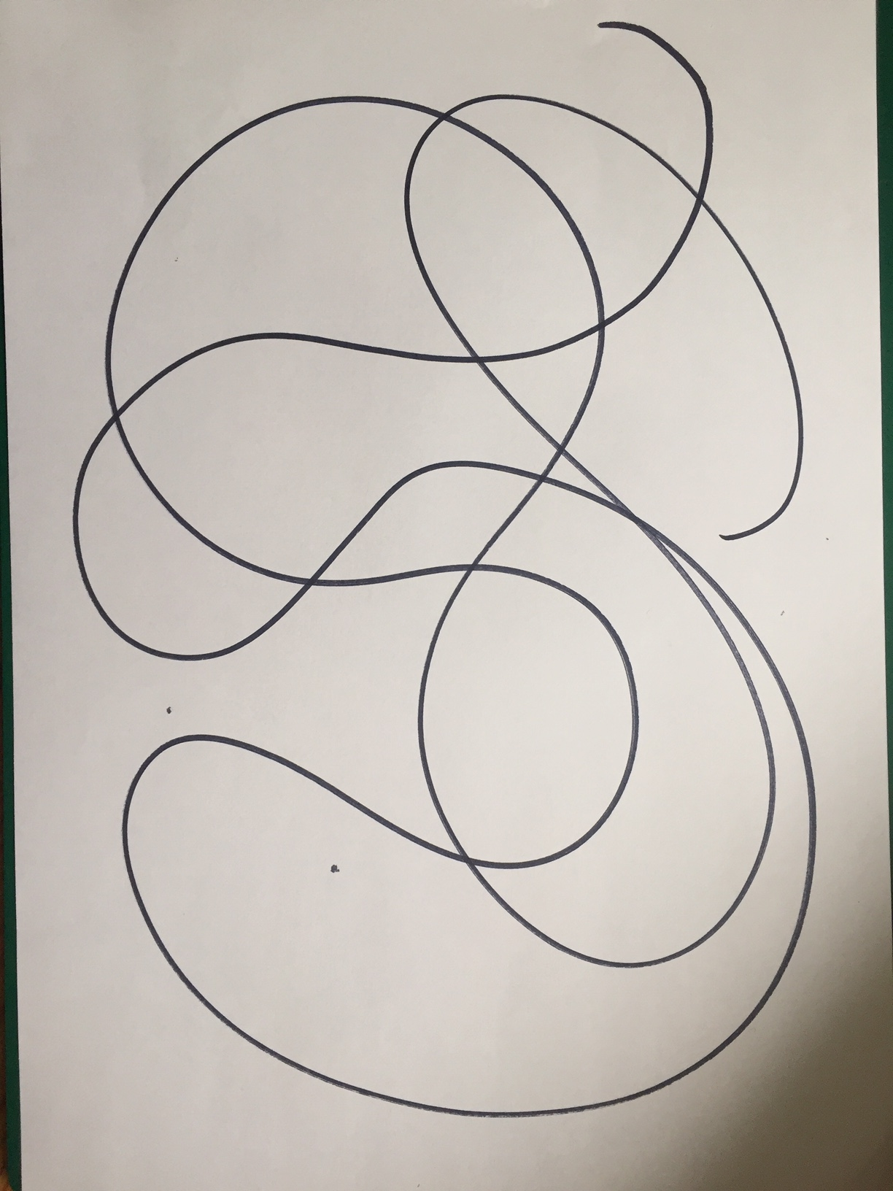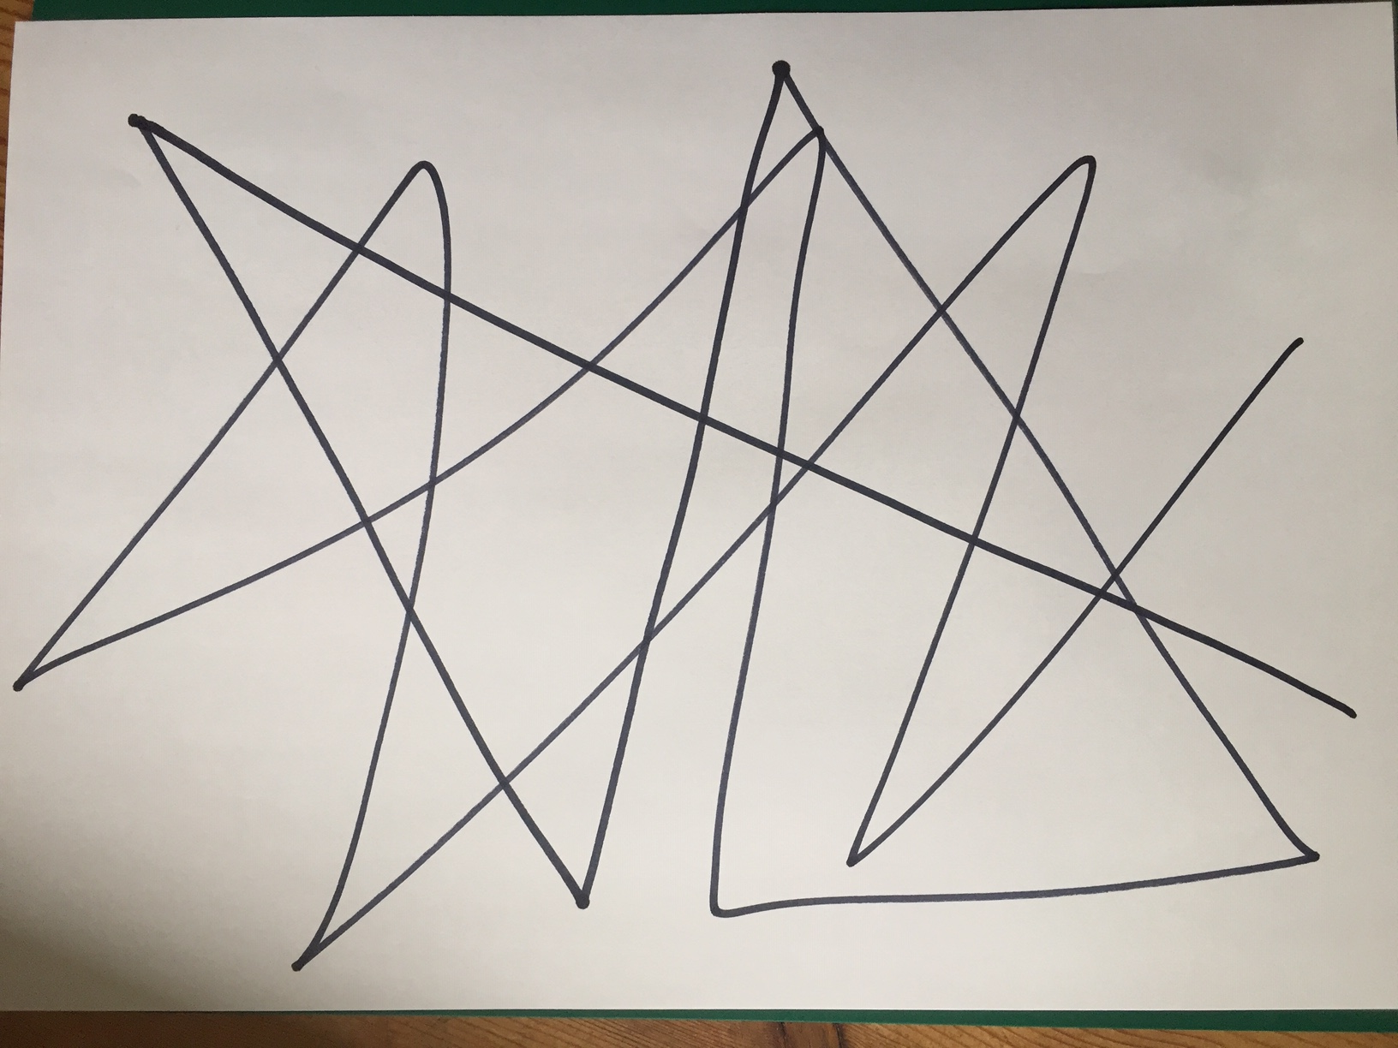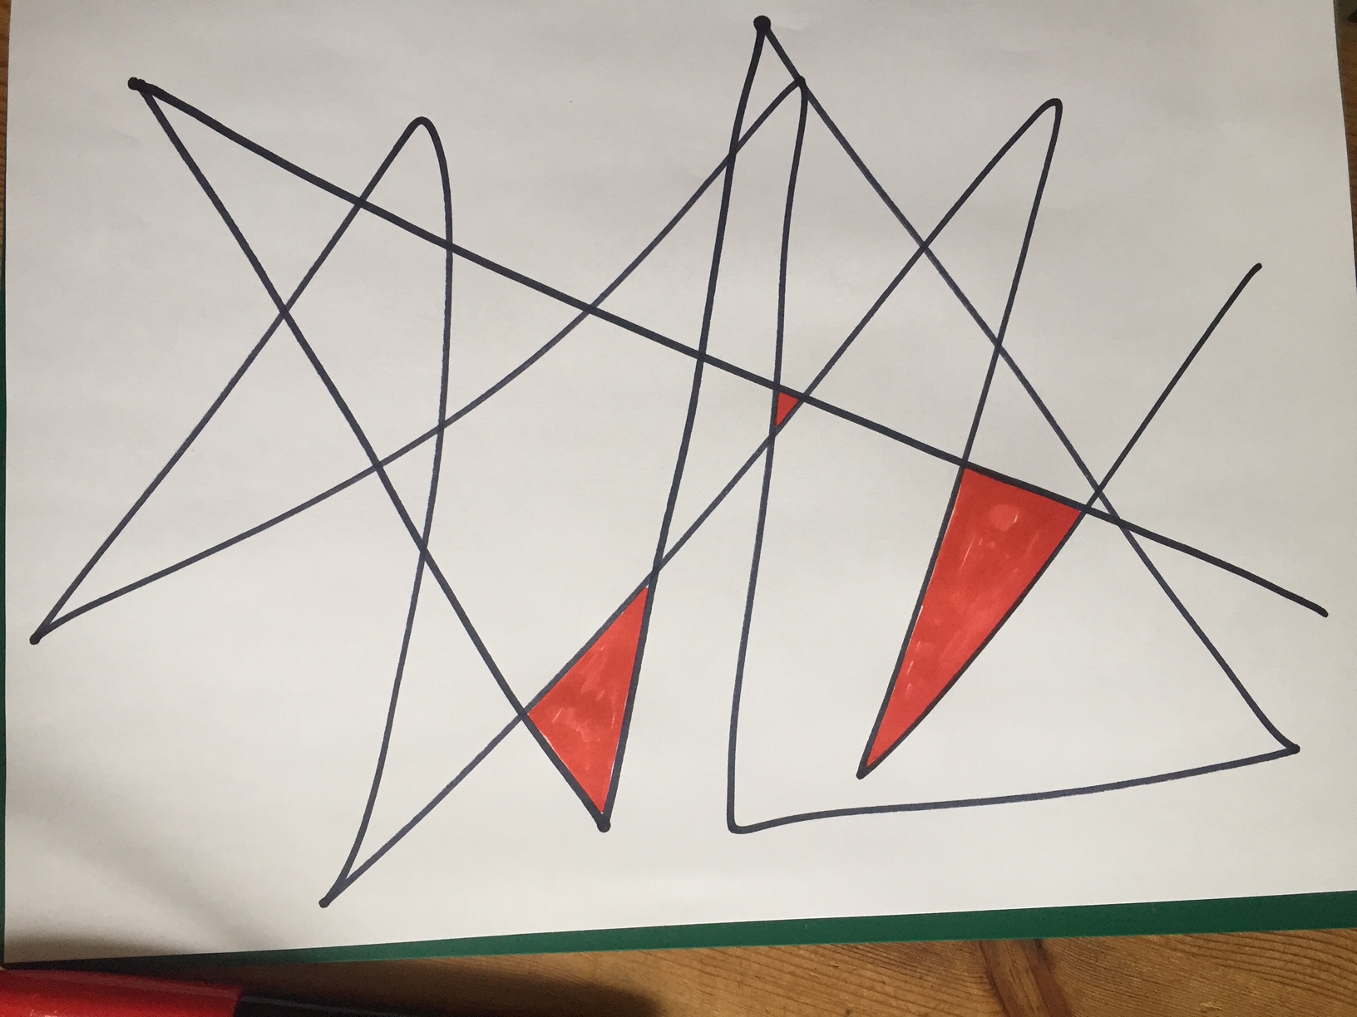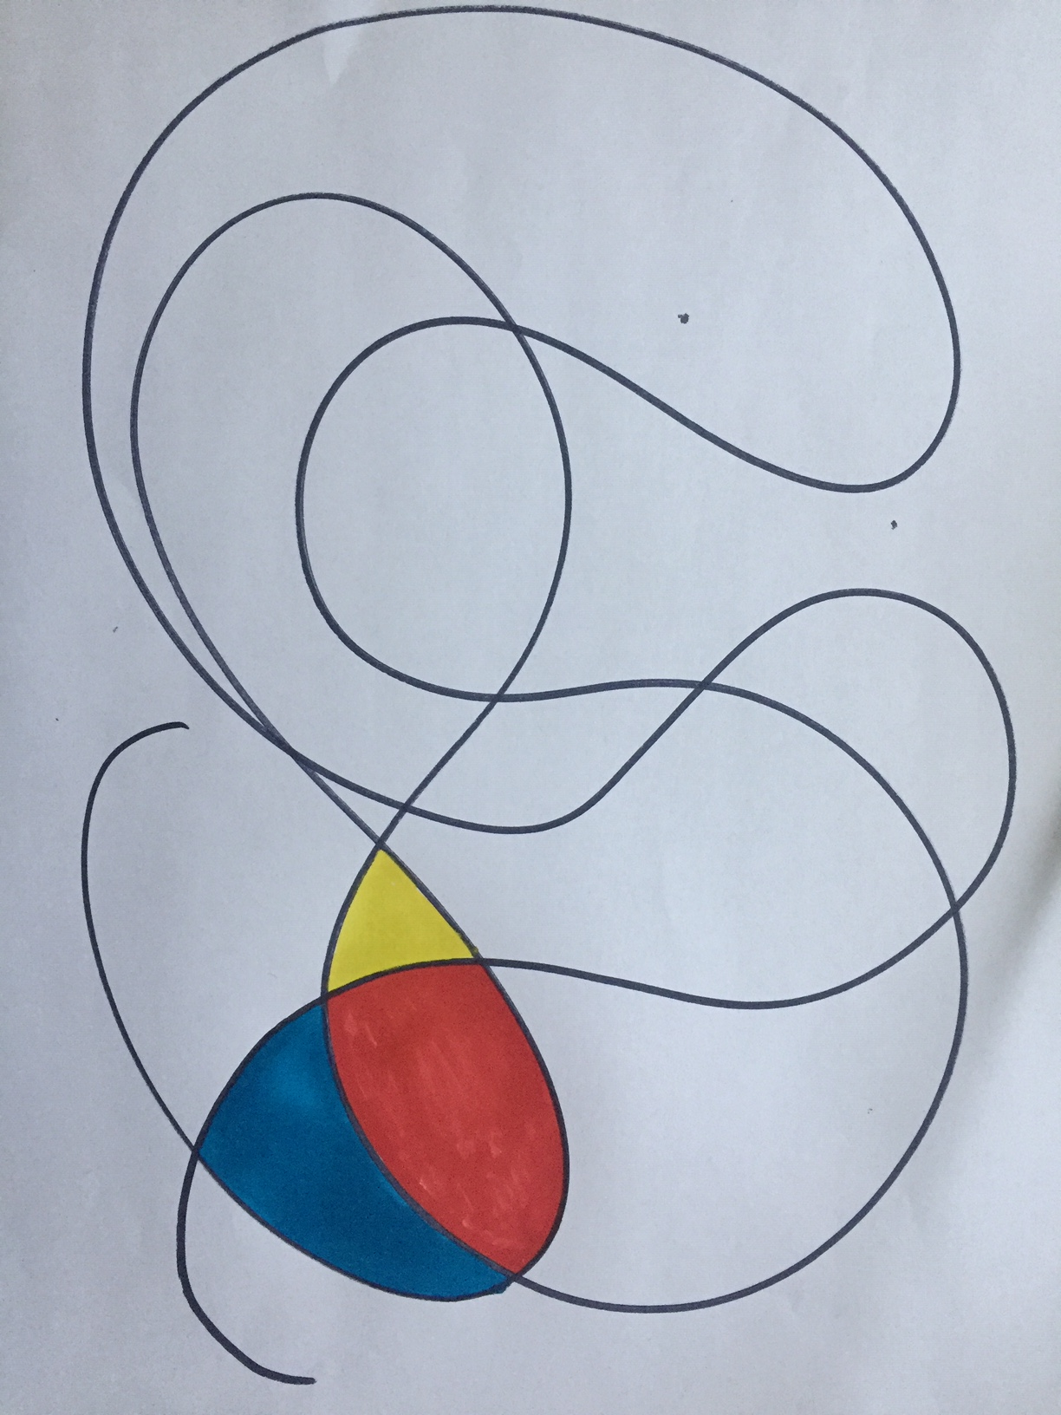

Step 2