**Chef!**

**What you need:**   
Adult supervision

Ingredients for your meal.  
Camera/device for taking pictures.

**What to do:**Create or make your snack or meal for the day. Have an adult to supervise and help with any tricky parts. Take photographs of each step to create a visual instruction list – this will help you next time remember what steps to do!

**What it is good for:**

Fine and gross motor skills, speaking and listening, following instructions, independence.   
  
  
[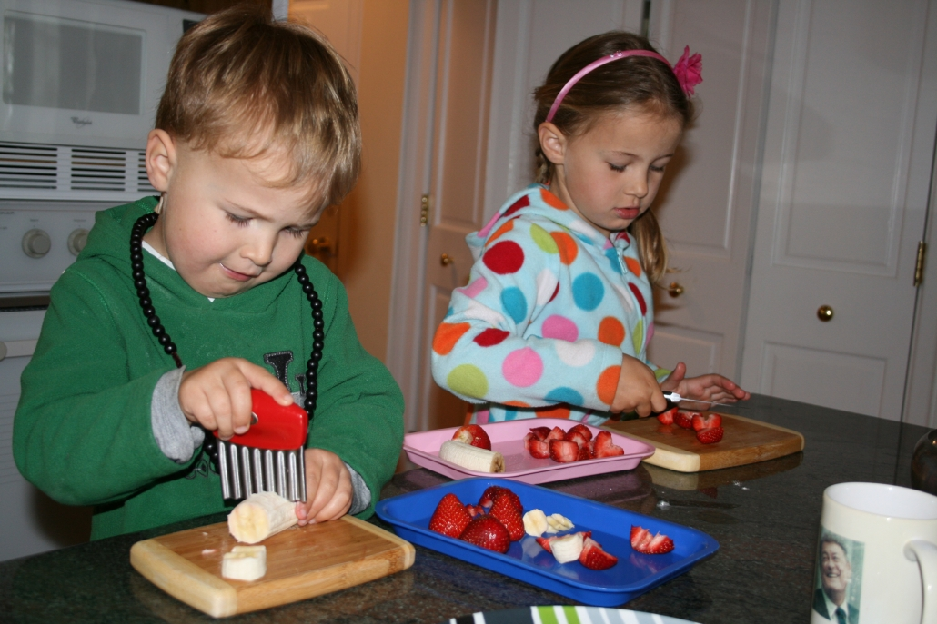](https://www.google.co.uk/url?sa=i&url=https%3A%2F%2Fwww.leportschools.com%2Fblog%2Fpacking-school-lunches%2F&psig=AOvVaw1T6xMKvPAAODwJHjlEEtr1&ust=1600779012070000&source=images&cd=vfe&ved=0CAIQjRxqFwoTCLCPqdek-usCFQAAAAAdAAAAABAE)

[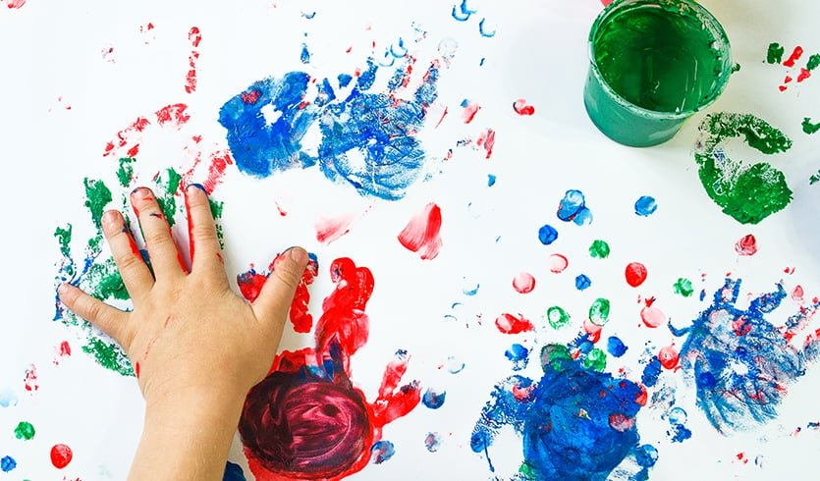](https://www.google.co.uk/url?sa=i&url=https%3A%2F%2Fdraxe.com%2Fbeauty%2Fhomemade-finger-paint%2F&psig=AOvVaw2_LEgT17DILDUhfeKfKQBX&ust=1600779394855000&source=images&cd=vfe&ved=0CAIQjRxqFwoTCNDt5oym-usCFQAAAAAdAAAAABAE)

**What you need:**   
Paper  
Primary colour paints (red, yellow and blue)  
your fingers  
A clear space (that you might not mind getting a bit dirty)

**What to do:**1. Free painting to create pictures and show expression.  
  
2. Can you make new colours?  
Try mixing: red and yellow, red and blue, blue and yellow.  
  
Are there any more colours you can make?

**What it is good for:**Exploration, fine motor skills, creativity, expression, imagination.

**Finger painting**

Teacher note/who for – Level 1 learners