Education City Log on – How to Guide

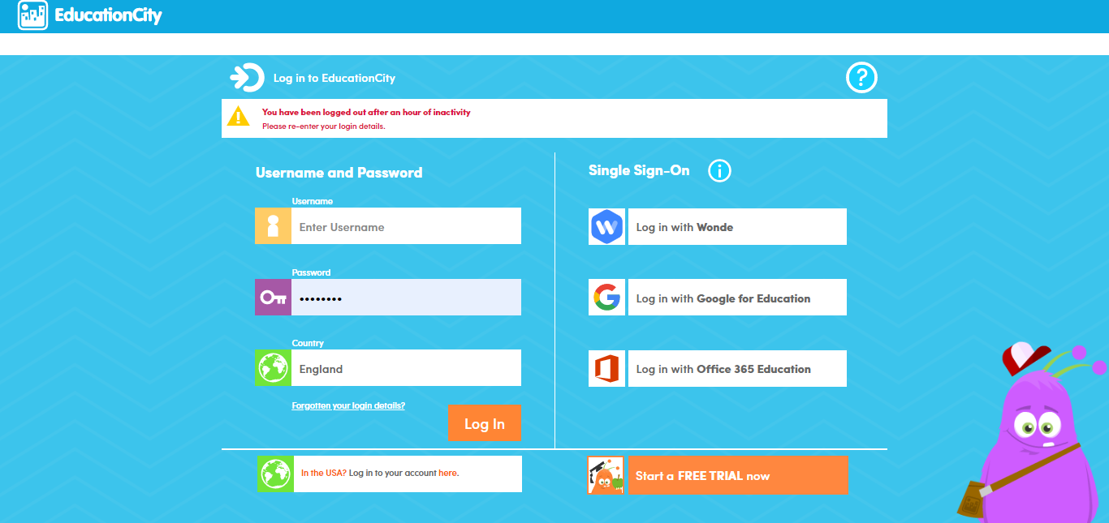
- Go to www.educationcity.com

- Enter your child’s log on details

The home page for your child looks like this -

- Your child can change how their avatar looks by clicking on it and choosing a different character
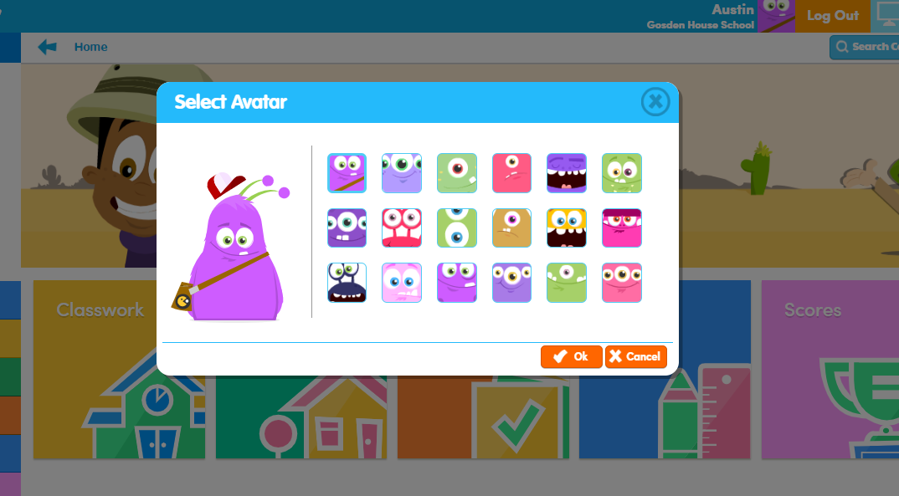

- Your child should go to the ‘Classwork’ section.
- In the homework section your child’s teacher will have set some activities and games specifically for them in a folder as below
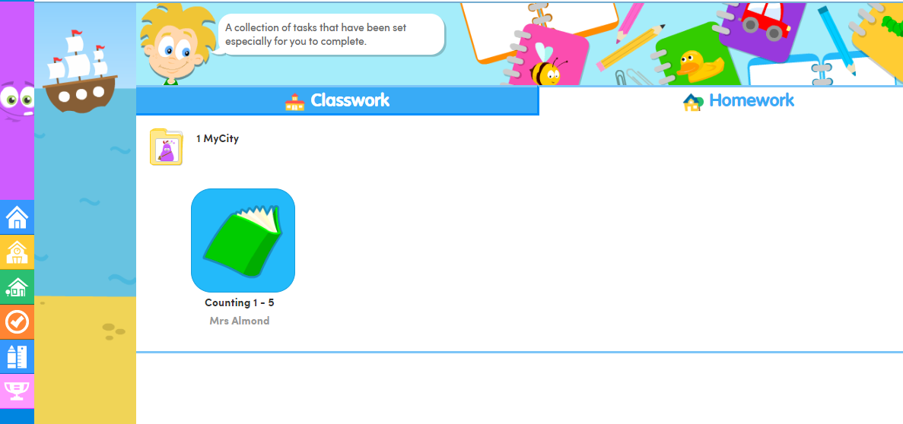

- Open the folder and then click on an activity or game to complete this (sometimes the teacher will order these meaning that one game can not be played before completing the other to ensure sequential learning)
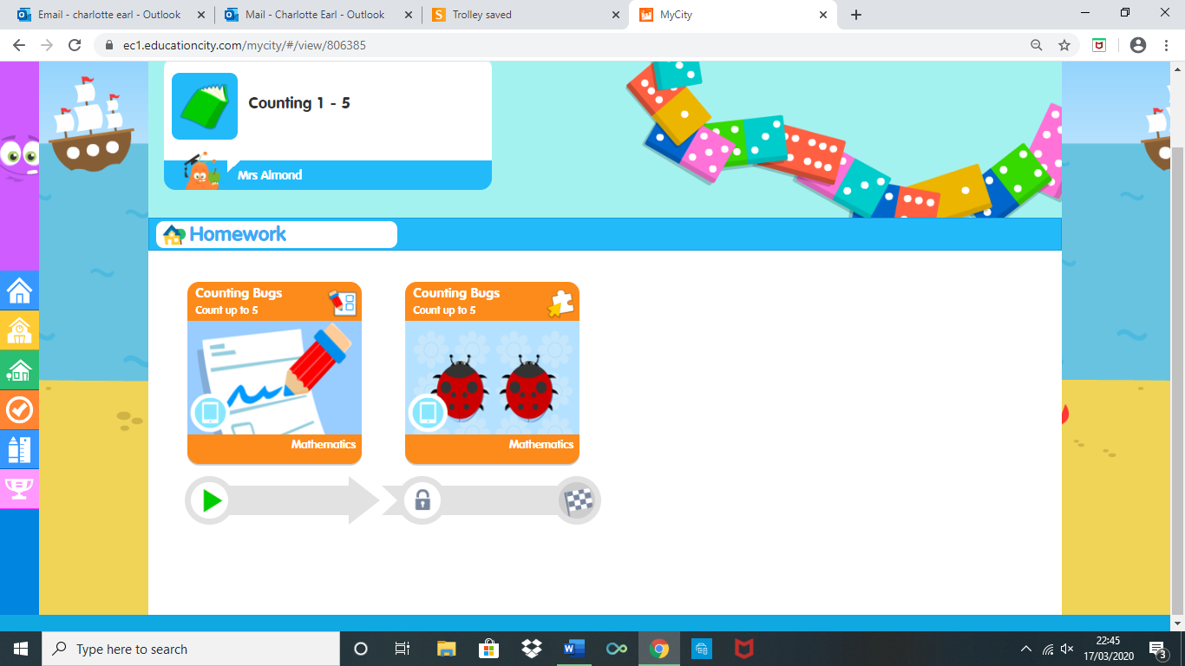
- Click on the ‘home’ button in the top left hand corner to return to the home screen and explore some more of education city

