**Counting**

**and grouping**

**What you need:**

Some toys and books

**What to do:**

Get a basket or box or your toys and sort them into objects that are similar i.e. all the books together, soft toys, puzzles etc

What do you have most of?

Least of?

How many do you have of each kind and altogether?

**What it is good for:**

Counting and sorting/grouping, increasing general mathematical skills, fine motor skills, increasing vocabulary, verbal skills. It will also help you tidy things too

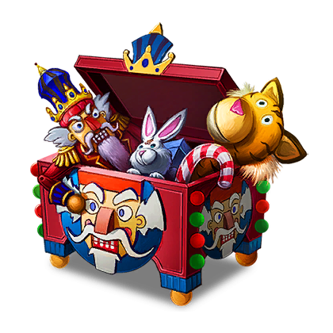

**Traffic survey**

**What you need:**

A safe place to stand where there is traffic going past

A clip board and pencil with a list on it of car, bike, lorry, (you can add others if you like such as caravan, motorbike etc

**What to do:**

Stand in a safe place with your adult support. Watch the traffic go by and each time one from your list goes by put a mark next to the word eg Car//, lorry///

**What it is good for:**

fine motor skills, counting skills, increasing mathematical skills, observational skills

