**People that help us**

**What you need:**

Access to the computer, adult to support you

**What to do:**

Look up on your computer, people who help us in our everyday lives. This might be people who help us if we are sick like doctors and nurses, people who help us if we are lost or we have had something stolen like police officers. Which one would you like to be when you get a job?

Talk to your adult about what you think the job would involve and then research what they do and find a way of recording it. You could draw and label a picture or use your computer skills to cut and paste pictures to make a collage.

**What it is good for:**

IT skills, finding out about the people who help us and who we can go to if we need help, PSHE

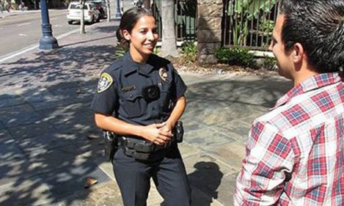

**Keeping safe in the kitchen**

**What you need:**

A kitchen, pen and paper

**What to do:**

Go in to your kitchen and look at things that could be dangerous. Make a list of everything that you can find and talk to your adult about how you can make them safe.

Here are some of the things that you might find:

Knives

Cooker

Animals

**What it is good for:**

Health and safety, observational skills, PSHE

