**Escaped creature!**

**Share a story.**

**What you need:**   
Story book  
Device to film on

**What to do:**Share a story together. This could be reading it together, acting it out or re-telling it. Encourage both adults and children to read bits each and together. Video how you do it so you can re-watch your favourite stories together.

**What it is good for:**

Phonics, reading, sharing, taking turns, acting.   
  
  
[](https://www.google.co.uk/url?sa=i&url=https%3A%2F%2Fdreme.stanford.edu%2Fnews%2F3-storybook-activities-deepen-math-understanding&psig=AOvVaw3qGyausxspreHwbexXYSyD&ust=1600780717138000&source=images&cd=vfe&ved=0CAIQjRxqFwoTCLj11IOr-usCFQAAAAAdAAAAABAE)

[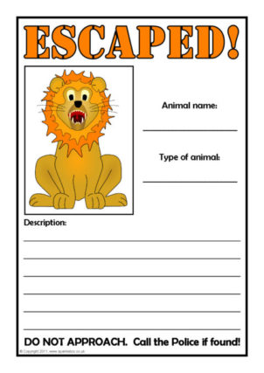](https://www.google.co.uk/url?sa=i&url=https%3A%2F%2Fwww.sparklebox.co.uk%2Ftopic%2Fworld-around-us%2Fplaces%2Fzoo.html&psig=AOvVaw24dhVpt6lTol9RuKnA6IsK&ust=1600780780737000&source=images&cd=vfe&ved=0CAIQjRxqFwoTCIDvnqGr-usCFQAAAAAdAAAAABAE)

**What you need:**   
Paper  
Pens/pencils/colours  
Favourite animal

**What to do:**Your favourite animal has escaped from the zoo/jungle/garden. Create an escaped creature poster. It needs to include: a picture/drawing, name, type of animal and 4 descriptive words (challenge: 4 sentences!!)

**What it is good for:**Sounding out, writing, imagination, fine motor skills, drawing.

Teacher note/who for – Level 1 learners