GOSDEN HOUSE

SCHOOL

KS4 Exam Courses

& Curriculum

2020-2021

Year 11

Student Name:

Dear Parent/Carer.
Please find attached our KS4 Exam courses pack. In it you will find out more information about the KS4 curriculum and be able with your child to look at the different exam options available to them and select together their coursework exam options. These courses are in addition to our Functional Skills Maths—Entry 1-Level 1, and English—Entry 1-Level 1, Careers and PSHE courses.
All our learners are working at a variety of levels so our KS4 curriculum provides a variety of courses at different levels and with consideration to our student’s areas of strength, areas for development and personal interest. Course options are split into two different coloured Pathways
Blue Pathway
Blue Pathway is for students working at and below N.C Step 3 These courses are for students that might be heading to a specialist provision Post 16 as a stepping stone before College or to access Support Learning at College our Blue Pathway courses offer a variety of valuable learning experiences to prepare them for post 16 transition.
Green Pathway
Green Pathway is for students working at .N.C Step 3 and above. These course are for students planning to head off to local mainstream F.E colleges post 16 to complete level 1 and 2 Vocational courses our green and blue pathways prepare them well for their next steps of learning at college. Green Pathway courses are available to students that are working from Entry 3 and towards Level 1. These courses require a degree of student led learning and also have a greater written coursework components.
…………………………………………………….. is currently working towards N.C Steps ………………………………with this in mind she would benefit from choosing courses from the …………………………………….. options.
Please do not hesitate to contact me should you wish to talk more about the different courses available. The KS4 team are really looking forward to working with you and your young person this year to help them to fully reach their potential.

Kind regards,
Emily Mainwaring

KS4 Curriculum and Exam Courses
KS4 students are able to undertake a variety of interesting and exciting qualifications which help to increase their confidence and independence as learners as well as developing key ‘Life Tools’ which will support them in preparing for their individual learning pathways post 16. To find out more about the Secondary Gosden Graduate Tool Box and Life Tools please see attached documents. There are also examples attached of two of our amazing Gosden Graduates to inspire and motivate our students.
Personal Learning Plans
In KS4 all students have their own Personal Learning Plan which records and tracks their qualification options throughout KS4 and shows students and parents the level they are working towards and their possible preferred options post 16. This plan will be available to you at the Autumn Term Parent’s Evening and your child’s Tutor will be able to discuss it with you both.
Curriculum Overviews
At the Autumn Term Parents’ Evening you will also be provided with a copy of the year’s Curriculum Overview to enable you to see clearly what learning is being covered over the year in all subjects areas including College Experience and Work Experience details.
Learning Pathways
The KS4 Department offers in-house courses from Entry 1, 2, 3 and up to Level 1(GSCE 1-3). Our curriculum in KS4 offers two different coloured pathways for our learners, taking into account their next steps post 16 and their needs as individual learners.
Below is a table which shows how Entry Level and Level 1 courses compare to N.C Steps and GCSE’S
National Curriculum Steps | National Qualifications Framework (NQF) | GSCEs
P Levels – 1a | Pre- Entry & Entry 1 – Blue Pathway | Pre GSCE
2c- 3c | Entry 2 – Blue Pathway | Pre GSCE
3c-4c | Entry 3 – Green Pathway | Pre GSCE
4-6 | Level 1 – Green Pathway | 1-3 GSCE grade

Blue Pathway
For students that might be heading to a specialist provision Post 16, as a stepping stone before College or to access Support Learning at College, our Blue Pathway courses offer a variety of valuable learning experiences to prepare them for post 16 transition. Blue Pathway courses are available to students that are working between national curriculum steps 1-3.
Green Pathway
For students wanting to head off to local mainstream F.E colleges post 16 to complete level 1 and 2 Vocational courses our green and blue pathways prepare them well for their next steps of learning at college. Green Pathway courses are available to students that are working from Entry 3 and towards Level 1
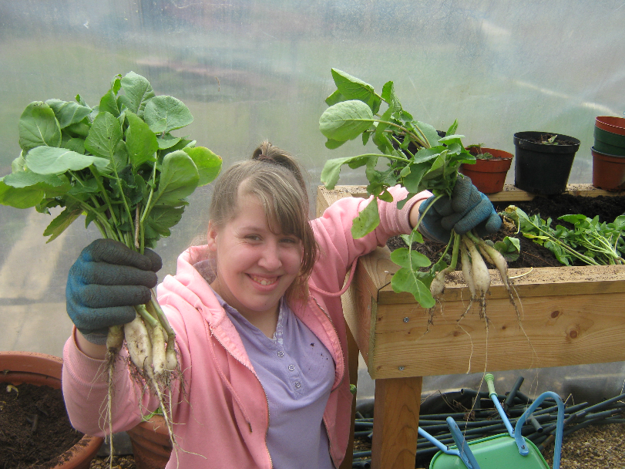
Horticulture Student harvesting and weighing produce.

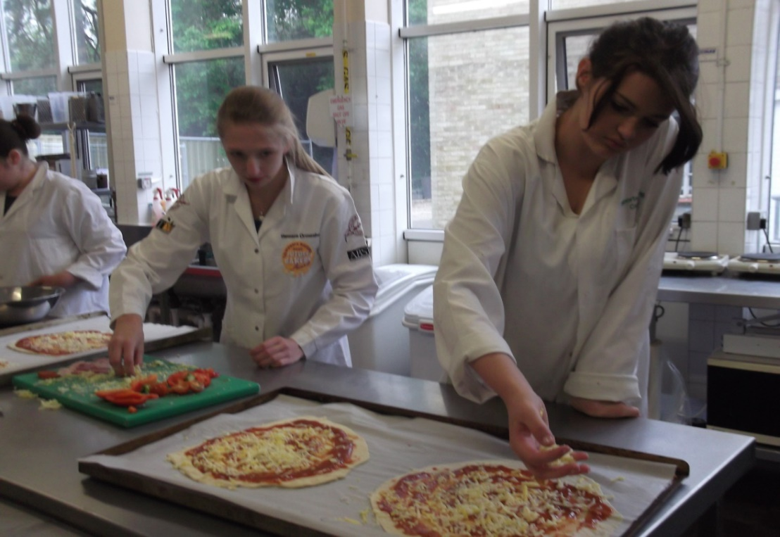
Student at College experience taking part in different vocational areas.

Year 11 Exam Options
Core Units/ Exams accessed by all students during KS4
Entry 1- Level 1 Functional Skills Literacy
Functional Skills Literacy gives students practical skills for the modern world and helps them get the most from life, learning and work. This course aims to ensure students have good communication skills in reading, writing, speaking and listening. It assesses whether students can use these skills in everyday situations.

Entry 1- Level 1 Functional Skills Numeracy
Numeracy focusses upon the life and functional skills of Maths and applying what we have learnt up to KS4. During the year we cover all four strands of Maths; Number, Measure, Geometry and Statistics. It assesses whether students can use these skills in everyday situations.

Entry 3- Level 1 Community Action
This unit aims to enable learners to participate in local community activities and understand the benefits of these activities for themselves and the community. Students will be encouraged to become ‘Active Citizens’ by deciding on an issue/s that they feel strongly about either within their local ,national or world community and find out ways in which they can support it.

Entry 2-3 Healthy Living
This unit enables learners to understand further the importance of leading a healthy lifestyle including discussion and project based around healthy eating, smoking, alcohol and drugs, personal hygiene and personal safety.

Entry 2-3 Preparation for Work and Preparing for Work Experience.
These units helps to prepare students for their three week Work Experience unit which takes place in in the Year 11Spring Term by developing further their understanding of the different workplaces, the purpose of work and their role within a workplace including their rights and responsibilities .

In addition to these exam units there are also exam options that students can choose from.
- Please look through the different exam options with your child.
- Please select by ticking an A,B,C from each of the three option tables, bearing in mind their coloured Pathway.

Tick one option Tick
OPTION 1 - Thursday Mornings | A.  Level 1 -Animal Care Green Pathway Only | Practical and hands on one/two year course which also includes a large element of written coursework. Student will be able to complete Level 1 units.  Key Tools covered during course.
 | B.  Explore and Bronze Arts Award Entry level and Level 1  Green and Blue Pathway | One/ two year course which inspires young people to grow their arts and leadership talents: it's creative, valuable and accessible. Areas covered will be Dance, Drama, Sculpture, Art, Animation and Set Design.  Key Tools covered during course.
 | C.  Entry 2-3 Food Studies course  Blue Pathway only | This is a one/two year course where Students will develop their food handling skills, be able to prepare a variety of meals and snacks with a focus on developing an understanding of healthy diets and important life skills.

Tick one option Tick
OPTION 2 – Thursday Afternoon | A.  Entry 3- Level 1 Food Studies course  Green and Blue Pathway | Students will develop their food handling skills and be able to prepare a variety of meals and snacks with a focus on developing an understanding of healthy diets and important life skills.  Key Tools covered during course.
 | B.  Sports Leadership Course ‘I Can Lead’ Award  Green and Blue Pathway | Learners will learn how to develop their leadership and organisation skills, also looking at a healthy lifestyle and fair play in sport along with the role of the official and what opportunities there are within sport and the community.  Key Tools covered during course.
 | C.  Entry 2-3 Getting Out and About  Blue Pathway Only | This course provides key life skills and provides learners with being able to develop their travels skills both on the bus and road safety awareness. Students will learn more about their local community and how to access different services. Students will also have the opportunity to develop their money handling skills in real life situations.  Key Tools covered during course.

Tick one option Tick
Option 3 – Friday Morning | A.  Entry Level 1-3 Horticulture ( Plant Care)  Green and Blue Pathway | This is a hands on and therapeutic course where students will develop their skills in growing and looking after plants covering areas of the science curriculum. Students will have the opportunity to grow their own produce and then be able to develop their money handling skill by selling it.  Key Tools covered during course.
 | B.  Entry 3- Level 1  Business Enterprise/ Coffee Shop  Green Pathway only | This course provides students with the experience of running a café including the importance of budgeting and marketing. Students will develop their ability to work as a team and their functional maths and English skills.  Key Tools covered during course.
 | C.  Farnborough College Vocational Experience  Green and Blue Pathway | Students will gain experience in different vocational areas including Hairdressing, Media and Public Service. This college experience can help to build self-confidence, provide an opportunity to try out different vocational pathway and support transition at Post 16  Key Tools covered during course.
We will do our best to ensure your child is able to take part in the options they have chosen.

