SECONDARY CURRICULUM
‘A nurturing and responsive curriculum which serves our students.’ Richard Baird OBE, Rochford Review

Our Secondary Curriculum is driven by and designed with the aim to nurture and develop our 10 essential ‘Key Tools’ (refer to Gosden Graduate Toolbox Doc.) . These outcomes form our ‘Gosden Graduate Toolbox’ and as a Department we believe they are essential in preparing our Gosden Learners for their individual pathways post 16.

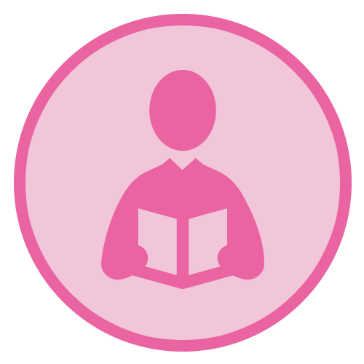 |  | 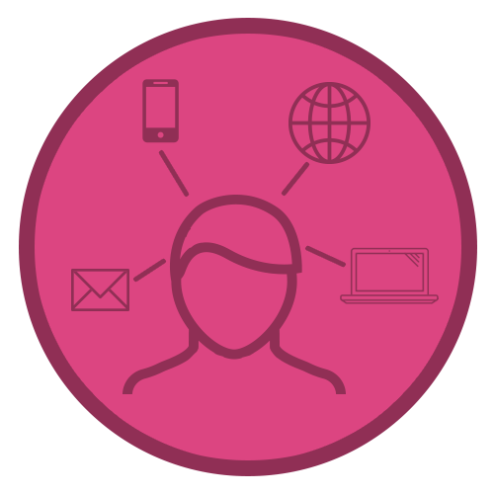 | 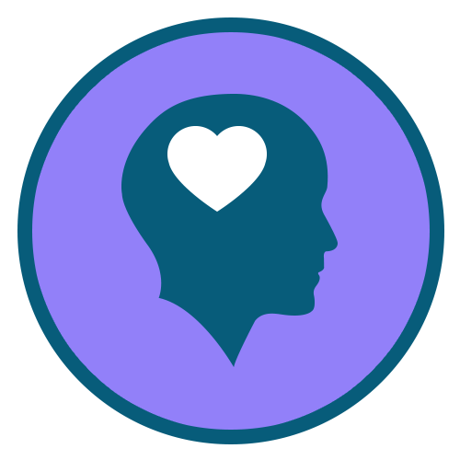 | 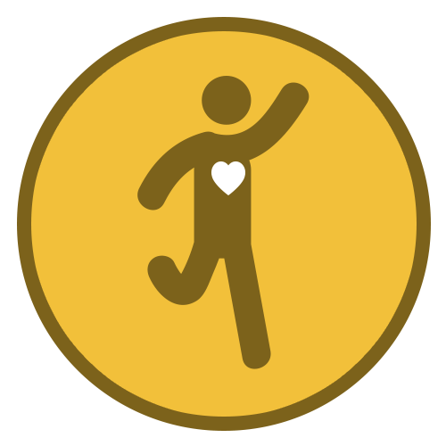 | 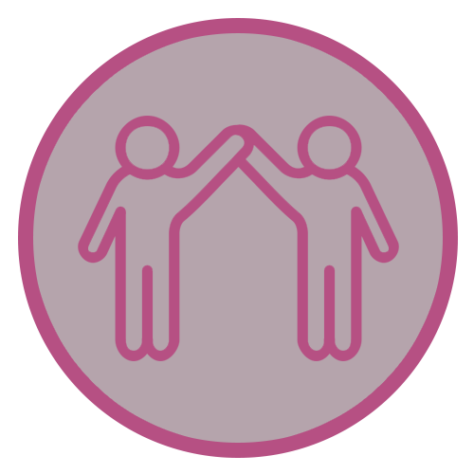 |  | 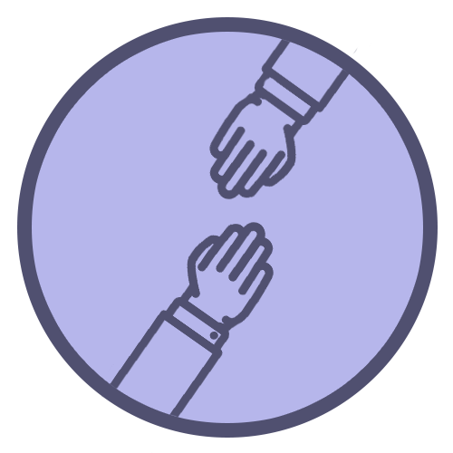 | 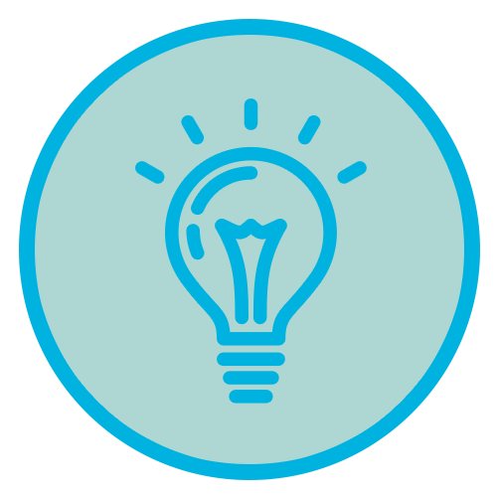 | 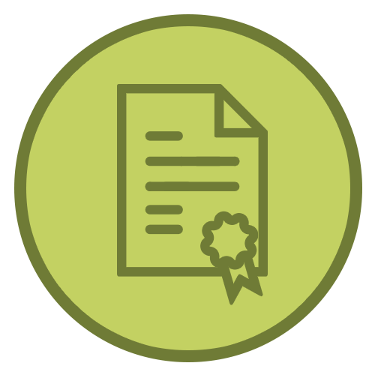
Functional  Literacy  Skills | Functional  Numeracy  Skills | Functional  ICT  Skills | Emotional  Wellbeing | Healthy Lifestyle | Healthy Relationships | Life Skills | Sense of  Belonging | Creative Thinker | Qualifications and Achievements

Simmonds OVERVIEW 2020-2021

Subject | AUTUMN | SPRING | SUMMER
Functional Maths | Number – Counting forwards and backwards, addition, subtraction, multiplication, division, fractions and place value  Measures – Time, money, weight, length, capacity and temperature  Geometry – properties of 2D and 3D shapes including positions and directions  Statistics – Carrying out surveys, interpreting data and presenting data in charts and graphs  Functional Skills – practical maths in everyday situations
Functional English | Short Fictional Stories; providing opportunities to develop understanding of texts including the use of descriptive language, characters and settings. Opportunity to develop speaking and listening skills through paired and group work. Promoting a love of reading for pleasure.  All pupils will work on key literacy skills including reading/writing/spelling of High Frequency words  Objectives/ skills to be covered through the year: Able to compare two characters, make predictions based on pictorial and textual clues, retell a story, describe a book as fiction or non-fiction, write simple sentences with capital letters, full stop and spaces, able to form a sentence with a capital letter and a full stop, able to create and comment on a display, able to arrange letters in alphabetical order, able to find two words that rhyme and discuss how their spellings differ, able to listen to, discuss and recite some poems, able to talk about the beginning, middle and end of a story, able to plan a simple story, able to write a sequence of sentences with illustrations to form a story, using capital letter and full stop most of the time.
Computing | Cross curricular, students encouraged to use skills in different lessons. Specific skills taught separately dependant on individual ability: Able to log on, open, save files, edit, insert pictures, understand how to use search engines effectively, use key board competently, know how to stay safe when online.
Citizenship / Careers | What is Citizenship? - Taking part and working together - Developing social skills and the ability to co-operate in a team. Groups and belonging - Developing a sense of self and where we fit in. Similarities and differences - Understanding that, although we are all different, we have more things in common. It’s OK to be different - If we have or do things that are a little bit different to other people, that are OK. Rights and responsibilities - Learning that with rights come responsibilities.  Careers: To understand what work is, why people do it and see positive benefits in developing a career, to understand that there are many different types of job in an organization and many different jobs in each job sector, to know how to research jobs online and in their community.
P.S.H.E.E  (Personal, Social, Health and Economic Education) | Understanding my body and feelings - types of feelings, zones of regulations, managing feelings and behaviour.  Personal safety, around the home, out and about and internet safety. (RSE)  • Being safe at home.  • Internet safety.  • Basic first aid  • Green cross code  Making and keeping friends (social skills)  Turn taking, resolving problems. Healthy relationships (RSE) | Me and My Relationships  RSE/Puberty  Puberty including body and emotional changes, body parts and differences between males and females. Human life cycle. Identify different kinds of love, Appropriate and inappropriate touch/physical contact.  Teeth brushing lessons with practical.  Sweating, germs, bacteria, viruses, oral hygiene
Science | Ecosystems – linked with seven wonders of the world. To understand that an ecosystem is made up of all of the living and nonliving things in an area. This includes all of the plants, animals, and other living things that make up the communities of life in an area. To know that an ecosystem also includes nonliving materials—for example, water, rocks, soil, and sand. | .  Plants.  What plants need to live, what is meant by living, non living and had lived. Tree and plant studies (labelling) What happens to plants and trees during different seasons. .
R.E. | What does it mean to be a Buddist?  To investigate the religious practices of Buddishm and how these influence home and family life, linking them with important Buddist beliefs. | The Easter Story and why it is important to Christians.  Palm Sunday, Maudy Thursday, Good Friday, Easter Sunday. | How can we live together in one world  To consider how understanding the things that different people believe might help us to live together more harmoniously. Developing concepts of a global community, and recognizing how people of many different beliefs, cultures and traditions should live together and learn from each other.
Our World and History | - Geography: Seven Wonders of the World. Seven Natural Wonders of the World (Mount Everest, Victoria Falls, Grand Canyon, Great Barrier Reef, Northern Lights, Paricutin Volcano, Harbour of Rio de Janerio) Level 1: Able to find the UK on a map/globe. Use simple Atlas. Find land masses and oceans on the globe. Begins to understand terminology and descriptions used in geography. Level 2: Able to locate and name the 5 continents and Oceans. Understand that people and places make a place unique. Able to identify similarities and differences in the UK and other non European places Objectives; To know and understand the term ‘natural wonders of the world’ To learn about features in other parts of the world. To share views and opinions on what is beautiful.  - Geography: Similarities and differences between Town and Country. Postal areas, addresses, shops and facilities. Continue to understand and use terminology and descriptions used in geography.  History: The Middle Ages
P.E. | Dance and fitness. |  | Cricket and Athletics  Students will learn new and improving existing individual skills, being able to combine skills, develop tactical awareness, recognise how they can improve and remember and follow safety rules  Students will learn new and improving existing individual skills, being able to combine skills, develop tactical awareness, recognise how they can improve and remember and follow safety rules.  English Links – the use of concrete and abstract language including the development of speaking and listening skills.  Math’s Links – Number, Geometry and Measure  Science Links – Human Biology  PSHE – Team work & Self Evaluation
DT | Nutrition and cooking  To include: 3 course meal including – hygiene and safety, use of equipment including the oven, following recipes, measuring, washing up, healthy eating, food groups, nutrition, balanced diets.
Art | Autumn Focus: Line. Skills to be covered: mark making, continuous line, cross hatching, layering line, expressive line, natural form and observational drawing.  Spring / Summer Term: Exploring and using different artist’s techniques; Pointillism (Georges Seurat) Pop art.

