GOSDEN HOUSE

SCHOOL

KS4 Curriculum & Courses

2020-2021

Year 11

Student Name:

Dear Parent/Carer.
Please find attached our KS4 Exam Course pack. In it you will find out more information about our KS4 curriculum. You will be able with your child to look at the different course and exam options available to them and together select which courses they would like to do. Courses listed are in addition to our Functional Skills Maths—Entry 1-Level 1, English—Entry 1-Level 1, Careers and PSHE courses.
All our learners are working at different levels so our KS4 curriculum provides a variety of courses taking into account our student’s areas of strength, personal interests and possible career/college pathways. Course options are split into two different coloured Pathways
Blue Pathway
Blue Pathway is for students working at and below N.C Step 3. These courses are for students that might be heading to a specialist provision Post 16 as a stepping stone before College. Our Blue Pathway courses offer a variety of valuable hands on learning experiences to prepare them for post 16 transition.
Green Pathway
Green Pathway is for students working at .N.C Step 3 and above. These courses are for students planning to head off to their local mainstream F.E colleges post 16 to take up a Vocational course. The green and blue pathways help prepare students for their next steps of learning at college. Green Pathway courses are available to students that are working from Entry 3 and towards Level 1. These courses require a degree of student led learning and also have a greater written coursework components.
…………………………………………………….. is working towards Entry Level ………………………with this in mind they would benefit from choosing courses from the …………………………………….. Pathway
Please do not hesitate to contact me should you wish to talk more about the different courses available or Sandra Tidbury our ‘Aspirations Advisor’ to talk about different post 16 options.
Emily Mainwaring – emainwaring@gosden-house.surrey.sch.uk
Sandra Tidbury – s.tidbury@gosden-house.surrey.sch.uk
The KS4 team are really looking forward to working with you and your young person this year to help them to reach their potential.
Kind regards,
Emily Mainwaring

KS4 Curriculum and Exam Courses
KS4 students are able to undertake a variety of interesting and exciting qualifications which help to increase their confidence and independence as learners as well as developing key ‘Life Tools’ which will support them in preparing for their individual learning pathways post 16. To find out more about the Secondary Gosden Graduate Tool Box and Life Tools please see attached documents. There are also examples attached of two of our amazing Gosden Graduates to inspire and motivate our students.
Personal Learning Plans
In KS4 all students have their own ‘Personal Learning Plan’ which records and tracks course and exam options throughout KS4 and shows students and parents the level they are working towards and their possible preferred options post 16. This plan will be available to you at the Autumn Term Parent’s Evening where your child’s Tutor will be able to discuss it with you both.
Curriculum Overviews
At the Autumn Term Parents’ Evening you will also be provided with a copy of the year’s Curriculum Overview to enable you to see clearly what learning is being covered over the year in all subjects areas including College Experience and Work Experience details.
Learning Pathways
The KS4 Department offers in-house courses from Entry 1, 2, 3 and up to Level 1(GSCE 1-3) Our curriculum in KS4 offers two different coloured pathways for our learners, taking into account their next steps post 16 and their individual needs learners.
Below is a table which shows how Entry Level and Level 1 courses compare to N.C Steps and GCSE’S
National Curriculum Steps | National Qualifications Framework (NQF) | GSCEs
P Levels – 1a | Pre- Entry & Entry 1 – Blue Pathway | Pre GSCE
2c- 3c | Entry 2 – Blue Pathway | Pre GSCE
3c-4c | Entry 3 – Green Pathway | Pre GSCE
4-6 | Level 1 – Green Pathway | 1-3 GCSE grade

Blue Pathway
The Blue Pathway would support students that might be heading to a specialist provision Post 16, as a stepping stone before College. Our Blue Pathway courses offer a variety of valuable learning experiences to prepare learners transition at the end of Year 11. Blue Pathway courses are available to students that are working between national curriculum steps 1-3.
Green Pathway
The Green Pathway would support students intending to head off to local mainstream F.E colleges post 16 to take up Vocational courses. Green Pathway courses are available to students that are working from Entry 3 and towards Level 1
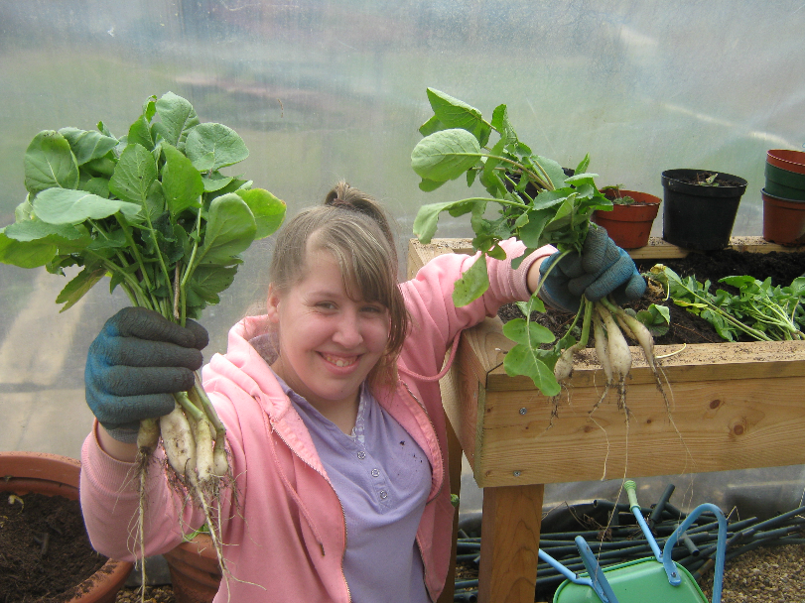
Horticulture Student harvesting and weighing produce.

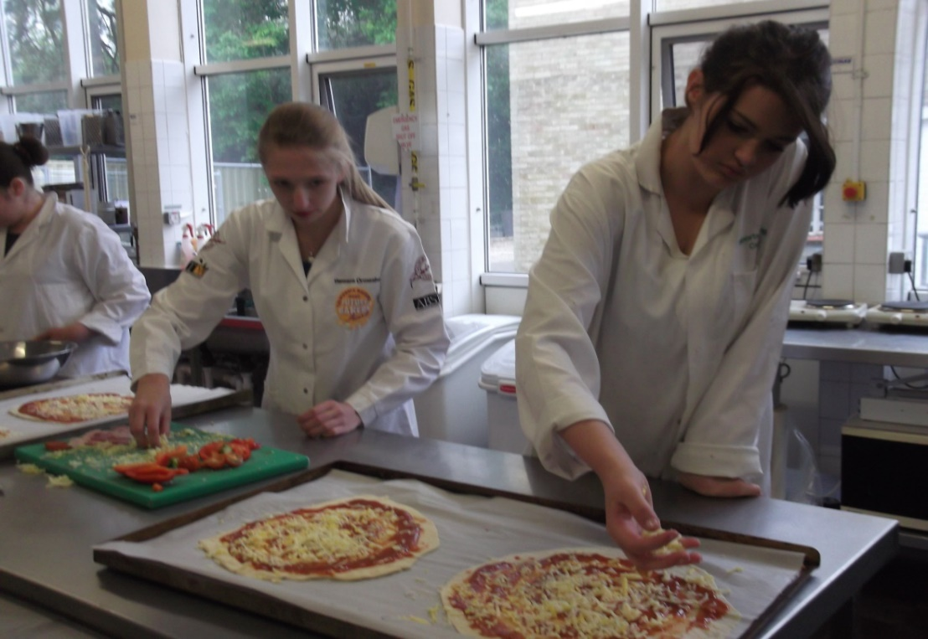

Student at on their College experience taking part in a Catering Course.

Year 11 Exam Options
Core Units/ Exams accessed by all students during KS4
Entry 1- Level 1 Functional Skills Literacy
Functional Skills Literacy gives students practical skills for the modern world and helps them get the most from life, learning and work. This course aims to ensure students have good communication skills in reading, writing, speaking and listening. It assesses whether students can use these skills in everyday situations.

Entry 1- Level 1 Functional Skills Numeracy
Numeracy focusses upon the life and functional skills of Maths and applying what we have learnt up to KS4. During the year we cover all four strands of Maths; Number, Measure, Geometry and Statistics. It assesses whether students can use these skills in everyday situations.

Entry 3- Level 1 Community Action
This unit aims to enable learners to participate in local community activities and understand the benefits of these activities for themselves and the community. Students will be encouraged to become ‘Active Citizens’ by deciding on an issue/s that they feel strongly about either within their local ,national or world community and find out ways in which they can support it.

Entry 2-3 Healthy Living
This unit enables learners to understand further the importance of leading a healthy lifestyle including discussion and project based around healthy eating, smoking, alcohol and drugs, personal hygiene and personal safety.

Entry 2-3 Preparation for Work and Preparing for Work Experience.
These units helps to prepare students for their three week Work Experience unit which takes place in in the Year 11Spring Term by developing further their understanding of the different workplaces, the purpose of work and their role within a workplace including their rights and responsibilities .

In addition to these exam units there are also course options that students can choose from on the following pages.
- Please look through the different exam options with your child.
- Please select by ticking a first and second choice from each of the option tables, bearing in mind their coloured Pathway.

Tick one option Tick
OPTION 1 Thursday Mornings | Animal Care Entry 3  Green and Blue Pathway | Hands on one/two year course providing students with a practical introduction to working with small animals.  This course will also help students to develop employability skills, and prepare for further training.  Key Tools covered during course.
 | Explore and Bronze Arts Award Entry level and Level 1  Green and Blue Pathway | One/ two year course which inspires young people to grow their arts and leadership talents: it's creative, valuable and accessible. Areas covered will be Dance, Drama, Sculpture, Art, Animation and Set Design.  Key Tools covered during course.
 | Entry 3- Level 1 (Money Handling) Coffee Shop  Green and Blue Pathway | This a one/ two year course providing students with the experience of running a café including the importance of budgeting and marketing. Students will develop their ability to work as a team and their functional maths and English skills. This course will also help students to develop employability skills, and prepare for further training.  Key Tools covered during course.
 | Entry 2-3 Food Studies course  Blue Pathway only | This is a one/two year course where Students will develop their food handling skills, be able to prepare a variety of meals and snacks with a focus on developing an understanding of healthy diets and important life skills.  This course will also help students to develop employability skills, and prepare for further training.  Key Tools covered during course.

Tick one option Tick
OPTION 2 Friday Morning | Entry Level 2-3 Horticulture (Plant Care)  Green and Blue Pathway | This is a one/two year, hands on and therapeutic course where students will develop their skills in growing and looking after plants covering areas of the science curriculum. Students will have the opportunity to grow their own produce and then be able to develop their money handling skill by selling it. This course will helping students to develop employability skills, and prepare for further training.  Key Tools covered during course.
 | Level 1 - Food Studies course  Green Pathway Only | This is a one/two year course where Students will develop their food handling skills, be able to prepare a variety of meals and snacks with a focus on developing an understanding of healthy diets and important life skills.  This course will also help students to develop employability skills, and prepare for further training.  Key Tools covered during course.
 | Entry 1 Getting Out and About  Blue Pathway | This one/two year course provides key life skills and provides learners with being able to develop their travels skills both on the bus and road safety awareness. Students will learn more about their local community and how to access different services. Students will also have the opportunity to develop their money handling skills in real life situations.  Key Tools covered during course.
 | Farnborough College Vocational Experience  Green and Blue Pathway | Students will gain experience in different vocational areas in Media and Catering. This college experience can help to build self-confidence, provide an opportunity to try out different vocational pathway and support college transition at Post 16  Key Tools covered during course.
 | Sports Leadership Course ‘I Can Lead’ Award  Green and Blue Pathway | This is a one year course. Learners will learn how to develop their leadership and organisation skills, also looking at a healthy lifestyle and fair play in sport along with the role of the official and what opportunities there are within sport and the community.  Key Tools covered during course.
We will do our best to ensure your young person is able to take part in the options they have chosen.

