**FUN IN THE SUN!**

**What you need:**

-Either sheet listed with pictures of **sun, hat, sun glasses, water, sun cream** or simple drawings.

-1 piece of A4 white paper folded as shown opposite

-scissors and glue

**What to do:**

If you have access to the internet enter into search engine and watch the video ‘Sun safety Mr Tumble’. Discuss with your child how to keep safe in the sun. Can they tell you how to keep safe in the sun?

Carefully cut out the objects; sun, hat, sun glasses, water, sun cream. Fold the sun in half and then cut it in half. Glue each side of sun as shown opposite. Arrange and glue the other objects in the centre of the leaflet.

**Extension:** colour in and decorate

**What it is good for:**

Understanding Sun Safety

Speaking and listening

Fine motor control

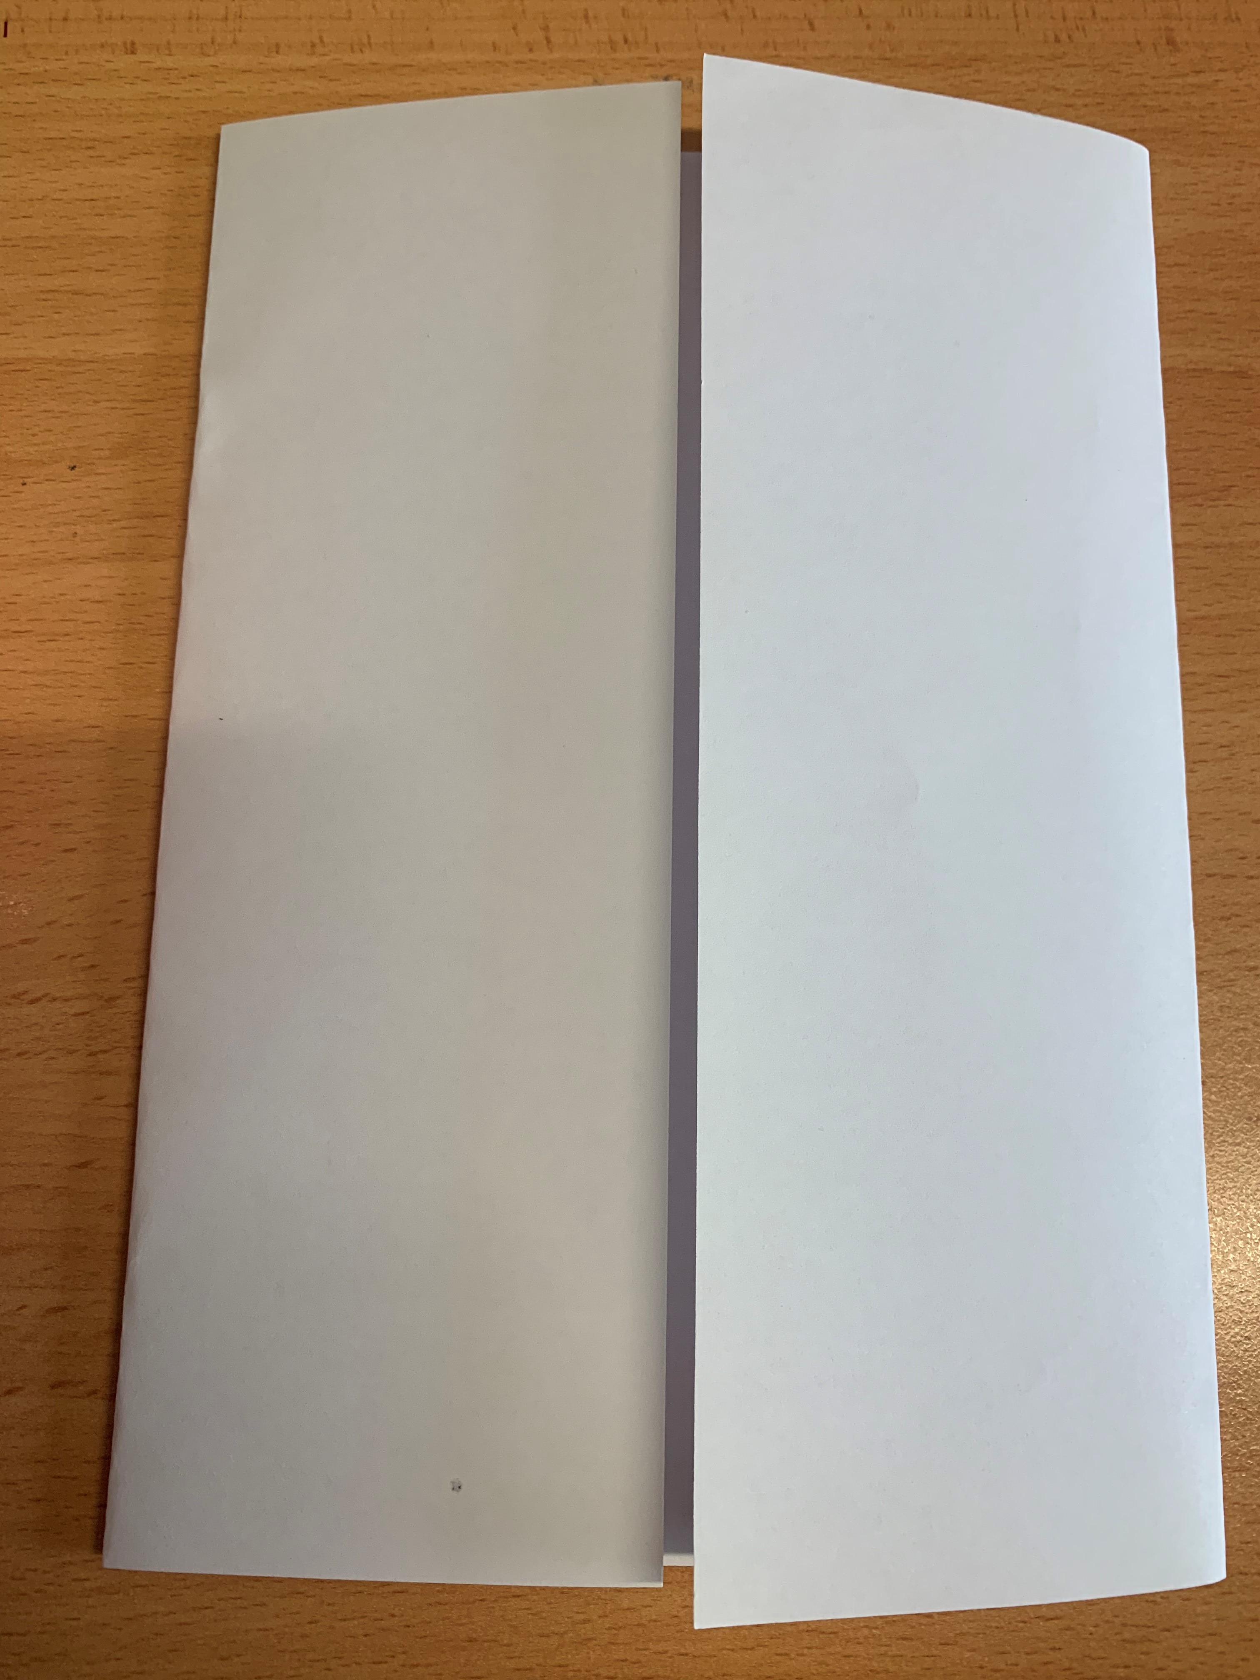

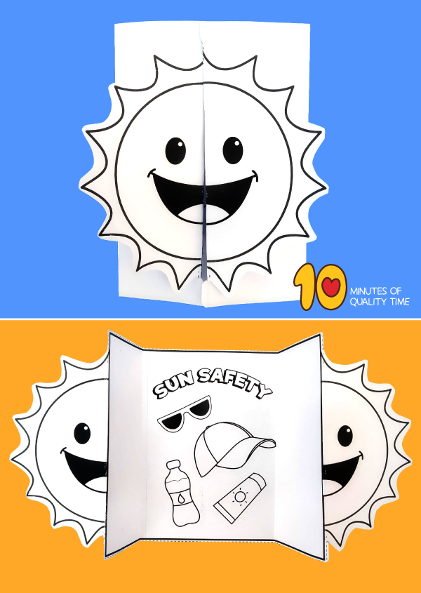

[Safe In The Sun - CBeebies - BBC](https://www.bbc.co.uk/cbeebies/watch/something-special-safe-in-she-sun-song?collection=something-special-songs)

[A Sun Safety Poem by Dr. Miriam Weinstein - Bing video](https://www.bing.com/videos/search?q=the+sun+safety+song&ru=%2fvideos%2fsearch%3fq%3dthe%2520sun%2520safety%2520song%26qs%3dn%26form%3dQBVDMH%26sp%3d-1%26pq%3dthe%2520sun%2520safety%2520song%26sc%3d2-19%26sk%3d%26cvid%3d8CE27002FB474BA48BE480272836E06C&view=detail&mid=2D67A29E8FE2E8C014B42D67A29E8FE2E8C014B4&&FORM=VDRVSR)