**Back and forth drawing game.**

**What you need: paper, pen or pencils.**

**What to do: One person starts the drawing with something simple and quick. For example it might be a circle, square shape, a line or eyes. Then you just take it in turns adding as you go along.**

**What it is good for: Imagination, creativity and sharing.**

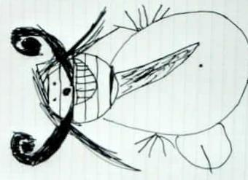

**What it is good for:**