SECONDARY CURRICULUM
‘A nurturing and responsive curriculum which serves our students.’ Richard Baird OBE, Rochford Review

Our Secondary Curriculum is driven by and designed with the aim to nurture and develop our 10 essential ‘Key Tools’ (refer to Gosden Graduate Toolbox Doc.) . These outcomes form our ‘Gosden Graduate Toolbox’ and as a Department we believe they are essential in preparing our Gosden Learners for their individual pathways post 16.

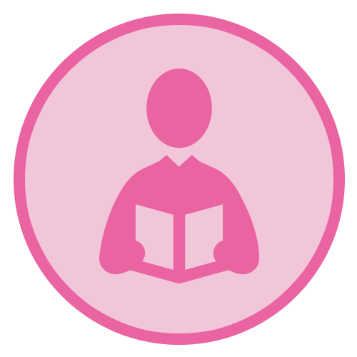 |  |  |  | 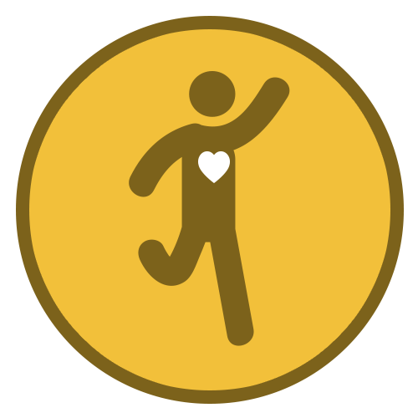 | 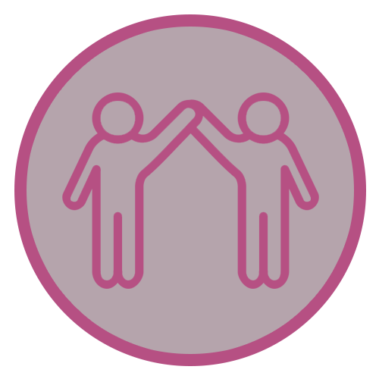 |  | 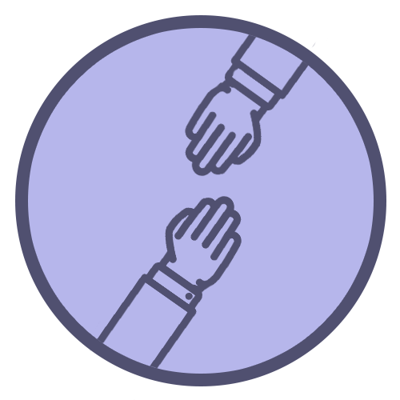
Functional  Literacy  Skills | Functional  Numeracy  Skills | Functional  ICT  Skills | Emotional  Wellbeing | Healthy Lifestyle | Healthy Relationships | Life Skills | Sense of  Belonging | Creative Thinker | Qualifications and Achievements

Simmonds OVERVIEW 2021 – 2022

Subject | AUTUMN | SPRING | SUMMER
Functional Maths | Number – Counting forwards and backwards, addition, subtraction, multiplication, division, fractions and place value  Measures – Time, money, weight, length, capacity and temperature  Geometry – properties of 2D and 3D shapes including positions and directions  Statistics – Carrying out surveys, interpreting data and presenting data in charts and graphs  Functional Skills – practical maths in everyday situations  HOME LEARNING OPPORTUNITIES lots of handling money opportunities , spending, budgeting and saving pocket money, number based online and board games , wearing a watch and talking about time including days of the week, months and the seasons, reading timetables.
Functional English | Short Fictional Stories; providing opportunities to develop understanding of texts including the use of descriptive language, characters and settings. Opportunity to develop speaking and listening skills through paired and group work. Promoting a love of reading for pleasure.  All pupils will work on key literacy skills including reading/writing/spelling of High Frequency words  Objectives/ skills to be covered through the year: Able to compare two characters, make predictions based on pictorial and textual clues, retell a story, describe a book as fiction or non-fiction, write simple sentences with capital letters, full stop and spaces, able to form a sentence with a capital letter and a full stop, able to create and comment on a display, able to arrange letters in alphabetical order, able to find two words that rhyme and discuss how their spellings differ, able to listen to, discuss and recite some poems, able to talk about the beginning, middle and end of a story, able to plan a simple story, able to write a sequence of sentences with illustrations to form a story, using capital letter and full stop most of the time.  Drama: exploring books; building confidence, concentration, language and communication through drama / role play.  Knowledge of alphabet – fluent and correct order  Knowledge of sounds of letter (Phase two & three)  Reading and writing CVC & HF words (Phase two and three)  Correct letter formation (print or cursive style)  Confidence in Speaking and Listening tasks.  Experience of asking and answering simple questions to each other.
Computing | Individual programmes in Computer skills , Basic Programming skills with a strong focus on online behaviour and  Internet Safety.  HOME RESOURCES – NSPCC online. Online Safety Co-ordinator is also available to support and guide parents.
P.S.H.E.E/ Citizenship  (Personal, Social, Health and Economic Education) | My World  People who help in our community. Who can help – school, local community and emergency services · Safety @ home – first aid cuts, burns, emergency first aid, hazards, medicine etc. | Health and Wellbeing  Sun safety  Basic first aid  Road safety  Keeping calm – emotional wellbeing, mental heath  Keeping clean: teeth brushing. | Me and My Relationships  Identifying differences, friendship and bullying  My body – SRE differences between males and females. Sweating, germs, bacteria, viruses. Puberty including body and emotional changes identify different kinds of love, Appropriate and inappropriate touch/physical contact human life cycle.
R.E. | Students will learn about inspirational people. They will identify what an inspirational person is, the qualities they have and how they impact on others. Students will learn about Nelson Mandela, Ghandi, Mother Theresa, JK Rowling, Jesus, The Dalai Lama and others. Students will get the opportunity to practice their ICT skills in doing this
 | Diwali  Christmas  Chanukah | Holi  Easter | Ramadan
DT | Explore and research different cultures arts and designs. | To design, make and evaluate a clock. | To design, make and evaluate:  Using an electrical circuit in own products
Food Techmology | Cooking a variety of foods chosen by the class and developing their kitchen skills, including:  Making hot drinks, toast, macaroni cheese, pizza, lasagna, sushi
P.E. | Ball Skills: Volleyball  Students will learn new and improving existing individual skills, being able to combine skills, develop tactical awareness, recognise how they can improve and remember and follow safety rules.  English Links – the use of concrete and abstract language including the development of speaking and listening skills.  Math’s Links – Number, Geometry and Measure  Science Links – Human Biology  PSHE – Team work & Self Evaluation | Boccia & Football  Students will learn new and improving existing individual skills, being able to combine skills, develop tactical awareness, recognise how they can improve and remember and follow safety rules.  English Links – the use of concrete and abstract language including the development of speaking and listening skills.  Math’s Links – Number, Geometry and Measure  Science Links – Human Biology  PSHE – Team work & Self Evaluation | Cricket & Athletics  Students will learn new and improving existing individual skills, being able to combine skills, develop tactical awareness, recognise how they can improve and remember and follow safety rules.  English Links – the use of concrete and abstract language including the development of speaking and listening skills.  Math’s Links – Number, Geometry and Measure  Science Links – Human Biology  PSHE – Team work & Self Evaluation
Swimming  Summer Term | Endeavour  Working on personal survival and lifesaving.  Distance badges  Increase endurance and technique in a variety of swimming strokes.  Water skills  Working on specific skills that are transferable into different swimming activities and helping to build water confidence.
Our World  Geography: | Africa and Asia identifying their key physical and human characteristics, countries and major cities Identify similarities and differences between Africa and a region of Asia. | Improve locational knowledge:  Different countries, continents and flags | Skills and Fieldwork: navigating around the local community, using maps
Citizenship | What is Citizenship? Taking part and working together. Community: People who help us and how can we help others. | Similarities and differences: Learning that it is ok to be different and celebrating diversity. Investigating rights and responsibilities. | Wants and needs: Considering the differences between those things we want and the ones, we really need.
Science | Earth and Space: to learn about the movement of the Earth and the other planets relative to the sun in the solar system. Develop understanding of the Earth’s rotation to explain day and night and the apparent movement of the sun across the sky. | Everyday Materials: to experience and explore different materials. They will gain an understanding of how materials behave in their natural state and under certain conditions will help them to understand why objects are made of specific materials. | Animal Classification. To learn about the differences in the life cycles of a mammal, an amphibian, an insect and a bird. They will also learn about the life processes of reproduction in some plants and animals.
History | Medieval Britain:  Churches  The inside and outside features of a medieval church. | Romans:  Life as a Roman | Dinosaurs:  What happened to them

