GOSDEN HOUSE

SCHOOL

KS4 Curriculum & Courses

2022-2023

Year 10

Student Name:

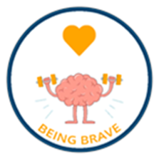
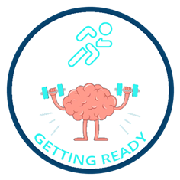

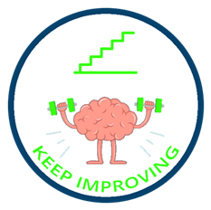
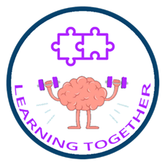

Dear Parent/Carer,
Please find attached our KS4 Course pack. In it you will be able to find out more information about our KS4 curriculum. You will be able to look at the different course options available with your child and select which courses they would like to do.
Courses listed are in addition to our Functional Skills Maths—Entry 1-Level 1, English—Entry 1-Level 1, Careers and PSHE courses.
Where relevant pupils will have the opportunity to sit Functional Skills Maths and English exams in the Summer Term during our Exams weeks.
All our learners are working at different levels, so our KS4 curriculum provides a variety of courses taking into account pupils’ areas of strength, personal interests and possible career/college pathways.
Course options are split into two different coloured Pathways
Blue Pathway
The Blue Pathway is for pupils working at and below N.C Step 3. These courses are for pupils that might be heading to a Post 16 specialist provision as a stepping stone before ‘Supported Learning’ at College. Our Blue Pathway courses offer a variety of valuable hands on learning experiences to help prepare pupils for post 16 transition.
Green Pathway
The Green Pathway is for pupils working at N.C Step 3 and above. These courses are for pupils planning to head off to their local mainstream F.E colleges Post 16 to take up a Vocational course. Green Pathway courses are available to pupils that are working at Entry 3 and towards Level 1. These courses require a degree of pupil led learning and also have a greater written coursework component.
…………………………………………………….. is working towards Entry Level ………………………
With this in mind they would benefit from choosing courses from the …………………………………….. Pathway
Please do not hesitate to contact me should you wish to talk more about the different courses available or Sandra Tidbury our ‘Aspirations Advisor’ to talk about different post 16 options.
Emily Mainwaring – emainwaring@gosden-house.surrey.sch.uk
Sandra Tidbury – s.tidbury@gosden-house.surrey.sch.uk
The KS4 team are really looking forward to working with you and your young person this year to help them to reach their potential.
Kind regards,
Emily Mainwaring

KS4 Curriculum and Exam Courses
KS4 pupils are able to undertake a variety of interesting and exciting courses which help to develop their Learning Muscles in additional to developing other key ‘Life Tools’ .To find out more about the Secondary Gosden Graduate Tool Box and Life Tools please look at the Secondary area of the school website.
Personal Learning Plans
In KS4 all pupils have their own ‘Personal Learning Plan’ which records and tracks course and exam options throughout KS4 and shows pupils the level they are working towards and their possible preferred options post 16. This plan will be available at the Autumn Term Parent’s Evening where your child’s Tutor will be able to discuss it with you both.
Curriculum Overviews
At the Autumn Term Parents’ Evening you will also be provided with a copy of the year’s ‘Curriculum Overview’ to enable you to see clearly what learning is being covered over the year in all subject areas.
Learning Pathways
The KS4 Department offers in-house courses from Entry 1, 2, 3 and up to Level 1(GSCE 1-3) Our curriculum in KS4 offers two different coloured pathways for our learners, taking into account their next steps Post 16 and their individual needs as learners.
Below is a table which shows how Entry Level and Level 1 courses compare to N.C Steps and GCSE’S
National Curriculum Steps | National Qualifications Framework (NQF) | GSCEs
P Levels – 1a | Pre- Entry & Entry 1 – Blue Pathway | Pre GSCE
2c- 3c | Entry 2 – Blue Pathway | Pre GSCE
3c-4c | Entry 3 – Green Pathway | Pre GSCE
4-6 | Level 1 – Green Pathway | 1-3 GCSE grade

Blue Pathway
The Blue Pathway would support pupils that might be heading to a Post 16 specialist provision before heading off to College. Our Blue Pathway courses offer a variety of valuable learning experiences to prepare the learners’ transition at the end of Year 11. Blue Pathway courses are available to pupils that are working between National Curriculum steps 1-3.
Green Pathway
The Green Pathway would support pupils intending to head off to local mainstream F.E colleges to take up Life Skills and Vocational courses. Green Pathway courses are available to pupils that are working from Entry 3 and Level 1.
Horticulture pupils providing the school kitchen with produce they have grown.

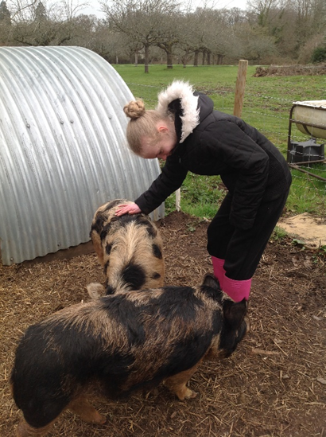

Pupil tending to the animals during their Animal Care lesson.

Core Units
Entry 1- Level 2 Functional Skills Literacy
Functional Skills Literacy gives pupils practical skills for the modern world and helps them get the most from life, learning and work. This course aims to ensure that students have basic skills in Reading, Writing and Speaking and Listening. It assesses whether students can use these skills in everyday situations.

Entry 1- Level 2 Functional Skills Numeracy
Numeracy focuses upon developing functional skills. During the year we cover all four strands of Maths; Number, Measure, Geometry and Statistics. It assesses whether students can use these skills in everyday situations.

Entry 3 Making the Most of Leisure Time
This unit aims to enable learners to access the community in order to stay healthy, as well as improve their travel training skills. Learners will identify different ways in which they can use their leisure time and participate in activities they find relaxing, challenging and new.

Entry 3 Managing Social Relationships
This unit enables learners to understand the importance of managing our relationships and emotions. It will also teach students to express their opinions and identify positive behaviours.

Entry 3 Working as Part of a Group
These units helps students to complete a project together, as a team. They will improve their communication skills, team working skills and employability skills. They will also learn to reflect and review their work in order to encourage progression.
By completing the units above, KS4 pupils will be working towards gaining an accredited qualification. At the end of their two years in KS4, students will achieve either an Award or a Certificate in Personal and Social Development.

In addition to these units there are also course options that pupils can choose from on the following pages.
- Please look through the different exam options with your child.
- Please select by ticking a first and second choice from each of the option tables, bearing in mind their coloured Pathway.

Tick one option Tick
OPTION 1 Thursday Mornings | Animal Care Entry 3  Green and Blue Pathway | Hands on one/two year course providing students with a practical introduction to working with small animals.  This course will also help students to develop employability skills, and prepare for further training.  Key Tools covered during course.
 | Explore and Bronze Arts Award Entry 1-L1  Green and Blue Pathway | One/ two year course which inspires young people to grow their arts and leadership talents: it's creative, valuable and accessible. Areas covered will be Dance, Drama, Sculpture, Art, Animation and Set Design. Students will participate in all elements of the Arts.  Key Tools covered during course.
 | Entry 1-3 Food Studies/Coffee Shop  Green and Blue Pathway | This is a one/ two year course providing students with the experience of running a café including the importance of budgeting and marketing. Students will develop their ability to work as a team and their functional maths and English skills. This course will also help students to develop employability skills, as well learning some basic cooking and catering skills.  Key Tools covered during course.
 | Sports Leadership Course ‘I Can Lead’ Award  Green and Blue Pathway | This is a one year course. Learners will learn how to develop their leadership and organisation skills, also looking at a healthy lifestyle and fair play in sport along with the role of the official and what opportunities there are within sport and the community.  Key Tools covered during course.

Tick one option Tick
OPTION 2 Friday Morning | Entry Level 2-3 Horticulture (Plant Care)  Green and Blue Pathway | This is a one/two year, hands on course where pupils will develop their skills in growing and looking after plants covering areas of the science curriculum. Pupils will have the opportunity to grow their own produce and then be able to develop their money handling skill by selling it. This course will enable pupils to develop employability skills and prepare for further training.  Key Tools covered during course.
 | Level 1 - Food Studies course  Green Pathway Only | This is a one/two year course where pupils will develop their food handling skills, be able to prepare a variety of meals and snacks with a focus on developing an understanding of healthy diets and important life skills.  This course will also help pupils to develop employability skills and prepare for further training.  Key Tools covered during course.
 | Entry 1 Getting Out and About  Blue Pathway | This one/two year course provides key life skills and enables learners to further develop their travels skills, both on the bus and with road safety awareness. Pupils will learn more about their local community and how to access different services. Pupils will also have the opportunity to develop their money handling skills in real life situations.  Key Tools covered during course.
 | Entry 2-3 Design Technology  Green and Blue Pathway | This is a one/two year course which allows learners to explore their creative and inventive sides. Pupils will improve their life skills in the work shop and invent/create some exciting pieces of work.  Key Tools covered during course.
We will do our best to ensure your young person is able to take part in the options they have chosen.

