**CAREERS AT GOSDEN HOUSE**

**To be read in conjunction with ‘Careers Development Plan’ and ‘Gatsby Benchmark Audit’ documents.**

**KEY END POINTS IN OUR LEARNER’S JOURNEYS**

The Careers curriculum supports the progress of our learners in achieving our purposeful and ambitious ‘End Points’. These identified ‘End Points’ focus on ‘tooling’ up our eventual Gosden Graduates for their future pathways. In addition to these guiding End Points, all learners have ILPs (Individual Learning Plans) based on their EHCP individual outcomes under the four areas of need, which are developed and progressed throughout their time at Gosden.

**PRIMARY END POINTS**

CREATIVE AND CURIOUS –

EYFS / KS1 – I am learning to be curious about the world around me, through practical and creative exploration. I am excited to find out more.

KS2 – I am becoming more confident in exploring the wider world and I use my curiosity and creativity to investigate and to express my learning. I explore my own ideas and beliefs and value those of others.

**SECONDARY END POINTS**

* KS3 EMPLOYABILITY SKILLS WIIFM (What’s in it for me?)– I am developing an understanding of the expectations needed for my future aspirations and to successfully transition into KS4.
* Ks4 EMPLOYABILITY SKILLS WIIFM KS4 – I have an individualised skill set that enables me to access qualifications and a work based environment, in preparation for my future pathway.
* LIFE SKILLS WIIFM - I am building a range of life skills and experiences that equip me with the confidence and sense of belonging, to be an active participant in my community.
* HEALTHY REALTIONSHIPS WIIFM - I recognise what different relationships look like. I am empowered to understand and develop healthy relationships. I feel comfortable with, when and where to get support and help, if I need to.
* SENSE OF BELONING WIIFM - I have the skills to be confident in my community and feel valued in making positive contributions. I am interested in the world outside my door and I want to play a part in it, understanding differences in people and my community.
* ICT Skills WIIFM - I have functional ICT skills that I can use in the workplace. I can also use these skills to help me engage with the online world positively.

**WHAT DO WE BELIEVE IS ESSENTIAL IN THE TEACHING AND LEARNING OF CAREERS FOR OUR GOSDEN LEARNERS?**

At Gosden, we follow The Gatsby Benchmark Framework, which allows us to monitor and track what we are offering. These are broken down into eight steps:

1. A stable careers programme

2. Learning from career and labour market information

3. Addressing the needs of each pupil

4. Linking curriculum learning to careers

5. Encounters with employers and employees

6. Experiences of workplaces

7. Encounters with further and higher education

8. Personal guidance

The intention of the steps are to ensure we are offering the best outcomes for our learners, as well as covering all aspects of careers at Gosden.

At Gosden, we have an Aspirational Advisor. Their role is essential in the teaching and learning of careers. Below is an outline (written by our Aspirations Advisor) as to what her role entails:

*‘As Aspirations Adviser, I support the learners and families with their future pathways. I help the learners to make positive and meaningful decisions by sharing up to date information about pre-supported internships, Sixth Form opportunities and FE College Pathways with an emphasis on a particular job ore route they would like to go down.*

*From Year 9 when the students are introduced to their Vocational Profile in the latter part of the summer term, “aspirations” are discussed. This is the beginning of their journey into KS4, a different curriculum, a focus on Preparation for Adulthood and independence and a meaningful pathway going forward. This Profile will continue with them on their journey and be updated as appropriate and will also be a tool to take with them into their Reviews. KS4 offers work experience opportunities and often extended placements as well as vocational tasters, a college experience and an emphasis on the importance of Functional Maths and English.*

*Alongside working with the learners and their families, I will attend Annual Reviews to support next steps and this encompasses visits and interview support, filling in college applications and travel support forms. I network with training providers, colleges, Sixth Form provisions, employers and work experience placements and aim to collaborate with other SEND providers to bring together a Careers Fair that can be accessed every year.*

*All of the work done is intertwined with the 8 Gatsby Benchmarks that every school and college should implement. As a school we work closely with the Careers & Enterprise Company which is a Government-funded agency, who support the development of careers programmes within schools and colleges and network with ideas and resources around the Benchmarks.’*

**HOW DO WE DEVELOP, STRETCH AND NURTURE THE ESSENTIAL SKILLS AND KNOWLEDGE IN CAREERS?**

Currently, we implement elements of all eight steps within our curriculum and we are continuing to develop within this subject area, as we understand the relevance and benefit of offering a careers programme to each individual.

We believe that all classes should have ‘class jobs’ that can tailored to each age range. This allows learners to gain independence and key life skills throughout their time at the school. It also teaches them responsibility and promotes ownership.

The school advocates Learning Muscles/Habits as well as The Gosden Graduate and The Toolkit. Within these areas, we are embedding the key life skills that are required within careers to allow the learners to flourish once they leave Gosden. We believe we are setting them up with the requirements needed within the working world. This includes aspects such as: working together, continuing to improve, problem solving, as well celebrating essential tools such as functional skills, healthy relationships and employability skills. We introduce the Learning Habits in reception and develop these throughout their years at Gosden, enabling a learner to succeed within careers.

We adapt the national curriculum in order to enable all of our students to access learning. This allows us to guide them through the essential skills they need before they leave, in the hope that we can set them up for a bright future, regardless of their learning or physical disability. An example of this is within KS4, where we have recently introduced an ASDAN Certificate. This is an accredited qualification that is recognised by external providers, but is suitable for our learners. It is a coursework based qualification (removing the anxiety that comes with exams) and it targets the skills and qualities we believe a Gosden Graduate would need in their next steps.

Within our lessons, throughout the school, we emphasise the importance of child led learning. This enables learners to promote their problem solving skills, use their creativity and increases engagement; skills needed within the world of work.

Our teaching of careers is not restricted to a set lesson. We have a ‘hands on’, vocational approach to our learning, where we embed key skills within other lessons, such as The Gosden Café, the Plant Care shop and use external providers such as GASP to enrich our programmes.

We also promote these skills throughout our adapted curriculum, including a ‘Careers Day’ which we hope to make a week in the future. This allows all classes to focus on the importance of careers, as well as get an understanding of the possibilities that could be in their future. Within our EYFS curriculum, we look at ‘People who Help us’ to introduce the concept on jobs and working at an early age. We also set realistic expectations for our learners, by focusing on achievable job roles, such as retail and catering.

We wish to continue and expand careers within the school and believe KS3 would be an area that could be developed further.

**PUPIL LEARNING JOURNEY IN CAREERS**

|  |  |  |  |  |  |  |  |  |
| --- | --- | --- | --- | --- | --- | --- | --- | --- |
|  | **EYFS Curriculum** | **KS1** | **KS2** | **Year 7** | **Year 8** | **Year 9** | **Year 10** | **Year 11** |
|  | Careers Day- Whole school  Class Jobs  Learning Habits  Understanding the World  People who help us  (half a term)  This involves role play, external visitors to explain each job. Interactive workshops (watching a haircut etc) | Careers Week- Whole school  Class Jobs  Learning Habits  Understanding the World  People who help us  (half a term)  This involves role play, external visitors to explain each job. Interactive workshops (watching a haircut etc)  In Year 2 the children enjoy responsibilities that might link slightly more explicitly with certain job roles i.e., role-playing as the 'teacher', or caring for Owls/Robins by delivering them to their classroom etc.  We start talking in more detail about different types of jobs/what jobs we can do through role-play/interactive workshops  Woodpecker class interviewed Adam and then became caretakers for the day. | | Careers Week – Whole school  Aspirations Wheel – Year 7  Thinking Thursday (aspirations Year 8)  Class Jobs  Class Targets  College visits x 2 for Year 9 (National Careers Week 2025)  School Council  Linked with PSHE- self-esteem and the life skills module (I can call 999, I can walk to the shop etc) – weekly sessions  Business Enterprise project in Year 9  Aspirations- My Future Pathways document starts in Year 9  Vocational Profiles introduced in Year 9 with 2 added pages for Years 7 and 8  Try a Train – Year 9  Gosden Graduates  National Manufacturing Day 26/09  Learning Muscles/ Toolkit  Citizenship project : Guildford House Care Home – years 7-9  Learning About Workplaces WJEC unit- Year 9.  Transition Event – November parents evening  Future:  E1 Exploring the Community to be introduced in Year 9, so they have all had some experience on public transport, to allow us to progress this further in KS4.  Careers input in Secondary Assemblies – aspirations, jobs past, present and future  Additional speakers to assemblies and classroom sessions eg ALPS, Halow, including Alumni | | | Careers Week – Whole school  Class Jobs  Class Targets  School Council  Careers lesson- 1.5 hours per week on the timetable  ASDAN units  Working as Part of a Group- Yr10  Preparation for Work- Year 11  Work Experience Year 11 – 2 weeks  Social Enterprise Project – The Forge  The Army – in house workshop about teamwork, problem solving etc (employability skills)  Traineeship – The Hideaway  Paul – Employability skills x 6 weeks  National Manufacturing Day 26/09  Vocational Options Thursdays and Fridays  Transition Event – November parents evening  Gosden Graduates  Learning Muscles/ Toolkit  Year 11 attend several careers fair  SEND Careers Fair - annually  Progression Trackers completed which states work placements and qualifications  Travel Training: ‘Try a Train’ scheme and external visits from Travel Choices.  Lunch Monitors  Platform7teen – interview skills workshops and coaching  Future:  Internal WEX for Year 10  Aspirations Advisor to deliver Careers input in Secondary Assemblies – aspirations, jobs past, present and future  Additional speakers to assemblies and classroom sessions eg ALPS, Halow and including Alumni | |

**HOW DO WE KNOW OUR LEARNERS ARE ACTUALLY LEARNING? HOW DO OUR LEARNERS KNOW HOW THEY ARE DOING?**

Assessment is a key element in all of our subjects at Gosden. It is vital to track our learners to ensure what we are offering is having an impact on each individual. Within Careers, all classes use Evisense to capture those ‘wow’ moments that cannot be summarised in a worksheet. This is a wonderful way to share learning with all members of staff at the school, as well as parents and carers.

ILP targets are used throughout the school. These are individual targets used to track a learner’s progress. We believe those targets are relevant to careers, regardless of their age and class, for example: being independent, life skills, social skills and exam qualifications. ILPs are updated termly to ensure a learner is making progress and learning is adapted accordingly. Targets are shared with a learner and discussed on a weekly basis.

In addition, the whole school uses Bsquared to upload, track and analyse our data for each individual. From September, KS4 will be moving over to a new programme within B-squared, ‘steps 4 life’. One of the selling points for this move, was the careers package it offered. Steps 4 life has a significant focus on careers with multiple learning steps and objectives over a larger range of levels than previously (E1-L2). This system will allow us to track a learner’s progression within careers, not only in their set careers lesson, but in all of their subject areas, where these key skills are being achieved.

Moreover, for those learners who take exam courses, internal moderations are pivotal. Within the vocational programmes in KS4, learners are assessed through WJEC. This work is internally verified (by the Aspirations Advisor) and checked again by the Lead IV (Deputy Head). This ensures a rigorous moderation process and guarantees there is a standardised approach amongst all of our vocational offers. Similarly, for those accredited qualifications, ASDAN coursework is internally verified by our Lead IV (KS4 Co-coordinator) and all functional skills papers are moderated by both our Aspirations Advisor and our KS4 Co-ordinator. Following our internal moderations, all coursework and exams are then externally moderated. Our quality assurance process is robust and we are proud of the system we have in place. The variety of qualifications we offer at Gosden, helps us to monitor the impact our teaching has on our learners, we know our qualifications have to be bespoke, in order for all students to access learning and we believe we offer that.

**IN CAREERS HOW WILL OUR GOSDEN GRADUATE BENEFIT FROM THEIR SKILLS AND KNOWLEDGE IN THE FUTURE?**

At Gosden, we have our Secondary Toolkit, these essential life tools allow a learner to see the relevance (what’s in it for me?) during their time at Gosden. These life tools are nurtured and developed throughout our secondary curriculum. We believe they are the life tools that prepare our future Gosden Graduates for post 16. By encouraging student led tools, we are continuously driving forwards and moulding our curriculum to benefit our learners. Each year, we track and monitor the progress of our Year 11 graduates, this allows quality assurance that we are providing the right skills through our toolkit and setting our learners on the right path. We often welcome back our Gosden Graduates to share their successes and achievements with our current students. This allows our current learners to continue to see the purpose and benefit of the bespoke programmes we offer at Gosden.

Below are some examples of our previous Gosden Graduates and how the tools embedded in them have led them on to success within their careers

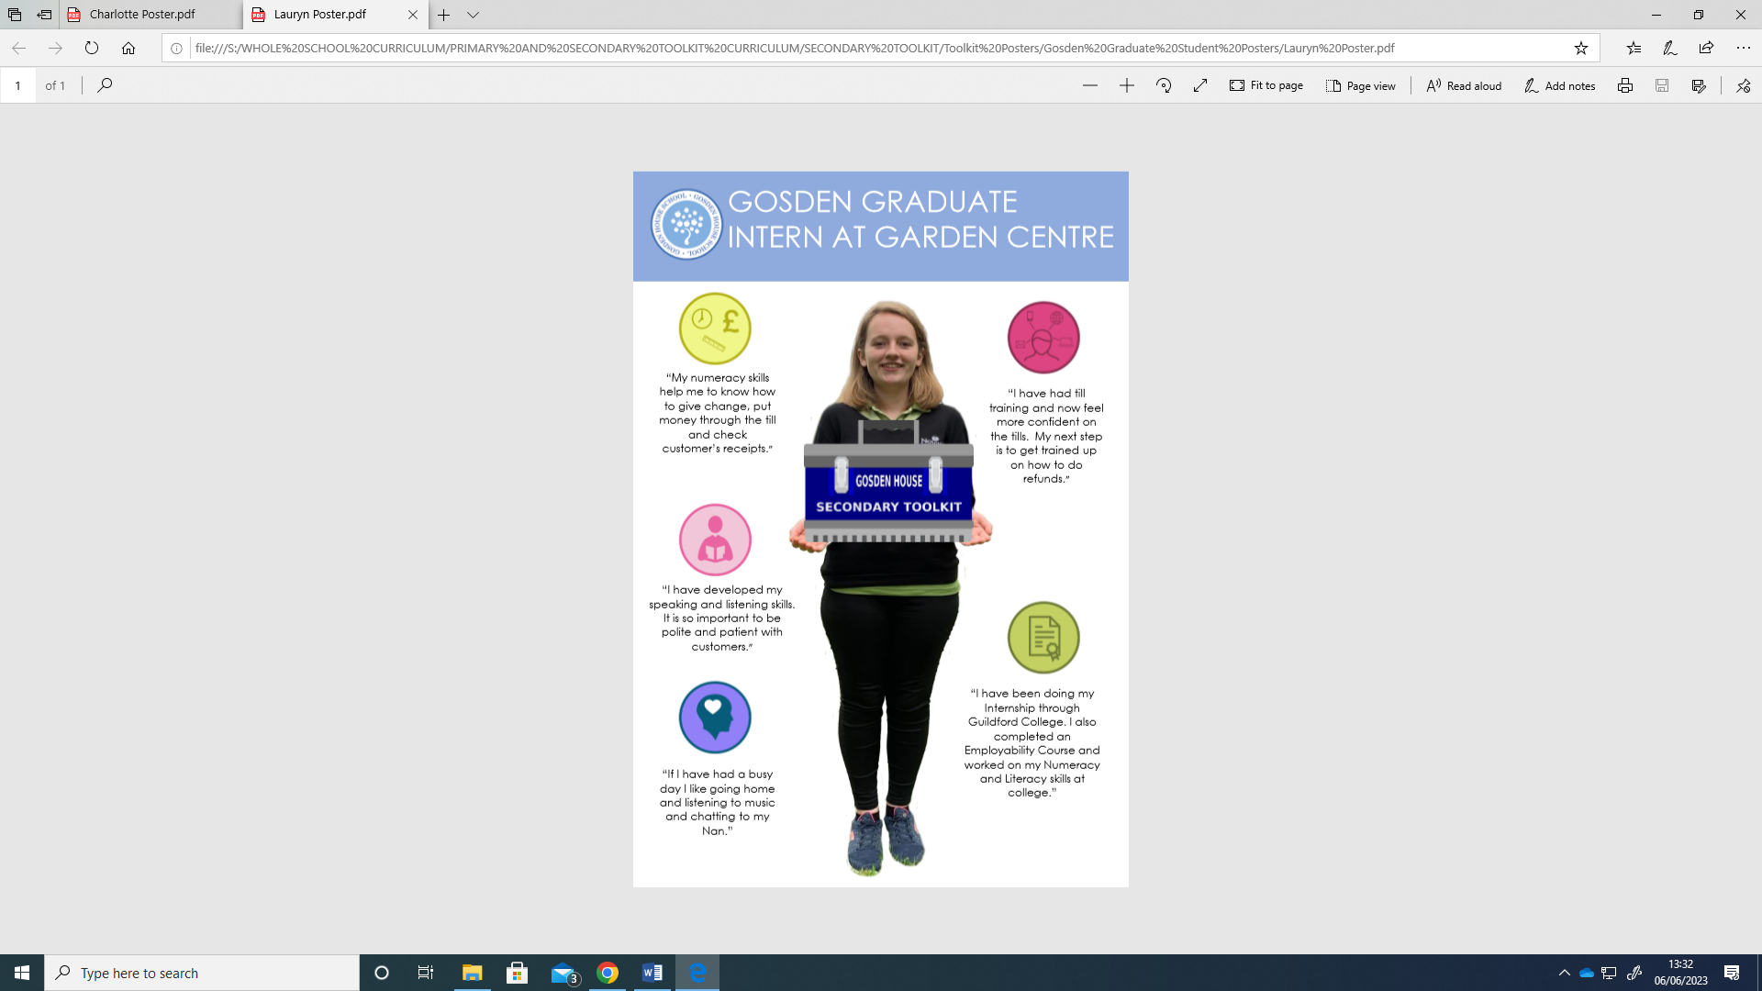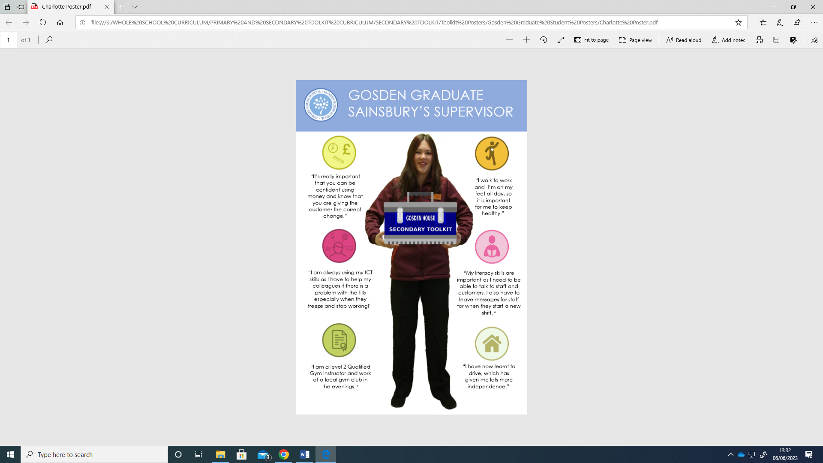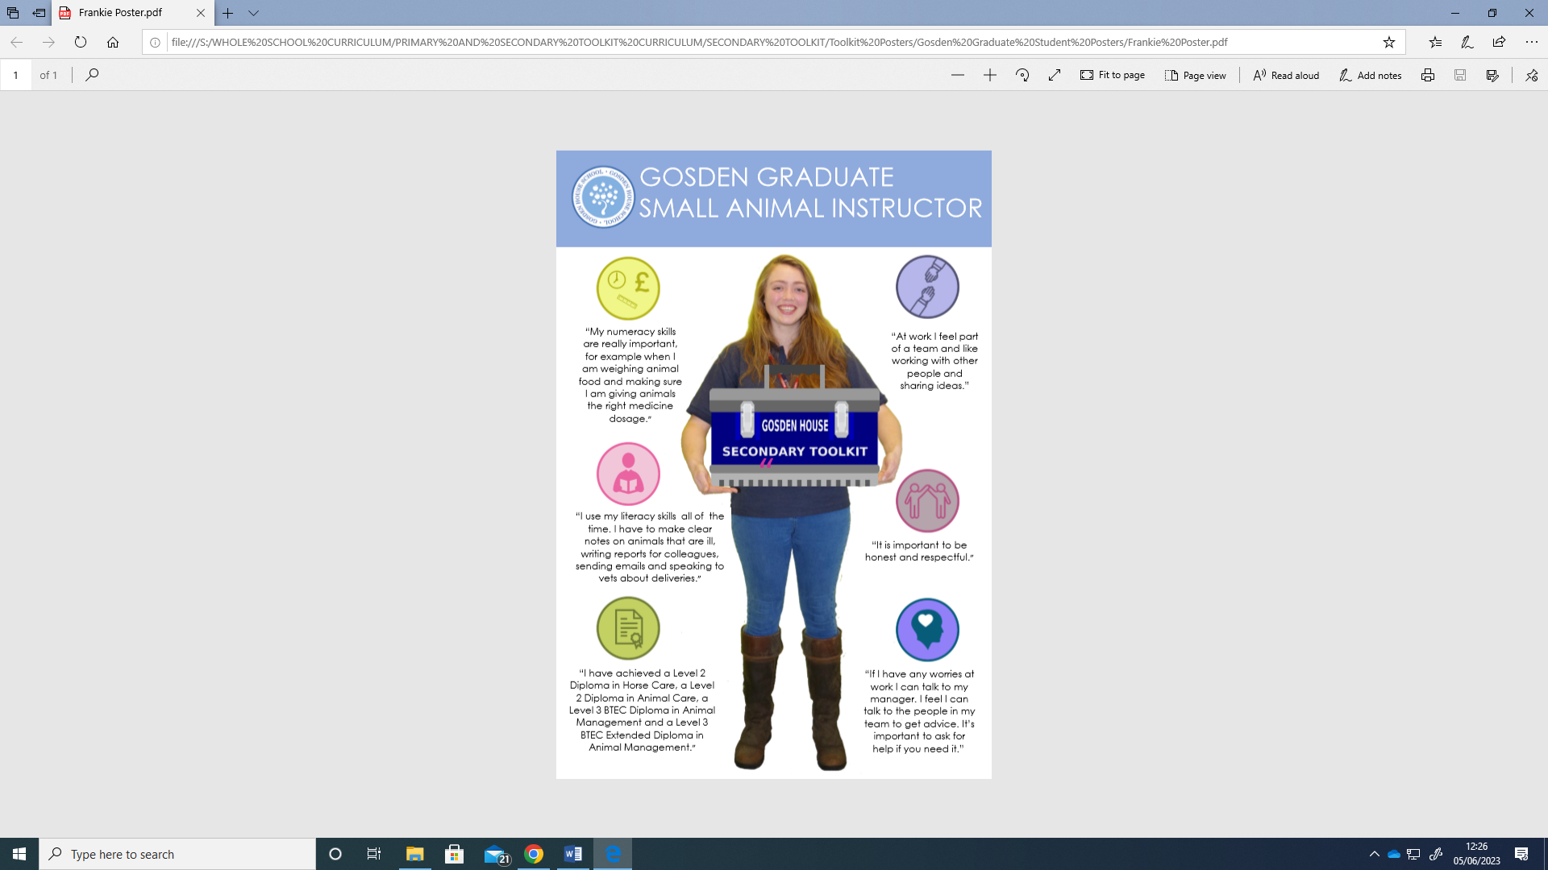

Furthermore, our learners continue to see the benefit of accredited exams and enjoy having that sense of purpose and achievement. We offer Edexcel Functional Skills exams, which are recognised to all post 16 providers, as well as employers, internships and apprenticeships. Our KS4 learners quickly understand the benefit and opportunities these qualifications will have on their future and they continuously strive to achieve them each year.

Lastly, we offer work experience to all of our Year 11 students. The benefit of this is tremendous and each year we notice the benefit and change in each of our learners, as they adopt a new work ethic and mature throughout the journey. They are given a hands on approach which allows them to see the purpose and an outcome of all their hard work. This year, several employers have asked our learners to return following their initial two week work experience, including one learner being offered a 12 week internship so that she can learn on the job. This journey excites our learners, it encourages them to begin to think about life after Gosden and it motivates them to continue to strive for success.