**CREATIVE ARTS AT GOSDEN HOUSE**

**KEY END POINTS IN OUR LEARNER’S JOURNEYS**

The Creative Arts curriculum supports the progress of our learners in achieving our purposeful and ambitious ‘End Points’. These identified ‘End Points’ focus on ‘tooling’ up our eventual Gosden Graduates for their future pathways. In addition to these guiding End Points all learners have individualised ILPs (Individual Learning Plans) and within their EHCP individual outcomes under the four areas of need which are developed and achieved throughout their time at Gosden.

**PRIMARY END POINTS**

EYFS / KS1 – I am learning to be curious about the world around me, through practical and creative exploration. I am excited to find out more.

KS2 – I am becoming more confident in exploring the wider world and I use my curiosity and creativity to investigate and to express my learning. I explore my own ideas and beliefs and value those of others.

**SECONDARY END POINTS**

WIIFM (What’s in it for me) - I have the skills to be confident in my community and feel valued in making positive contributions. I am interested in the world outside my door and I want to play a part in it, understanding differences in people and my community.

**WHAT DO WE BELIEVE IS ESSENTIAL IN THE TEACHING AND LEARNING OF CREATIVE ARTS FOR OUR GOSDEN LEARNERS?**

At Gosden House we understand the importance of expression, individuality and creativity for our learners. We provide a warm and vibrant learning environment, where exploration and curiosity are nurtured and valued. Creative Arts at Gosden House is used as a vessel for our learners to develop their enquiry skills and to express their individuality and creativity. Up until the end of KS3 we follow a topic based approach for our Creative and Curious curriculum, Creative Arts is used as a vessel to bring these topics to life, allow our learners to fully immerse themselves within their topic and develop essential enquiry skills.

Throughout their Creative Arts journey, our learners are able to build upon their learning power by using their Learning Habits and Muscles. Our delivery of Creative Arts allows our learners to explore their curiosity of learning and express their thoughts and feelings creatively. Through this experiential approach, we are able to nurture a lifelong love of learning within our learners and equip them with the tools they will need as a Gosden Graduate.

**HOW DO WE DEVELOP, STRETCH AND NURTURE THE ESSENTIAL SKILLS AND KNOWLEDGE IN CREATIVE ARTS?**

At Gosden House our delivery of Creative Arts enables our learners to develop their learning power throughout their Creative Arts journey. Our experiential approach, enables our learners to understand and articulate their learning.

All Creative and Curious areas of the Curriculum have subject specific ‘Learning Power Ladders’ these ensure that the delivery of Creative Arts is progressive and builds all learners Creative Arts enquiry skills whatever their level, and starting points.

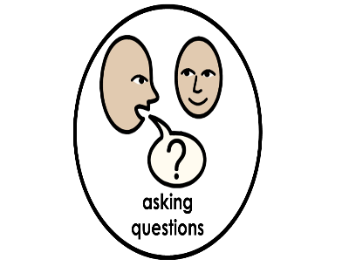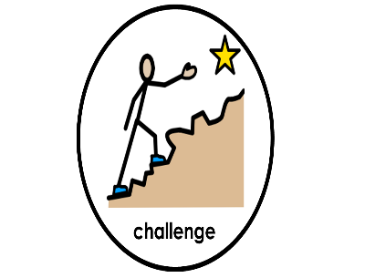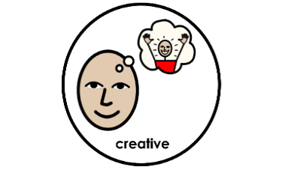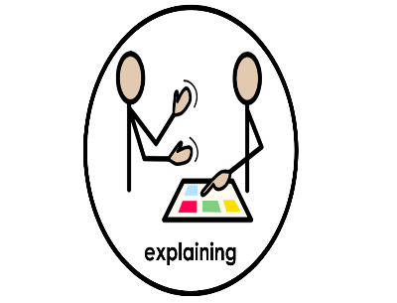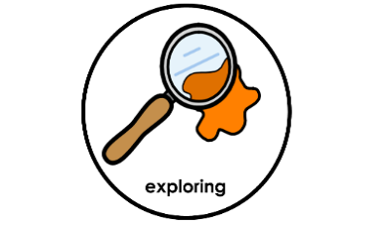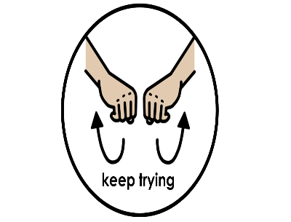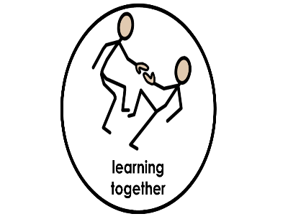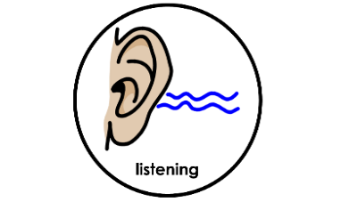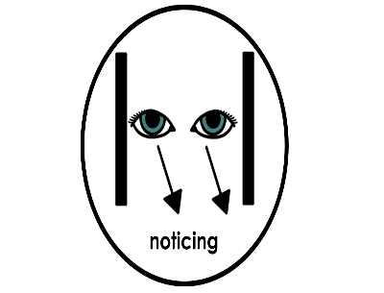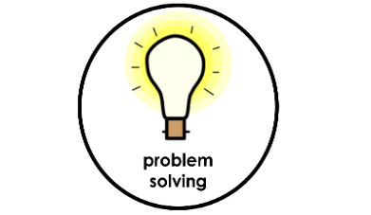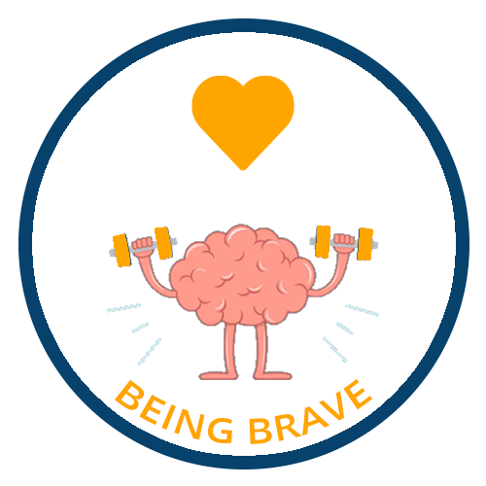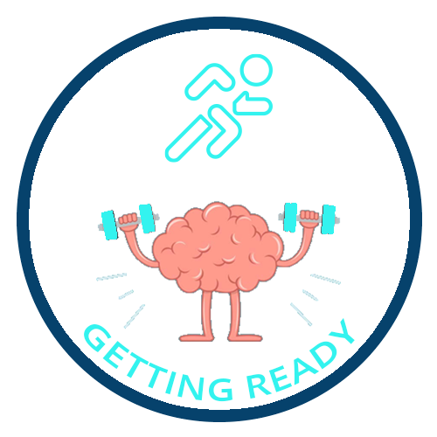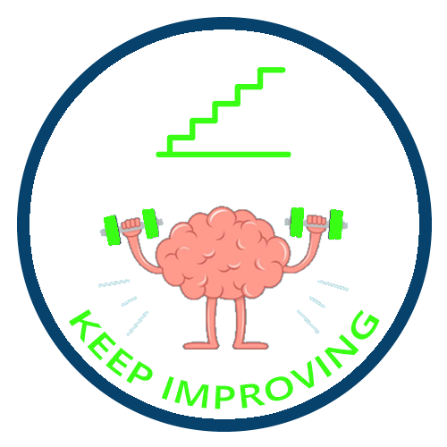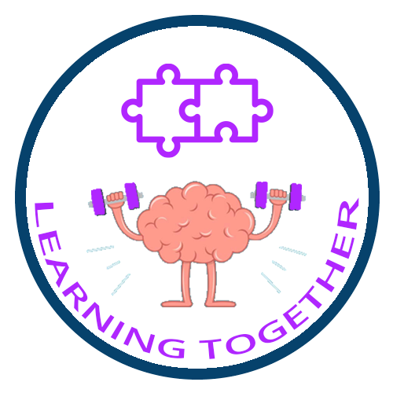

The EYFS Framework and the Primary National Curriculum for Creative Arts have been adapted, to ensure that the curriculum is accessible and purposeful for our learners. Pupils in KS4, then have the option to expand their skills by following the Bronze Arts Award Level 1 framework. Topics are used as a way to support the development of pupil’s enquiry skills in Creative Arts – ref. Creative Arts Learning Power Ladders.

|  |  |  |  |  |  |
| --- | --- | --- | --- | --- | --- |
|  | **EYFS**  **&**  **Year 2** | **Year 3 & 4** | **Year 5 & 6** | **KS3** | **KS4** |
| **CONTENT COVERAGE**  **Topics/Projects** | **First Year**   * This is Me * The Gingerbread Man * Around the World * On the Farm * Space * Under the Sea   **Second Year**   * Goldilocks * Let’s Celebrate * People Who Help Us * Dinosaurs * Let it Grow * Pets at Home   **Third Year**   * Healthy Me * Toys * The Three Little Pigs * Trains, Planes and Automobiles * Minibeasts * Seaside | **First Year**   * Castles, Knights and Dragons * The Frozen Planet * The Green Planet * Rainforest * Food Glorious Food * Our School Community   **Second Year**   * Fire! Fire! * Great Fire of London * In the Sky * On the Farm * Travel and Transport Motion * Under the Ground | **First Year**   * The Romans * Feathers, Furs and Fins * Seas, Rivers, Canals   **Second Year**   * Ancient Egypt * The Human Body * Roots, Shoots and Juicy Fruits | **Autumn Term**   * Year 7 – Movement & Migration * Year 8 – Invaders & Settlers * Year 9 – War   **Spring Term**   * Year 7 – Food of the Gods * Year 8 – The Victorian Life * Year 9 – Middle Ages & Microbes   **Summer Term**   * Year 7 – Marvellous Monarchs * Year 8 – Voyages of Discovery * Year 9 – Human Rights | **Bronze Arts Award Level 1**  One/ two year course which inspires young people to grow their arts and leadership talents: it's creative, valuable and accessible. Areas covered will be Dance, Drama, Sculpture, Art, Animation and Set Design. |

**PUPIL LEARNING JOURNEY IN CREATIVE ARTS**

Throughout our Learner’s journeys in Creative Arts, they experience a variety of topics/projects in which they are encouraged to use their Learning Habits and Muscles and develop their enquiry skills.

Within our Primary Department, our learners will experience cross-curricular topic based learning, their Creative Arts lessons are used to offer creative and immersive experiences of these topics. Within Key Stage Three, our Learners will experience project-learning; which we refer to as Our World. Each project will begin with a KWL session (I know, I wonder, I learnt), which is used to spark the creativity and curiosity of our learners. Creative Arts plays a fundamental role within the Our World projects, each class will have bespoke Drama, Music and Art lessons related to their project, as well as Creative Arts opportunities woven throughout their project.

Within Key Stage Four, our Learners are able to build on their Creative Arts skills and choose to study a Level 1 Bronze Arts Award. This is a one/two year course aimed at inspiring learners to take an active part in Creative Arts activities as well as experiencing the Creative Arts as audience members. Learners research an artist/craftsperson who inspires them and develop their leadership skills through passing on their Creative Arts skills to others. Learners record their activities in a Creative Arts portfolio.

**HOW DO WE KNOW OUR CREATIVE ARTS LEARNERS ARE ACTUALLY LEARNING? HOW DO OUR LEARNERS KNOW HOW THEY ARE DOING?**

Our Creative Arts curriculum has a significant impact on our learners’ personal, social, emotional, and academic development. It enables them to:

* Develop essential ‘Enquiry Skills’ which are transferable across the curriculum and in their daily lives.
* Develop their creativity, imagination, and self-expression.
* Build their confidence, self-esteem, and sense of identity.
* Develop their communication, collaboration, and problem-solving skills.
* Enhance their emotional intelligence, empathy, and resilience.

Our Creative Arts curriculum also supports our wider school values of inclusivity, diversity, belonging and equity, enabling every learner to participate and thrive regardless of their background or needs. Moreover, it enables our learners to make meaningful connections between different subject areas, deepening their learning and understanding of the world around them.

Through the use of EVISENSE, displays/exhibitions and school performances, our learners will be able to showcase the skills they have developed through their Creative Arts journey. Continuous assessment for learning will be used to allow learners to understand where they are on their journey and their next steps.

**IN CREATIVE ARTS HOW IS DIVERSITY, EQUITY, INCLUSION AND BELONGING (DEIB) INCORPORATED WITHIN THE CURRICULUM**

Within our delivery of Creative Arts we encourage all learners to be expressive and share their personal messages through their creativity. Our delivery of Creative Arts is accessible to all and we empahsise the importance of the process and celebrate each and every learner’s Creative Arts journey. We explore arts from a range of artists from a variety of backgrounds, this representation allows all of our learners to feel that they are a part of the Creative Arts community.

**IN CREATIVE ARTS HOW WILL OUR GOSDEN GRADUATE BENEFIT FROM THEIR SKILLS AND KNOWLEDGE IN THE FUTURE?**

Our delivery of Creative Arts supports our learners to develop essential and transferable enquiry skills, develop their curiosity of the world around them and provide them with ways to express and share their thoughts and feelings through visual literacy. Through this experiential approach, we are able to nurture a lifelong love of learning within our learners and equip them with the tools they will need as a Gosden Graduate. Please see below a range of our WIIFM (What’s in it for me) our Key end points that are developed through our Creative Arts Curriculum.

The below Life Tools are interwoven into the Creative Arts curriculum and signposted for pupils so that they can understand the purpose and value of participating in the Creative Arts Curriculum.

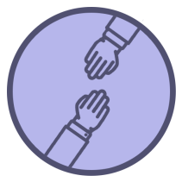

Sense of Belonging - I have the skills to be confident in my community and feel valued in making positive contributions. I am interested in the world outside my door and I want to play a part in it, understanding differences in people and my community.



Employability Skills- I have an individualised skill set that enables me to access qualifications and a work based environment, in preparation for my future pathway.



Life Skills - I am building a range of life skills and experiences that equip me with the confidence and sense of belonging, to be an active participant in my community.



Literacy Skills - As a Gosden Graduate, I am equipped with functional Literacy skills and an enjoyment of language. I am confident to apply these tools for self-expression and can communicate effectively in my everyday life.



ICT Skills - I have functional ICT Skills, I can use these skills in ways that help me engage with the online world positively.

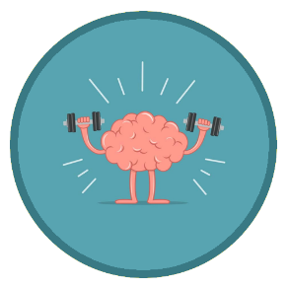

Learning Power - I recognise the role that my Learning Muscles/Habits play in my development as a resilient and confident learner, ready for the next step. These fundamental tools enable me to understand myself better as a learner and so support me in experiencing success, central to me being able to have higher personal aspirations.